EQUINET EXECUTIVE BOARD ELECTIONS 2019
Overview of Candidates
Geographical Group I (out of which to select a maximum of 4 candidates)
 | Kirsi PIMIÄ  Ombudsman  Non-Discrimination Ombudsman, Finland kirsi.pimia@oikeus.fi
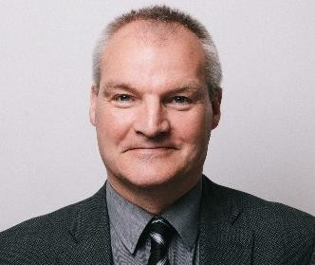 | Laurence BOND  Director  Irish Human Rights and Equality Commission (IHREC) labond@ihrec.ie
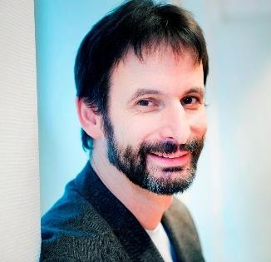 | Patrick CHARLIER  Co-Director  Unia (Interfederal Centre for Equal Opportunities), Belgium pach@unia.be
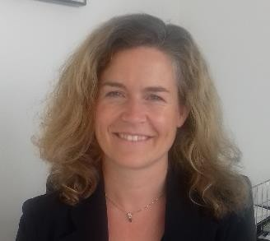 | Valérie FONTAINE  Advisor for Partnerships and Public Relations Defender of Rights, France valerie.fontaine@defenseurdesdroits.fr

