**APPLICATION FORM**

**PART-TIME JOB POSITION**

**ETHNIC PROFILING EVENT ASSISTANT (4 months)**

***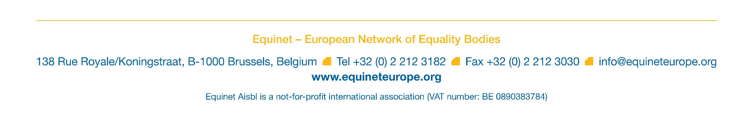*Please send the completed application form together with your latest CV (both in English) by 15 August to** [**jobs@equineteurope.org**](mailto:jobs@equineteurope.org) **and with reference “Ethnic profiling event assistant”.**

*Please refer to the Position Description available together with this form and answer the questions below. The completed application form should not exceed two pages in total. Please expand each answer field 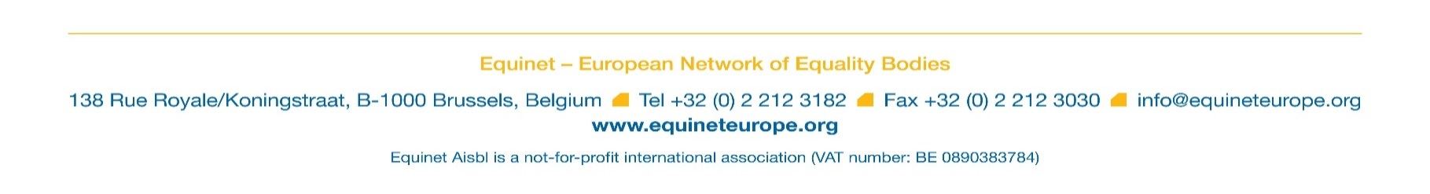below (max. 250 words per question).*

**Applicant’s name (required):**

**Question 1: Please explain your motivation for applying for this part-time position within the Equinet team, including your interest and experience in non-discrimination issues and particularly ethnic profiling issues (expand the textbox to as you see fit)**

|  |
| --- |
|  |

**Question 2: What are the key strengths that you would bring to this position, in relation to the stated requirements? (Expand the textbox to as you see fit)**

|  |
| --- |
|  |

**Question 3: What is your practical knowledge of Project Management, Project budgeting and reporting and general Office Management? In case you do have practical knowledge, please mention any tool you might have already used in that regard (expand the textbox to as you see fit):**

|  |
| --- |
|  |