**APPLICATION FORM**

**Equinet Traineeship – Policy and Communication Assistant (April 2017)**

***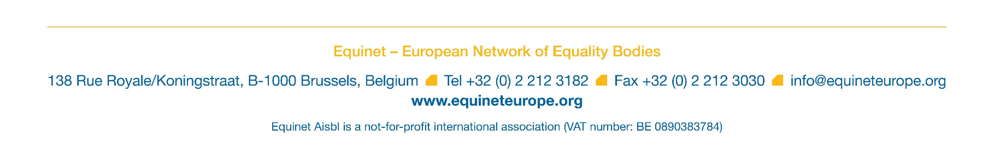*Please send the completed application form together with your latest CV (both in English) by 14 April (midday) to** [**jobs@equineteurope.org**](mailto:jobs@equineteurope.org) **and with reference “Equinet Traineeship II – Admin & Communication”.**

*Please refer to the Application Package sent together with this form and answer the questions below. The completed application form should not exceed two pages in total. Please expand each answer field as required.*

**Applicant’s name:**

**Question 1: Please explain your motivation for applying for a traineeship within the Equinet team, including your interest and experience in non-discrimination issues**

|  |
| --- |
|  |

**Question 2: What are the key strengths that you would bring to this traineeship, in relation to the stated requirements?**

|  |
| --- |
|  |

**Question 3: What is your perception of the added value brought by Equality bodies and Equinet to the Equality agenda at EU level?**

|  |
| --- |
|  |