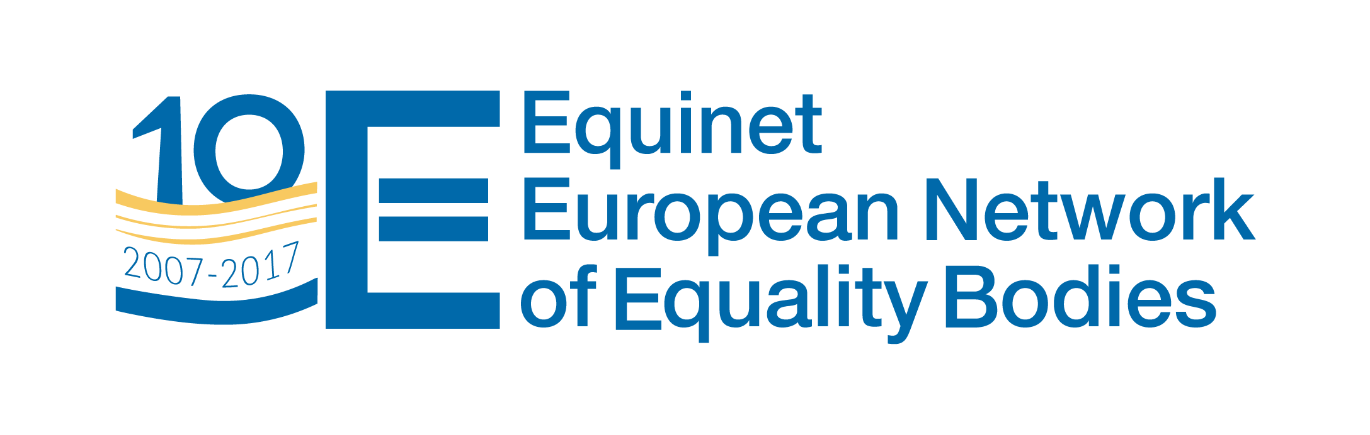
Equinet Working Group on Policy Formation
2nd 2017 meeting
Office of the Ombudswoman
Trg hrvatskih velikana 6 - Zagreb, Croatia
Tuesday 19th September (09:00 – 16:00)
AGENDA
09:00 – 10:00 | - Welcome and introduction of participants  - Update on key developments at national level (tour de table)  - Update on Equinet policy work and other updates
Preparation required: Identify any developments on anti-discrimination and equality in your country + new initiatives within your equality body that are interesting for other WG members.
10:00 – 10:30 | FACTSHEET - Equality Bodies contributing to the List of Actions by the European Commission to advance LGBTI equality  Presentation & debriefing session
10:30 – 10:45 | Coffee break
10:45 – 13:00 | PERSPECTIVE: The specificities of ombudspersons as equality bodies
10:45 – 13:00 | Discussion on the objectives and content of the Perspective  See questions for discussion below.
Preparation required: Please prepare your input to the questions for discussion below.
13:00– 14:00 | Lunch break
14:00– 15:45 | STUDY VISIT: Institutions with multiple mandates – A practical case  Visit and presentation by the Croatian Office of the Ombudswoman
15:45– 16:00 | CONCLUDING SESSION
15:45– 16:00 | Conclusion of the meeting & Next steps

First Discussion of Perspective on “Links between Offices of Ombudsperson and Equality Bodies”

QUESTIONS:
Introduction: Discussion on the objectives of the Perspective

- Office of Ombudsperson
  - What is the core mission and values of the Office of Ombudsperson?
  - What are the core activities of the Office of Ombudsperson?
  - How is success defined for the Office of Ombudsperson?
  - What conditions are required for the Office of Ombudsperson to achieve success?

- Offices of Ombudsperson and Equality Bodies
  - What do equality bodies and Offices of Ombudsperson have in common?
  - What are the differences between an Office of Ombudsperson and an equality body?

- Links between Offices of Ombudsperson and Equality Bodies
  - What is the focus for such links and how are they operationalised?
  - What are the difficulties in achieving effective links?
  - What is required to achieve effective links?
  - Why develop these links?
  - If links have not been developed, why not?

- Multi-mandate bodies combining mandates of Office of Ombudsperson and of Equality Body
  - How are the two mandates organised internally?
  - What are the difficulties in managing the two mandates effectively?
  - What is required for such a multi-mandate body to be effective?
  - What are the risks in and benefits of being a multi-mandate body?

