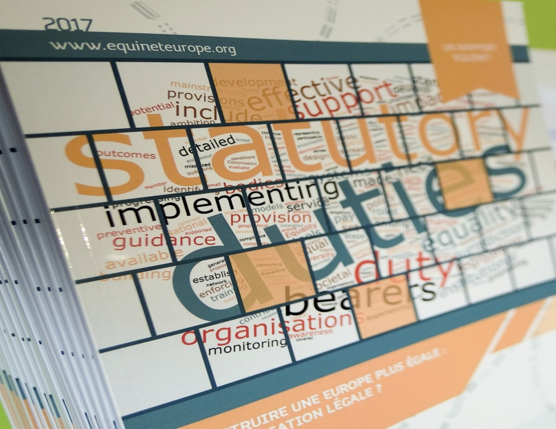

**By Sedana Halilčević (EPSA, Inclusion Europe) and Ingrid Egeland Thorsnes (Equinet)**

EASY TO READ SUMMARY

4 May 2017 Brussels, Belgium

**Equinet Conference**

Advancing Equality:

The Potential of Equality Duties

|  |  |
| --- | --- |
|  | On the 4 May 2017, Equinet had a conference in Brussels, Belgium. A conference is a big meeting. People came to talk about how best to fight special kinds of unfair treatment that we call discrimination.  It is against the law to discriminate against someone just because, for example, they are a woman, disabled or believe in a different god than most other people. But it still happens sometimes.  Is it better to wait for someone to complain because they have been discriminated? Or should someone try to help before discrimination happens? And if someone can help, how can they do that? These were the main questions we talked about.  Many of the people at the conference work in special offices called equality bodies. People who feel discriminated can go to these offices for help. These offices also work with others, like companies, to help them treat people in a fair way.  There are many things companies and countries can do to make sure people are treated fairly. A company can, for example, write a report saying what they do to make sure everyone in their company is treated fairly. When companies have to write reports like that, it can be called an equality duty. The purpose of the conference was for people to learn more about equality duties like that.  An example of an equality duty can be to have companies check if there are differences in how much they pay women and men. If they see that men make more money, the company should do something to make sure women are paid equally.  Another example can be when the Government should think about if a new law will have a bad effect for some people, for example persons with disabilities. Even though there could be a good reason for the new law, it might be discriminatory for some people. If the Government has to think about that before making a new law, it can be called an equality duty.  There were many good speakers at the conference to teach us about equality duties. We also sat in smaller groups discussing and learning from each other. Understanding what equality duties are can be a bit confusing, since there are so many different types. But we did our best to help each other understand more, and learn from the different kinds of equality duties we have in our different countries |