**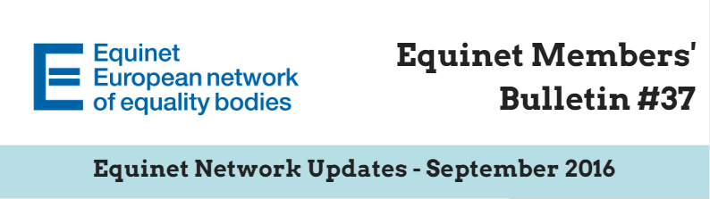  
Dear Equinet Members,**

This Members’ Bulletin gathers **the main Equinet internal updates, with a view to provide you with a clearer overview of Equinet activities**. We very much hope this members’ bulletin will be useful in your day-to-day work and we would be grateful if you could **disseminate it among your colleagues**. Your feedback is also greatly appreciated. Should you have any comments or further questions, please do not hesitate to contact **Jessica Machacova, Equinet Membership and Policy Officer** ([Jessica.machacova@equineteurope.org](mailto:Jessica.machacova@equineteurope.org) / 0032 2 212 31 80).

**Equinet Members’ Bulletin on Internal Network Updates – Table of contents**

***(Ctrl + Click to follow the link)***

**PART 1: EQUINET UPDATES**

* **Equinet Annual General Meeting** (29th – 30th September 2016, Brussels, Belgium) - Agenda and voting documents
* Reminder: **Equinet Working Paper on Standards** - Dissemination and call for translation
* **Launch of the Equinet Online Directory** - Update your profile by 28th September
* **Equinet Executive Board and Secretariat meet with Finnish equality bodies**
* **Equinet consultation meetings with social partners and civil society organisations**
* Updates: **Cooperation Platforms involving Equinet - Council of Europe – ENNHRI – European Union Agency for Fundamental Rights (FRA)**
* **Save the date!** Next Equinet Meetings

**PART 2: EQUINET MEMBERS**

* **Equinet members’ requests**
* **Updates from Equinet members**

**PART 3 – EXTERNAL STAKEHOLDERS’ REQUESTS**

* Invitation – **ERIO 5th Workshop with Equality Bodies** “Ending school discrimination of Roma: the Role of Equality Bodies” Brussels, 13 October 2016
* **Council of Europe Seminar** Fight against racism, xenophobia, homophobia and transphobia (25 – 26 July 2016, Barcelona, Spain) - Presentations available

### **PART 1: EQUINET UPDATES**

# Equinet Annual General Meeting 29th – 30th September 2016, Brussels, Belgium Agenda and voting documents

We look forward to welcoming you to the **Equinet Annual General Meeting 2016** that will take place in Brussels at the THON EU Hotel (Rue de la Loi 75, 1040, Brussels) on **Thursday 29th September 2016 in the afternoon and Friday 30th September in the morning**.

Equinet members are also invited to join the **networking reception** which will take place at the Norway House (Rue Archimède 17, 1000 Brussels) on 29 September evening from 18:45 to 20:30.

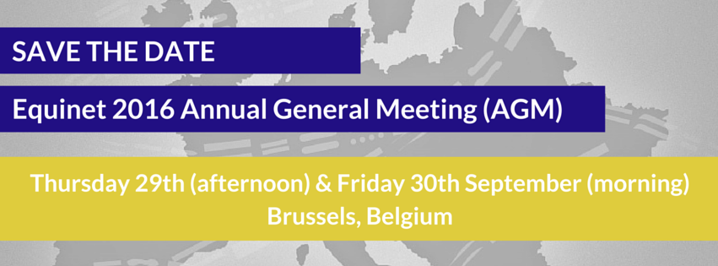

These are the voting items that will be put forward to the vote of the General Assembly of Members at the AGM, following review and proposed by the Equinet Board:

* Application for membership from the Human Rights Ombudsman of Bosnia and Herzegovina
* Equinet Draft Work Plan 2017
* Final Equinet Accounts 2015
* Draft Minutes of the Equinet AGM 2015
* Proposal for revised Equinet Board elections procedure

**Amendment Proposals (Deadline: Monday 26th September, 12:00)**

All represented member organisations are kindly requested to review the voting documents ahead of the AGM. The following documents are open to written amendments by members until 26th September (12h00 CET):

* Minutes of the Equinet AGM 2015
* Equinet Work Plan and Budget 2017
* Revised Equinet Board elections procedure

Amendments to these voting items can only be submitted using ‘Amendment proposal form’, to be completed and emailed back to Equinet by no later than 26th September (12h00 CET), so that we can inform other members of any proposed amendment ahead of the AGM.

**The voting documents as well as the agenda of the AGM and the amendment proposal form are available on the** [**Equinet Member’s Area**](http://www.equineteurope.org/-Annual-General-Meeting-)**.** In case you lost your login information, please contact [Jessica.machacova@equineteurope.org](mailto:Jessica.machacova@equineteurope.org).

For any questions please contact Jessica Machacova, Membership and Policy Officer ([Jessica.machacova@equineteurope.org](mailto:Jessica.machacova@equineteurope.org)) or call the Equinet Secretariat at +32 (0)2 212 31 80.

# Reminder: Equinet Working Paper on Standards Dissemination and call for translation

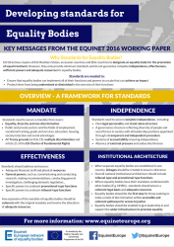

|  |
| --- |
| In June 2016, Equinet officially launched its **working paper on developing standards for equality bodies**.  This Working Paper is the result of discussions that took place in the framework of the **Equinet Cluster on Standards** in 2015, as well as contributions and comments provided by Equinet members.  It seeks to establish positions that equality bodies could promote, negotiate and advance vis-à-vis European and national administrations in the establishment of standards for equality bodies at European level and their implementation at national level. |

**Dissemination**

The Working Paper, as well as a visual briefing summarising its key messages, are available [on the Equinet website](http://www.equineteurope.org/Equinet-Working-Paper-on-Developing-Standards-for-Equality-Bodies). We would be grateful if you could disseminate it to your relevant contacts in order to ensure maximum impact of our messages.

**Translation**

UNIA, one of the two Belgian equality bodies, kindly translated the Working Paper in French (available soon). If your organisation would consider its translation it in your national language, please get in touch with **Tamás Kádár, Head of Legal and Policy** ([tamas.kadar@equineteurope.org](mailto:tamas.kadar@equineteurope.org)).

Read and download **the Working Paper** [here](http://www.equineteurope.org/Equinet-Working-Paper-on-Developing-Standards-for-Equality-Bodies).   
Materials of the 16th June **Conference on strengthening the effectiveness of European equal treatment legislation** are available [here](http://www.equineteurope.org/Strengthening-the-effectiveness-of-European-Equal-Treatment-Legislation) (a summary of the event will be published soon).

# Launch of the Equinet Online Directory Update your profile by 28th September

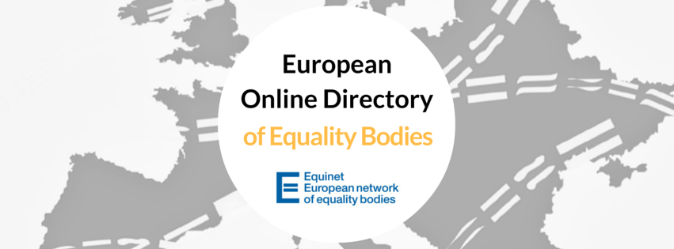

The European **Online Directory of Equality Bodies** will be launched on **Thursday, 29th September, during our Annual General Meeting**.

We are looking forward to having a space on our website which improves the visibility we give to our members, and better highlights the wide range of work that you all do. The Directory will also include some comparative sections, to allow users to identify which mandates and functions you share with others.

We will send you the official links to the Directory after the launch. We hope you will like it!

In advance of the launch, in order to make sure that all of the information on your organisation is as it should be, could you please check your profile as it currently appears in the internal version of the Online Directory: <http://www.equineteurope.org/spip.php?page=tableau_neb&section=overview>

**Ideally, this would be checked (and updated if necessary) before 28th September**. It would be great if the most complete and up-to-date version possible were included on launch date.

In any case, the Directory is a work in progress, so we will invite you to include new statistics at the beginning of every year to keep it up to date. However, feel free to update it with any changes you may have throughout the year.

In case you need assistance with **updating your profile**, please contact Sarah Cooke O’Dowd, Equinet Communication Officer ([Sarah.CookeODowd@equineteurope.org](mailto:Sarah.CookeODowd@equineteurope.org)).

# Equinet Executive Board and Secretariat meet with Finnish equality bodies September 2016, Helsinki, Finland

The Equinet Executive Board and Secretariat were invited to Helsinki on 7 September by our Finnish members, the [Non-Discrimination Ombudsman](http://www.syrjinta.fi/) and the [Ombudsman for Equality](https://www.tasa-arvo.fi/), to meet with staff members and Finnish stakeholders to discuss the work of equality bodies and common challenges for equality in Europe.

The following day, the Equinet Executive Board held its third meeting of the year. Minutes of the meeting will be made available after being approved by the Board members on the [Equinet Members’ Area](http://www.equineteurope.org/-Board-Meetings-and-Minutes-87-).

More information is available on the [Equinet website](http://www.equineteurope.org/Equality-in-Europe-and-Finland).

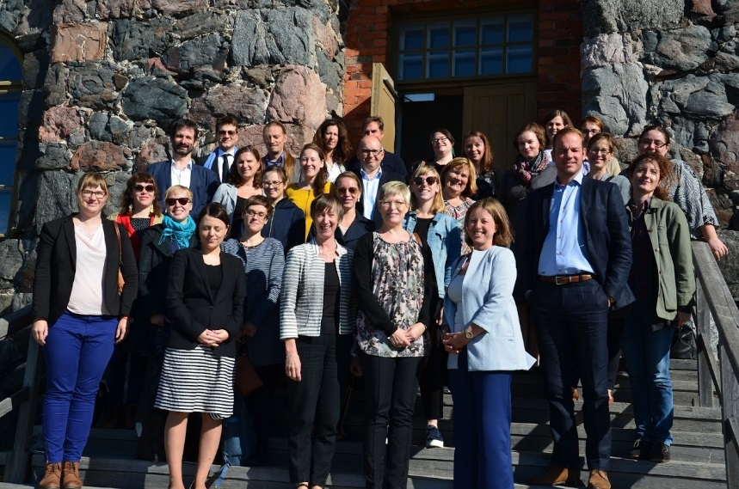

# Equinet consultation meetings with social partners and civil society organisations August 2016, Brussels, Belgium

On 30 August, Equinet representatives met with a variety of social partners and civil society organisations in order to highlight priorities of Equinet’s draft Work Plan for 2017 and to hear about their current and future priorities in order to find synergies and ways for cooperating in the future.

**Civil Society Organisations**

At the meeting with civil society organisations, representatives of the [European Network against Racism](http://www.enar-eu.org/), the [European Disability Forum](http://www.edf-feph.org/), the [European Youth Forum](http://www.youthforum.org/assets/2015/10/Multiple-discrimination-and-young-people-in-Europe.pdf), [Amnesty International’s EU Office](http://www.amnesty.eu/), [ILGA Europe](http://www.ilga-europe.org/), the [Social Platform](http://www.socialplatform.org/) and the [European Women’s Lobby](http://www.womenlobby.org/) discussed their priorities for 2017 with the aim of identifying possible areas of cooperation.

**Social Partners**

In the meeting with European social partners it was important to not only hear their key priorities in the field of equality and anti-discrimination for 2017, but also to discuss what Equinet and its member organisations can do in order to support and further the social partners’ work. Representatives of the [European Trade Union Confederation](https://www.etuc.org/), the [UEAPME](European%20Association%20of%20Craft,%20Small%20and%20Medium-Sized%20Enterprises) (European Association of Craft, Small and Medium-Sized Enterprises), and [Business Europe](https://www.businesseurope.eu/) attended the meeting.

More information is available on the [Equinet website](http://www.equineteurope.org/Equinet-consultation-meetings-with-social-partners-and-civil-society).

# Updates: Cooperation Platforms involving Equinet - Council of Europe – ENNHRI – European Union Agency for Fundamental Rights (FRA)

In October 2013, Equinet, the Council of Europe (CoE), the European Network of National Human Rights Institutions (ENNHRI) and the European Union Agency for Fundamental Rights (FRA) took the decision to establish [common platforms for cooperation](http://www.equineteurope.org/-Thematic-Platforms-for-Cooperation-) on four pressing topics.

1. **COOPERATION PLATFORM ON ADVANCING SOCIAL AND ECONOMIC RIGHTS**

The next meeting of the Platform will be held on 10th October in Belgrade, Serbia, hosted by the Serbian Commission for the Protection of Equality. The meeting should provide the platform and Equinet members with an opportunity to engage inter alia with the European Pillar of Social Rights, for which the Commission currently conducts an ongoing open consultation process.

**Equinet contact person:** Katrine Steinfeld, Equinet Policy Officer ([katrine.steinfeld@equineteurope.org](mailto:katrine.steinfeld@equineteurope.org)).

1. **COOPERATION PLATFORM ON RIGHTS OF MIGRANTS AND ASYLUM SEEKERS**

The second meeting of the Asylum and Migration Cooperation Platform was held in Vienna on 15th and 16th February 2016. The summary is available [on the Equinet website](http://www.equineteurope.org/-Thematic-Platforms-for-Cooperation-).

**Equinet contact person:** Jessica Machacova, Equinet Membership and Policy Officer ([Jessica.machacova@equineteurope.org](mailto:Jessica.machacova@equineteurope.org)).

1. **COOPERATION PLATFORM ON ROMA EQUALITY**

The last meeting of the Operational Platform for Roma Equality (OPRE) was held on 7th and 8th June in Athens, Greece. A [joint statement on evictions of Roma people](http://www.equineteurope.org/Press-Release-Stop-Evictions-of-Roma-and-Travellers) was published in June 2016.

**Equinet contact person:** Tamás Kádár, Head of Legal and Policy ([tamas.kadar@equineteurope.org](mailto:tamas.kadar@equineteurope.org)).

1. **COOPERATION PLATEFORM ON HATE CRIME**

The FRA working party on hate was held on 28th and 29th April in Amsterdam. A short meeting of the Platform was organised on 29th April. It was decided to continue the cooperation among Platform members mostly based on information exchange (Newsletters, emails etc). In order to maintain this information exchange, **please send FRA (**[elena.balzarini@fra.europa.eu](mailto:elena.balzarini@fra.europa.eu) ) **information on activities, meetings, studies and publications in the field of combating hate crime and hate speech, which you think could be interesting for the other Platform members**.

**Equinet contact person:** Sarah Cooke O’Dowd, Communication Officer ([sarah.cookeodowd@equineteurope.org](mailto:sarah.cookeodowd@equineteurope.org)).

# Save the date! Next Equinet Meetings

|  |  |  |
| --- | --- | --- |
| **Capacity-building events** | **Thursday 13th and Friday 14th October** | Training event on social media *(Dublin, Ireland)* |
| **Wednesday 9th and Thursday 10th November** | Seminar on race and ethnicity *(Budapest, Hungary)* |
| **Governance**  **Meetings** | **Thursday 29th and Friday 30th September** | Equinet Annual General Meeting (AGM) *(Brussels, Belgium)* |
| **Thursday 8th December** | Board meeting *(Brussels, Belgium)* |
| **Conferences and other Equinet events** | **Wednesday 7th December** | Conference on intersectionality and gender equality *(Brussels, Belgium)* |
| **Working Groups** | **Thursday 6th October** | Working Group Policy Formation *(Brussels, Belgium)* |
| **Friday 4th November** | Working Group Gender Equality *(Malta)* |
|  | **Week of 21st November**  **(Please reply to Doodle by 27 September to identify date: http://doodle.com/poll/vn9kms2grrkfexkr)** | Working Group on Communication *(Bratislava, Slovakia)* |

### **PART 2: EQUINET MEMBERS**

# Equinet members’ requests

* **Unia (Interfederal Centre for Equal Opportunities), Belgium – Insurances and clients with psychiatric diseases**

Unia often receives cases of insurances refusing persons who have had psychiatric diseases in the past. Other insurances do not refuse, but have an exclusion clause in the contract, excluding any risk related to any psychiatric disease in the future.

This is problematic and seems to us not proportionate. We would like to know:

1. If there are specific rules/legislations regarding this problem in other countries (like the “right to forget” in France, for people who have had cancer)
2. If there have been judicial decisions in other countries.

**Please send your contribution to Emilie Van Laer (**[**emilie.vanlaer@unia.be**](mailto:emilie.vanlaer@unia.be)**) as soon as possible.**

# Updates from Equinet members

* **Public Defender of Rights (Czech Republic) -**

Unequal pay between men and women presents a fascinating social phenomenon with no simple solution. Unfortunately, it is still frequent and common – as we know from the audits made in the Czech Republic. There is still a prevailing belief that men are breadwinners, hence they deserve higher financial rewards than women. However, this gender stereotype does not reflect the diversity of family arrangements in our contemporary society.

The publication **Collection of Contributions at the International Conference on the Topic of Gender Pay Gap** include the contributions of the speakers at the conference on unequal pay between women and men held in Brno in January 2016. It is available in English [here](http://www.ochrance.cz/fileadmin/user_upload/DISKRIMINACE/Knihovna/Sbornik_NORA_AJ.pdf).

### **PART 3 – EXTERNAL STAKEHOLDERS’** **REQUESTS**

# Invitation – ERIO 5th Workshop with Equality Bodies “Ending school discrimination of Roma: the Role of Equality Bodies” Brussels, 13 October 2016 Deadline for Registration: Friday 23rd September

ERIO, in close cooperation with Equinet, invites you to attend **a workshop with Equality Bodies, anti-discrimination experts and Roma representatives on 13 October 2016 in Brussels (address to be confirmed)**.

Within the framework of the Race Equality Directive 2000/43 (RED) and national laws on equal treatment as well as on education, the workshop will focus on how Equality Bodies **can stop school segregation and discrimination of Roma children and ensure their equal treatment in education**.

Roma children across the EU continue to be denied equal access to quality education and still face discrimination and segregation. They are educated in inferior segregated environments or sent to “special schools” (schools for children with special needs with simpler curricula than mainstream schools). The European Commission initiated infringement proceedings against Czech Republic (2014), Slovakia (2015) and Hungary (2016) for breaching the Race Equality Directive 2000/43 (RED) in their treatment of Roma school children and where Roma children are significantly over-represented in “special schools” and segregated in mainstream schools.

The aims of this workshop are to:

* Promote cooperation between Equality Bodies and civil society to jointly address discrimination against Roma, including in education
* Foster discussion between different Equality Bodies, civil society and anti-discrimination experts on challenges and effective practices to end discrimination in education of Roma children
* Assist Equality Bodies to work effectively with Roma to tackle discrimination

ERIO will arrange and cover the expenses of the accommodation and travel of representatives of Equality Bodies. The workshop will be in English.

**REGISTRATION**

Places are limited. Please confirm participation **as soon as possible**. Register by email by sending your name, surname and organisation: [office@erionet.eu](mailto:office@erionet.eu). Tel: +32 (2) 733 3462

# Council of Europe Seminar Fight against racism, xenophobia, homophobia and transphobia (25 – 26 July 2016, Barcelona, Spain) Presentations available

In July 2016, the Equinet Secretariat and several Equinet members participated in the Council of Europe Seminar. The presentations of the Seminar are available [here](https://mycloud.coe.int/index.php/s/wIh9Ard6RXXjVOE).

More specifically, the webpage includes:

* [HELP28 overview](https://mycloud.coe.int/index.php/s/wIh9Ard6RXXjVOE#pdfviewer)
* [ECHR and Asylum e-learning course](https://mycloud.coe.int/index.php/s/wIh9Ard6RXXjVOE#pdfviewer)
* [Non-discrimination: an overview of the case-law of the European Court of Human Rights and the European Committee of Social Rights](https://mycloud.coe.int/index.php/s/wIh9Ard6RXXjVOE#pdfviewer)
* [Council of Europe standards on combating discrimination on grounds of sexual orientation or gender identity](https://mycloud.coe.int/index.php/s/wIh9Ard6RXXjVOE#pdfviewer)

Feel free to use these tools and disseminate them to your colleagues!

In case you need more information, please contact Sarah Cooke O’Dowd, Equinet Communication Officer ([sarah.cookeodowd@equineteurope.org](mailto:sarah.cookeodowd@equineteurope.org)), who participated in the training event.