**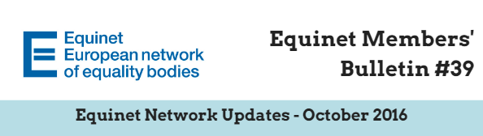  
Dear Equinet Members,**

This Members’ Bulletin gathers **the main Equinet internal updates, with a view to provide you with a clearer overview of Equinet activities**. We very much hope this members’ bulletin will be useful in your day-to-day work and we would be grateful if you could **disseminate it among your colleagues**.

Your feedback is also greatly appreciated. Should you have any comments or further questions, please do not hesitate to contact **Jessica Machacova, Equinet Membership and Policy Officer** ([Jessica.machacova@equineteurope.org](mailto:Jessica.machacova@equineteurope.org) / 0032 2 212 31 80).

**TABLE OF CONTENTS**

***(Ctrl + Click to follow the link)***

**PART 1: EQUINET UPDATES**

* **Register to the Equinet Seminar on fighting discrimination on grounds of race and ethnic origin** (9th & 10th November 2016, Budapest, Hungary) - Deadline: 28th October 2016
* **Register to the Equinet Conference on intersectionality** (7th December 2016, Brussels, Belgium) - Deadline: 21st November 2016
* **Equinet Annual General Meeting** (29th – 30th September 2016, Brussels, Belgium) - Outcomes
* Reminder: **Equinet Working Paper on Standards - Dissemination and call for translation**
* **European Journalist Award on Diversity** – Final results and award ceremony (Monday 17th October, Dublin, Ireland)
* **Equinet Chair and Director meet with leadership of the Irish equality body** (Monday 17th October, Dublin, Ireland)
* **Updates: Cooperation Platforms** involving Equinet - Council of Europe – ENNHRI – European Union Agency for Fundamental Rights (FRA)
* **Save the date!** Next Equinet Meetings

**PART 2: EQUINET MEMBERS**

* **Equinet members’ requests**
* **Updates from Equinet members**

**PART 3 – EXTERNAL STAKEHOLDERS’ REQUESTS**

* **Invitation – European Commission** – Annual Legal Seminar on gender equality and anti-discrimination law (25th November 2016, Brussels) - Deadline for Registration: 27th October 2016

### **PART 1: EQUINET UPDATES**

# Register to the Equinet Seminar on fighting discrimination on grounds of race and ethnic origin (9th & 10th November 2016, Budapest, Hungary) Deadline: 28th October 2016

On **9th and 10th November 2016**, Equinet and the [Hungarian Office of the Commissioner for Fundamental Rights](http://www.equineteurope.org/Parliamentary-Commissioner-for-the) are co-organising a capacity-building seminar on **fighting discrimination on grounds of race and ethnic origin**. The seminar will take place in Budapest, Hungary.

The Seminar aims to:

* Build capacity among Equinet members to combat discrimination on the ground of race and ethnic origin, including a focus on discrimination against Roma people
* Offer a platform to discuss good practices and promising tools
* Discuss issues of multiple discrimination where race and ethnic origin intersect with other grounds such as gender, religion or belief

**More information, as well as the draft agenda, is available on the** [**Equinet website**](http://www.equineteurope.org/Equinet-Seminar-Fighting-discrimination-on-grounds-of-race-and-ethnic-origin)**.   
Register** [**here**](https://form.jotform.com/62793002086959) **by 28th October.**

**EQUINET CONTACT PERSON**: Silvana Roebstorf, Policy and Communication Assistant (trainee) ([Silvana.Roebstorf@equineteurope.org](mailto:Silvana.Roebstorf@equineteurope.org) - Tel. +32 (0)2 212 3186)

# Register to the Equinet Conference on intersectionality (7th December 2016, Brussels, Belgium) Deadline: 21st November 2016

In order to strengthen equality bodies’ strategic approach to addressing intersectional discrimination and to promoting equality on an intersectional basis, as well as to continue raising awareness about intersectional discrimination in the European agenda, [Equinet’s on Policy Formation and Gender Equality](http://www.equineteurope.org/-Thematic-Working-Groups-) have cooperated to draft a Perspective on Innovating at the Intersections - Equality Bodies Tackling Intersectional Discrimination *(to be published in November 2016).*

The conference aims to:

* Provide a platform to discuss the challenges in promoting an intersectional approach to equality and in litigating intersectional discrimination
* Present the conclusions of the **2016 Equinet Perspective “Innovating at the Intersections - Equality Bodies Tackling Intersectional Discrimination”**
* Set out a vision for future work to promote an intersectional approach to equality and to combat intersectional discrimination

**More information, as well as the draft agenda, is available on the** [**Equinet website**](http://www.equineteurope.org/Register-to-the-Equinet-Conference-Diverse-Inclusive-and-Equal-Innovating-at)**.   
Register** [**here**](https://form.jotform.com/62793002086959) **by 21st November.**

**EQUINET CONTACT PERSONS**: Jessica Machacova, Membership and Policy Officer ([Jessica.machacova@equineteurope.org](mailto:Jessica.machacova@equineteurope.org) - Tel. +32 (0)2 212 3180) & Katrine Steinfeld, Policy Officer ([Katrine.steinfeld@equineteurope.org](mailto:Katrine.steinfeld@equineteurope.org))

# Equinet Annual General Meeting 29th – 30th September 2016, Brussels, Belgium Outcomes

**EEA AND NORWAY GRANTS**

The AGM was preceded by a meeting which aimed to inform members of the priorities in the field of equality and human rights of the upcoming financing period of the **EEA and Norway Grants**, coordinate members’ priorities for capacity building and explore possibilities for regional cooperation.

The EEA and Norway Grants were also the main theme of the networking reception that was held in Norway House on the evening of 29 September.

**ADOPTION OF THE EQUINET 2017 WORK PLAN**

The proposed draft work plan was unanimously adopted by the Equinet members. It final version is available [here](http://www.equineteurope.org/-Annual-Reports-and-Workplans,80-).

**EQUINET WELCOME ITS 46th MEMBER**

This year, Equinet members also unanimously ratified the membership of the [Institution of Human Rights Ombudsman of Bosnia and Herzegovina](http://www.ombudsmen.gov.ba/Default.aspx?id=0&lang=EN). More information about the Bosnian equality body will be made available soon on the [Equinet European Directory of Equality Bodies](http://www.equineteurope.org/-Members-Directory-).

**More information about the outcomes of the AGM, as well as the pictures, are available on the** [**Equinet website**](http://www.equineteurope.org/Equinet-welcomes-46th-member-launches-European-Directory-of-Equality-Bodies)**.**

# Reminder: Equinet Working Paper on Standards Dissemination and call for translation

|  |  |
| --- | --- |
| |  | | --- | | Overview - PDFIn June 2016, Equinet officially launched its **working paper on developing standards for equality bodies**.  This Working Paper is the result of discussions that took place in the framework of the **Equinet Cluster on Standards** in 2015, as well as contributions and comments provided by Equinet members.  It seeks to establish positions that equality bodies could promote, negotiate and advance vis-à-vis European and national administrations in the establishment of standards for equality bodies at European level and their implementation at national level. | |

**Dissemination**

The Working Paper, as well as a visual briefing summarising its key messages, are available [on the Equinet website](http://www.equineteurope.org/Equinet-Working-Paper-on-Developing-Standards-for-Equality-Bodies). We would be grateful if you could disseminate it to your relevant contacts in order to ensure maximum impact of our messages.

**Translation**

UNIA, one of the two Belgian equality bodies, kindly translated the Working Paper into French. The German Federal Anti-Discrimination Agency has also translated the paper into German. ([See both here](http://www.equineteurope.org/Equinet-Working-Paper-on-Developing-Standards-for-Equality-Bodies)) If your organisation would consider its translation it in your national language, please get in touch with **Tamás Kádár, Head of Legal and Policy** ([tamas.kadar@equineteurope.org](mailto:tamas.kadar@equineteurope.org)).

Read and download **the Working Paper** [here](http://www.equineteurope.org/Equinet-Working-Paper-on-Developing-Standards-for-Equality-Bodies).   
Materials of the 16th June **Conference on strengthening the effectiveness of European equal treatment legislation** are available [here](http://www.equineteurope.org/Strengthening-the-effectiveness-of-European-Equal-Treatment-Legislation) (a summary of the event will be published soon).

**EQUINET CONTACT PERSON**: **Tamás Kádár, Head of Legal and Policy** ([tamas.kadar@equineteurope.org](mailto:tamas.kadar@equineteurope.org) – Tel: 0032 2 212 31 83)

**Equinet launches   
European Directory of Equality Bodies**

The European **Online Directory of Equality Bodies** was launched at the Equinet AGM in September 2016.

The European Directory of Equality Bodies is a new database which brings together up-to-date profiles of our member equality bodies with comparable search options on their mandates, functions and accountability.

Do not hesitate to disseminate it and to advertise it on your website !

**The** **European Directory of Equality Bodies is available** [**here**](http://www.equineteurope.org/-Members-Directory-)**.   
Update your profile** [**here**](http://www.equineteurope.org/-Members-Area-?redirect=spip.php%3Fpage%3Dmembersdata_edit)**.**

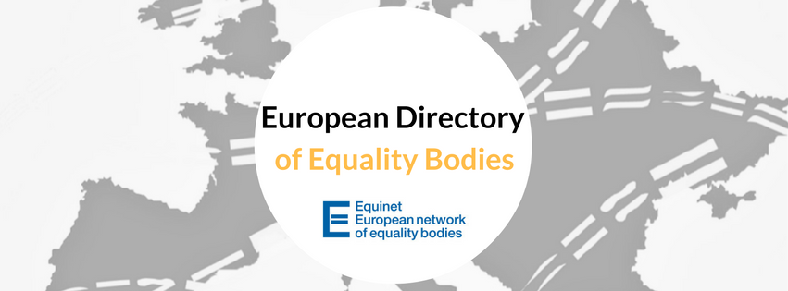

**EQUINET CONTACT PERSON**: Sarah Cooke O’Dowd, Communication Officer ([saco@equineteurope.org](mailto:saco@equineteurope.org) – Tel: 0032 2 212 31 84)

# European Journalist Award on Diversity – Final results and award ceremony Monday 17th October, Dublin, Ireland

The European Commission announced the winners of the **European Journalist Awards on in Dublin on Monday, 17th October**. This Award recognises excellent journalism that promotes diversity and raises awareness of discrimination in the EU.

It is the first edition of the EU-wide award which is one of the follow-up actions announced in the conclusions of the [first Fundamental Rights Colloquium](http://ec.europa.eu/justice/events/colloquium-fundamental-rights-2015/index_en.htm) that took place in Brussels last year.

In line with the theme of the Colloquium, the articles selected focused on "Promoting social acceptance and diversity of all faiths and beliefs". The articles were published over the past 1-2 years in all 28 EU Member States and they all showcase examples of print and online journalism promoting diversity and combatting discrimination. The jury was made up of experts on journalism and equality (including our Communication Officer Sarah Cooke O’Dowd), as well as European Commission staff. All winning articles will be presented here.

The Award was announced in conjunction with the 7th Annual Forum of Diversity Charters, which brought together businesses, academics and policymakers in Dublin to discuss how diversity can be better promoted.

Chosen from the best articles from the EU-28, the winning journalists were:

* Dora Koretić, Croatia for her article [’Our life under the hijab in Zagreb – ’I wear a headscarf, but no, I’m not a housewife. I have a PhD in Neuroscience and I want to win the Nobel Prize’](http://ec.europa.eu/information_society/newsroom/image/document/2016-43/croatia_en_18534.pdf). (Read article in Croatian [here](http://www.jutarnji.hr/globus/nas-zivot-pod-hidzabom-u-zagrebu-nosim-maramu-ali-ne-nisam-domacica.-doktorica-sam-neuroznanosti-i-zelim-dobiti-nobelovu-nagradu/295882/)).
* Verena Mayer, Germany for her article [’God’s House’](http://ec.europa.eu/information_society/newsroom/image/document/2016-43/germany_en_18535.pdf). (Read article in German [here](http://www.sueddeutsche.de/leben/weltreligionen-gottes-haus-1.2734398)).
* Imane Rachidi, Spain for her article [’Being Muslim, gay and an imam in Europe: "The Koran doesn’t say anything against homosexuals"](http://ec.europa.eu/information_society/newsroom/image/document/2016-43/spain_en_18533.pdf)’. (Read article in Spanish [here](http://msur.es/2016/10/17/francia-imam-gay/))

**More information as well as pictures of the event are available** [**here**](http://www.equineteurope.org/Awarding-excellent-journalism-that-promotes-diversity)**.**

**EQUINET CONTACT PERSON**: Sarah Cooke O’Dowd, Communication Officer ([saco@equineteurope.org](mailto:saco@equineteurope.org) – Tel: 0032 2 212 31 84)

# Equinet Chair and Director meet with leadership of the Irish equality body Monday 17th October, Dublin, Ireland

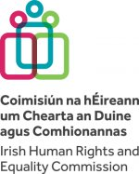

Equinet Chair Evelyn Collins and Executive Director Anne Gaspard met with the Irish Human Rights and Equality Chief Commissioner Emily Logan and her team while in Dublin on 17 October last. This was an excellent opportunity to hear about the recent developments within the Irish Human Rights and Equality Commission (IHREC), following the merger of the Human Rights Commission and Equality Authority in November 2014. Earlier this year, the IHREC has released their [strategy statement for 2016-2018](https://www.ihrec.ie/documents/strategy-statement-2016-2018/)) and the meeting in Dublin allowed for a very fruitful exchange and update on respective strategic priorities and work plans ahead.

After hearing about the IHREC’s upcoming priorities, Evelyn and Anne had the opportunity to highlight some of Equinet’s plans for 2017 that could be of particular interest to the IHREC such as Equinet training on strategic litigation and various thematic Working Groups, Equinet Cluster on Research and Project on violence against women, or indeed the conference on positive duties, amongst others.

In attendance at the meeting were the following IHREC representatives:

* Emily Logan (Chief Commissioner)
* Sinéad Gibney (Director)
* Michael O’ Neill (Head of Legal and Information)
* Ruth Gallagher (Head of Policy and Public Engagement)
* Laurence Bond (Head of Research)

who were also joined by colleagues of IHREC legal team.

The previous week, Jessica Machacova (Equinet Membership and Policy Officer) and Sarah Cooke O’Dowd (Equinet Communication Officer) also held a visit to IHREC in Dublin and met with Brian Dawson (Communications Manager), and Walter Jayawardene and Cathal Kelly (Policy & Engagement) to update them on plans and progress of Equinet Working Groups and discuss other areas of interest within Equinet’s 2017 work plan.

**Equinet Training on Social Media  
13th and 14th October 2016, Dublin, Ireland**

Equinet recently organised a training for its members on advanced social media use, which took place in the Facebook offices in Dublin. The material developed for and from the training will be available to the whole membership, and will be distributed in due time.   
  
In the meantime, Facebook has given us the opportunity to have direct contact with their country coordinators. So, **if you wish to be able to contact your Facebook country coordinator directly, please send an email to Sarah by 15 November asking her to put you in contact. All of those who attended the event will be put in touch automatically.**

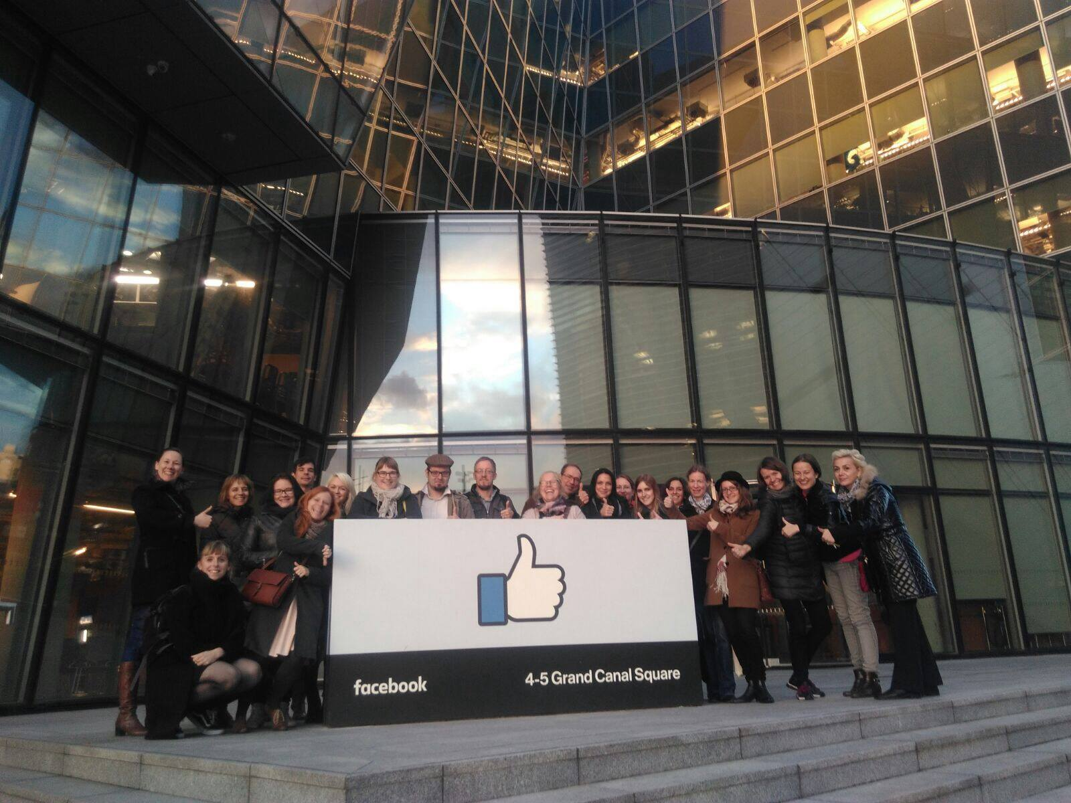

**EQUINET CONTACT PERSON**: Sarah Cooke O’Dowd, Communication Officer ([saco@equineteurope.org](mailto:saco@equineteurope.org) – Tel: 0032 2 212 31 84)

# Updates: Cooperation Platforms involving Equinet - Council of Europe – ENNHRI – European Union Agency for Fundamental Rights (FRA)

In October 2013, Equinet, the Council of Europe (CoE), the European Network of National Human Rights Institutions (ENNHRI) and the European Union Agency for Fundamental Rights (FRA) took the decision to establish [common platforms for cooperation](http://www.equineteurope.org/-Thematic-Platforms-for-Cooperation-) on four pressing topics.

1. **COOPERATION PLATFORM ON ADVANCING SOCIAL AND ECONOMIC RIGHTS**

The last meeting of the Platform was held on **10th October in Belgrade, Serbia**, hosted by the Serbian Commission for the Protection of Equality. A summary of the meeting will be ready soon.

**EQUINET CONTACT PERSON:** Katrine Steinfeld, Policy Officer ([katrine.steinfeld@equineteurope.org](mailto:katrine.steinfeld@equineteurope.org) – Tel: 0032 2 212 31 85).

1. **COOPERATION PLATFORM ON RIGHTS OF MIGRANTS AND ASYLUM SEEKERS**

The second meeting of the Asylum and Migration Cooperation Platform was held in Vienna on 15th and 16th February 2016. The summary is available [on the Equinet website](http://www.equineteurope.org/-Thematic-Platforms-for-Cooperation-).

**EQUINET CONTACT PERSON:** Jessica Machacova, Membership and Policy Officer ([Jessica.machacova@equineteurope.org](mailto:Jessica.machacova@equineteurope.org) – Tel: 0032 2 212 31 80).

1. **COOPERATION PLATFORM ON ROMA EQUALITY**

The last meeting of the Operational Platform for Roma Equality (OPRE) was held on 7th and 8th June in Athens, Greece. A [joint statement on evictions of Roma people](http://www.equineteurope.org/Press-Release-Stop-Evictions-of-Roma-and-Travellers) was published in June 2016.

**EQUINET CONTACT PERSON:** Tamás Kádár, Head of Legal and Policy ([tamas.kadar@equineteurope.org](mailto:tamas.kadar@equineteurope.org) – Tel: 0032 2 212 31 83).

1. **COOPERATION PLATEFORM ON HATE CRIME**

The FRA working party on hate was held on 28th and 29th April in Amsterdam. A short meeting of the Platform was organised on 29th April. It was decided to continue the cooperation among Platform members mostly based on information exchange (Newsletters, emails etc). In order to maintain this information exchange, **please send FRA (**[elena.balzarini@fra.europa.eu](mailto:elena.balzarini@fra.europa.eu) ) **information on activities, meetings, studies and publications in the field of combating hate crime and hate speech, which you think could be interesting for the other Platform members**.

**EQUINET CONTACT PERSON:** Sarah Cooke O’Dowd, Communication Officer ([sarah.cookeodowd@equineteurope.org](mailto:sarah.cookeodowd@equineteurope.org) – Tel: 0032 2 212 31 84).

# Save the date! Next Equinet Meetings

|  |  |  |
| --- | --- | --- |
| **Capacity-building events** | **Wednesday 9th and Thursday 10th November** | Seminar on race and ethnicity *(Budapest, Hungary)* |
| **Governance**  **Meetings** | **Thursday 8th December** | Board meeting *(Brussels, Belgium)* |
| **Conferences and other Equinet events** | **Wednesday 7th December** | Conference on intersectionality and gender equality *(Brussels, Belgium)* |
| **Working Groups** | **Friday 4th November** | Working Group Gender Equality *(Malta)* |
| **Monday 21st November** | Working Group on Communication *(Bratislava, Slovakia)* |

### **PART 2: EQUINET MEMBERS**

# Equinet members’ requests

* **Office of the Equal Opportunities Ombudsperson, Lithuania: discriminatory advertisements of goods and services**

The following request was sent by the Lithuanian Office of the Equal Opportunities Ombudsperson

Does your Equality Body is in charge to investigate complaints and to monitor the discriminatory advertisements of goods and services? (e.g. humiliation of women or national minorities etc.)

**Please send your feedback to Laima Vengalė-Dits (**[**laima.vengale@lygybe.lt**](mailto:laima.vengale@lygybe.lt)**) as soon as possible.**

* **Unia (Interfederal Centre for Equal Opportunities), Belgium – Insurances and clients with psychiatric diseases**

Unia often receives cases of insurances refusing persons who have had psychiatric diseases in the past. Other insurances do not refuse, but have an exclusion clause in the contract, excluding any risk related to any psychiatric disease in the future.

This is problematic and seems to us not proportionate. We would like to know:

1. If there are specific rules/legislations regarding this problem in other countries (like the “right to forget” in France, for people who have had cancer)
2. If there have been judicial decisions in other countries.

**Please send your contribution to Emilie Van Laer (**[**emilie.vanlaer@unia.be**](mailto:emilie.vanlaer@unia.be)**) as soon as possible.**

# Updates from Equinet members

* **Slovak National Centre for Human Rights published its annual report on the observance of human rights**

The Slovak National Centre for Human Rights published its report on the observance of human rights including the observance of the principle of equal treatment in the Slovak Republic for the year 2015. Throughout the report the Slovak National Centre for Human Rights outlines opinions and recommendations aiming at ensuring a more efficient protection and exercise of human rights and fundamental freedoms. The report is available [here](http://www.snslp.sk/CCMS/files/2015_Report_on_the_observance_of_human_rights_including_the_principle_of_equal_treatment.pdf).

* **France: Study shows extent of ethnic discrimination in access to employment**

The Defender of Rights has launched the results of a call for evidence conducted in spring 2016 on ethnic discrimination in access to employment. These results illustrate the variety of challenges faced by people of foreign origin and the impact on their professional and personal lives. More information is available here.

* **Summary of the report On the activity Of The Ombudsman In Poland**

In July 2016 the Polish Ombudsman (Commissioner for Human Rights) published its Activity Report for 2015, focusing on the most important matters in the fields of constitutional and international law, criminal law, labour law, social security and uniformed services, civil law, administrative and economic law and the principle of equal treatment and combating discrimination.

* **Meeting of the Nordic Antidiscrimination and Gender Equality Ombudsmen, September 2016**

**The Nordic Antidiscrimination and Gender Equality Ombudsmen met in Nuuk, Greenland 1 and 2 September 2016**. These annual meetings are an informal opportunity for the ombudsmen to exchange experiences of our work and how we can bring it forward. Except for the hosts from the Council of Gender Equality in Greenland the participants this year came from Denmark, Finland, the Faeroe Islands, Greenland, Norway and Sweden.

We started with a brief overview of the most important issues each ombudsman has had to deal with since last meeting. As it seems, this part always seems to include information about plans for or changes already realized in legislation, mandate and/or organisation for some of the institutions. We also discussed how to work against discrimination in the recruitment processes, how to cooperate with civil society and how to work with reasonable accommodation for persons with disability.

***Article written by Kerstin Jansson from the Swedish Equality Ombudsman***

### **PART 3 – EXTERNAL STAKEHOLDERS’** **REQUESTS**

# Invitation – European Commission – Annual Legal Seminar on gender equality and anti-discrimination law (25th November 2016, Brussels) Deadline for Registration: 27th October 2016

On Friday 25th November, the European Commission is organizing its **Annual Legal Seminar on gender equality and anti-discrimination law**. It will take place in Brussels, at the Courtyard Hotel Marriot (Avenue des Olympiades 6, 1140 Brussels).

 The seminar is organised in cooperation with [the European Network of Legal Experts in gender equality and non-discrimination](http://www.equalitylaw.eu/). Its purpose is to provide an **update on issues concerning the implementation of the EU non-discrimination and gender equality Directives**. It will bring together representatives of national governments, national equality bodies, experts from the Network of Legal Experts in gender equality  and non-discrimination, representatives of NGOs and Commission officials.  It will assess current legal developments and look to future prospects in the area of anti-discrimination and gender equality.

 In addition to plenary sessions, there will be five parallel workshops on the following topics:

* Update on European case law
* The Meaning of Racial and Ethnic Origin in EU Law
* Links between migration and discrimination
* The Employment Equality Directive and supporting people with psychosocial disabilities in the workplace
* Wage transparency
* Equal pay – Sanctions, redress and compensation

An official invitation with a code was sent to each Equinet members via Member States Permanent Representations. Guests can register [here](https://www.regonline.co.uk/legalseminar_2016) by 27th October 2016. In case you have any questions or problems concerning the online registration, please contact Michelle Troost - Human European Consultancy, e-mail: [michelle@humanconsultancy.com](mailto:michelle@humanconsultancy.com) , tel. +31 30 634 1422.

The European Commission has invited the Member States to send up to four representatives in total: two from the relevant ministries and two from equality bodies in charge of anti-discrimination and equality between women and men - preferably lawyers and/or experts in anti-discrimination and equality law. The Commission is only able to pay **travel expenses for one representative per Member State and it is up to each Member State to decide who will benefit of the reimbursement.**