**Strengthening the effectiveness of european equal treatmeant legislation**

**CONFERENCE SUMMARY**

**european economic and social committee, brussels**

**16 june 2016**



|  |
| --- |
|  |
| **Funding Equinet** |

**CONTENT**

EQUINET & CONFERENCE BACKGROUND 3

CONFERENCE AGENDA 4

Towards an equal Europe - reception 8

Equinet working paper on developing standards for equality bodies 9

CONFERENCE SUMMARY 10

OPENING SESSION 10

KEYNOTE ADDRESS 11

SESSION 1 – SETTING THE SCENE: CHALLENGES IN THE FIELD OF EQUALITY LAW 12

SESSION 2 - The contribution and potential of equality bodies 15

SESSION 3 – Looking forward: Towards more effective equal treatment legislation 18

CLOSING ADDRESS 21

**Conference Support:** Equinet Secretariat Team

**Summary:** Tamás Kádár

*Co-funded by the Rights, Equality and Citizenship Programme of the European Union (2014-2020)*

# EQUINET & CONFERENCE BACKGROUND

**Equinet is the European Network of Equality Bodies**, a membership organisation bringing together [46 equality bodies](http://www.equineteurope.org/-Equinet-Members-) from 34 European countries including all EU Members States.

Equality bodies are public organisations assisting victims of discrimination, monitoring and reporting on discrimination issues, and promoting equality. They are legally required to do so in relation to one, some or all the grounds of discrimination covered by European Union law – **gender, race and ethnicity, age, sexual orientation, religion or belief, and disability**.

Equinet promotes equality in Europe through supporting and enabling the work of national equality bodies. It supports equality bodies to be independent and effective as valuable catalysts for more equal societies.

Equality and non-discrimination are key general principles of the European Union, as spelled out in the Treaties and the Charter of Fundamental Rights of the EU. However, despite the equality legislation already in place, challenges remain relating to their effective implementation and application. Equality bodies are key players in ensuring that legislation is effectively implemented.

Building on previous Equinet Perspectives and reports, the conference brought together stakeholders and equality bodies to assess progress achieved and remaining challenges, with specific attention to the role of equality bodies. The specific challenge of creating the conditions for equality bodies to fulfil their potential was also be discussed, using the [Working Paper on Developing Standards for Equality Bodies](http://www.equineteurope.org/Equinet-Working-Paper-on-Developing-Standards-for-Equality-Bodies), published by Equinet on the eve of the conference.

# CONFERENCE AGENDA

|  |  |
| --- | --- |
| **Equinet Conference**  ***Strengthening the effectiveness of European Equal Treatment Legislation***  **Brussels, Thursday, 16 June 2016** | |
|  | |
| **VENUE** | European Economic and Social Committee, Room VMA1  Rue Van Maerlant 2, 1040 Brussels, Belgium ([*How to get to the EESC*](http://www.eesc.europa.eu/?i=portal.en.about-the-committee-access)*)* |
| **BACKGROUND** | Equality and non-discrimination are key general principles of the European Union, as spelled out in the Treaties and the Charter of Fundamental Rights of the EU.  The European Union as well as the Council of Europe have already adopted wide-ranging and strong legislation to ensure equality and combat discrimination in Europe. These European legislative instruments have been largely transposed to the legal systems of Member States. However, “the review of national experiences reveal that there are still challenges to their implementation and application,”[1] jeopardising the effectiveness of the legislation and the reaching of its objective to put into effect in the Member States the principle of equal treatment.  As the European Commission highlighted in its [Report on the application of Council Directive 2004/113/EC](http://ec.europa.eu/justice/gender-equality/files/law_reviews/directive_2004_113_report_en.pdf), ‘*to combat discrimination and ensure equal treatment, Member States and stakeholders have recognised that equality bodies are essential to move from "the law on paper to the law in practice" and to ensure that the legal rights are actually applied on the ground*’. At the same time, the Commission also found it necessary to commit to exploring ‘*ways of clarifying the requirements concerning equality bodies under the Directive, particularly the key concepts of independence and effectiveness*’.  The work of equality bodies shows that there are areas where current levels of protection do not appear to be fully comprehensive and adequate, such as in the fields of work-life balance, education and media, or discrimination outside employment on various grounds.  Building on previous Equinet Perspectives and reports, the conference will bring together stakeholders and equality bodies to assess progress achieved and still to be made, with specific attention to the role of equality bodies in better regulation and implementation. The specific challenge of creating the conditions for equality bodies to fulfil their potential will also be discussed, using the [Working Paper on Developing Standards for Equality Bodies](http://equineteurope.org/IMG/docx/equinet_workingpaper_standardsnebs_march_2016_.docx), proposed by the Equinet Cluster on Standards for equality bodies. |
| **OBJECTIVES** | This one-day conference is organised under one of the four broad strategic goals of Equinet: ‘Contributing to the European Equality Agenda’.  Equality bodies are on the front line in the work of promoting equality and combating discrimination. They have developed practical experience, learning and expertise in the implementation of equal treatment legislation in their country.  In turn, ensuring the effective and correct implementation and application of Union legislation is at the heart of the European Commission’s [Better Regulation agenda](http://ec.europa.eu/smart-regulation/better_regulation/key_docs_en.htm#top).  **The conference sets out to discuss the experiences of equality bodies and other stakeholders with the implementation and possible shortcomings and gaps in EU equal treatment legislation and to find ways to make this legislation comprehensive in its scope and more effective on the ground.**  In particular, the conference aims to:   * **Provide a platform** to all stakeholders to discuss the challenges and gaps in the field of equal treatment legislation and its effective implementation * **Share the experiences** of equality bodies and other participants with implementing equal treatment legislation * **Identify shortcomings and gaps** in equal treatment legislation * **Set out a vision** for the future of comprehensive and effective EU equal treatment legislation * **Clarify requirements concerning equality bodies** under the EU equal treatment directives to ensure they can fulfil their potential in support of effective equal treatment legislation |
| **TARGET AUDIENCE** | This conference is aimed at heads and senior experts from National Equality Bodies, as well as from EU and international institutions and agencies, representatives from NGOs, national ministries, NHRIs and Ombud institutions, policy and legal experts, social partners and other organisations active in the field of equality. |
| **REGISTRATION** | Please register [**via this link**](https://form.jotform.com/61232013537949).  In case you need more information/support to fill in the form, please contact Yannick Godin, Administration and Finance Officer ([yannick.godin@equineteurope.org](mailto:katrine.steinfeld@equineteurope.org) / 0032 2 212 31 82). |
| **SOCIAL MEDIA** | You can follow the conference via [**Twitter**](https://twitter.com/equineteurope) (@equineteurope) and using the hashtags: **#EquinetConference**, **#MoreEquality** and **#BetterStandards**. |
| **FOLLOW-UP** | Equinet will publish a summary report of the Conference and will upload the speakers’ presentations on its website at: [**www.equineteurope.org/activities/events**](http://www.equineteurope.org/activities/events)  In addition to visiting our [**website**](http://www.equineteurope.org/), you can also follow the work done by Equinet and its 45 European member equality bodies by:   * Subscribing to our [**monthly newsletter**](http://www.equineteurope.org/-Equinet-Newsletters-) from our homepage; * Following us on [**Facebook**](https://www.facebook.com/EquinetEurope) (EquinetEurope) and [**Twitter**](https://twitter.com/equineteurope) (@equineteurope). |

|  |  |  |
| --- | --- | --- |
| **AGENDA** | | |
| **15 JUNE 2016** | | |
| **18.45 – 21.00** | | **Towards an equal Europe**  Reception for invited participants |
| **16 JUNE 2016** | | |
| **08.30 – 09.00** | | **Registration and Welcome** |
| **09.00 – 09.30** | | **Opening:**  **Evelyn Collins**, Chair of Equinet, Chief Executive, Equality Commission for Northern Ireland  **Pavel Trantina**, President, Section for Employment, Social Affairs and Citizenship (SOC), European Economic and Social Committee |
| 09.30 – 10.00 | | **Keynote Address:**  **Equal treatment as a cornerstone of Good Administration**  **Emily O’Reilly,** European Ombudsman |
| **10.00 – 11.00** | | **SESSION 1 – Setting the Scene: Challenges in the field of equality law**  **Chair: Kirsi Pimiä, Non-Discrimination Ombudsman, Finland**  Strong equality legislation already exists in Europe but reaching its full impact is hindered by the lack of effective implementation. This session will discuss issues and factors hindering effective implementation and promising practices in overcoming these obstacles. |
|  | | Contributions by:   * **Dr. Sara Benedi Lahuerta**, University of Southampton, United Kingdom * **Paul d’Auchamp**, Deputy Regional Representative for Europe, Office of the United Nations High Commissioner for Human Rights * **Christine Lüders**, Head, Federal Anti-Discrimination Agency, Germany |
| ***Questions & Answers – Discussion*** | | |
| **11.00 – 11.30** | | ***Coffee break*** |
| **11.30 – 13.00** | | **SESSION 2 – The contribution and potential of equality bodies**  **Chair: Evelyn Collins, Equinet Chair, Chief Executive of Equality Commission for Northern Ireland**  Equality bodies are essential factors in making equality legislation effective and impactful. Their potential spans from advice, promotion and monitoring to enforcement and sanctioning. However, the lack of clear and strong standards for the setting up, independence and operations of equality bodies often hinders the realisation of their full potential. This session will discuss the potential of equality bodies and the standards and safeguards they need in order to fulfil this potential. |
|  |  | Contributions by:   * **Professor Maleiha Malik**, King’s College London, United Kingdom * **Andreas Stein**, Head of Unit for Equality Legislation, European Commission DG JUST * **Tena Šimonović Einwalter**, ECRI member and Croatian Deputy Ombudswoman * **Patrick Charlier**, Director, UNIA (Interfederal Centre for Equal Opportunities), Belgium |
| ***Questions & Answers – Discussion*** | | |
| **13.00 – 14.00** |  | ***Lunch*** |
| **14.00 – 15.30** | | **Session 3 – Looking forward: Towards more effective equal treatment legislation**  **Chair: Sandra Konstatzky, Deputy Director, Ombud for Equal Treatment, Austria**  Equality and non-discrimination are key founding values and general principles of the EU. However, currently equality law does not cover all areas where the EU has legislative competence, resulting in a hierarchy of rights. Furthermore, as discussed in previous sessions, already existing legislation does not always live up to its potential due to the lack of effective implementation. This session will set out a vision for a comprehensive and effective equal treatment legislation in Europe. |
|  | | Contributions by:   * **Ulrike Lunacek**, Vice-President, European Parliament (video message) * **Soraya Post**, Member of the European Parliament * **Pierre Baussand**, Director, Social Platform * **Pavel Trantina**, President, Section for Employment, Social Affairs and Citizenship (SOC), European Economic and Social Committee * **Martin Mörk**, Deputy Ombudsman and Head of Litigation, Equality Ombudsman, Sweden |
| ***Questions & Answers – Discussion*** | | |
| **15.30 – 16.00** | | **Closing address – Professor Christopher McCrudden, Queen’s University Belfast**  **Final Remarks – Anne Gaspard, Executive Director, Equinet** |

# Towards an equal Europe - reception



On the eve of the conference Equinet organised a reception at the Office of the Northern Ireland Executive for invited participants, to officially launch the [Working Paper on developing standards for equality bodies](http://www.equineteurope.org/IMG/pdf/equinet_workingpaper_standardsnebs_oct_2016layout.pdf). The reception brought together the heads of equality bodies with top European officials, such as Commissioner for Justice, Consumers and Gender Equality, Věra Jourová and European Commission Director General for Justice and Consumers, Tiina Astola.

In her welcome address Commissioner Jourová underlined that “*Equality bodies are key to combatting discrimination and ensuring the effective implementation of equal treatment legislation. For more inclusive societies throughout Europe, it is vital to have independent and effective equality bodies with the powers and resources to ensure that our rights to equality are applied on the ground and made accessible to all. The European Commission is determined to help strengthen equality bodies and create conditions in which they can reach their full potential*”.

# Equinet working paper on developing standards for equality bodies



Equinet’s [Working Paper on developing standards for equality bodies](http://www.equineteurope.org/IMG/pdf/equinet_workingpaper_standardsnebs_oct_2016layout.pdf), launched on 15 June 2016, is based on discussions that took place during the Equinet Cluster on Standards in 2015, as well as contributions and comments provided since then by Equinet members.

It seeks to establish positions that equality bodies could promote, negotiate and advance vis-à-vis European and national administrations in the establishment of standards for equality bodies at European level and their implementation at national level.

EU Directives require all EU Members States, accession countries and EEA countries to designate an equality body for the promotion of equal treatment. However, the Directives only provide minimum standards for the competences and limited functional independence of equality bodies and do not guarantee complete independence, effectiveness, sufficient powers and adequate resources for equality bodies.

This Working Paper combines a concern to include minimum standards alongside standards that ensure the full potential of an equality body is achieved. It does so to ensure that standards recognise and:

* Enable the particular role, capabilities, and potential of equality bodies.
* Respond to the wider institutional architecture in which equality bodies are located.
* Address the changed context for equality bodies and new trends and evolution in their establishment, mandates, and operation.

The Working Paper provides a framework with key concerns that standards need to address to provide guarantees in four areas relevant to the structure and work of equality bodies:

* Mandate
* Complete independence
* Effectiveness
* Institutional architecture

# CONFERENCE SUMMARY

## OPENING SESSION

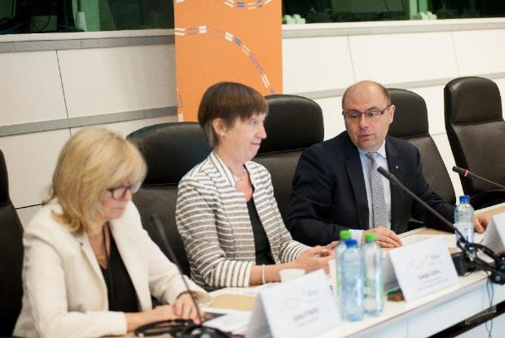

**Pavel Trantina**, President of the European Economic and Social Committee’s SOC section and host of the conference opened the event, underlining the importance of equality and human rights and the important role played by the EESC in ensuring it as the voice of the organised civil society. Mr. Trantina referred to EESC work and opinions concerning for instance the rights of migrants, Roma people, LGBTI persons, older persons, persons with disabilities, or women’s rights.

Mr. Trantina recalled that the EESC regularly requests the European Commission to systematically use its monitoring and enforcement powers in the field of equal treatment and that the EESC has long ago, already in 2009, expressed its support for making EU equal treatment legislation more comprehensive by the adoption of the so-called Horizontal Equal Treatment Directive.

Emphasising the key role equality bodies play, Mr. Trantina welcomed Equinet’s Working Paper on Standards for Equality Bodies and expressed his view that there is a need to strengthen equality bodies’ independence, legal situation as well as their effectiveness by ensuring adequate resources.

**Evelyn Collins**, Chair of Equinet welcomed all participants on behalf of the network and thanked Mr. Trantina and the EESC for hosting the conference. Discussing the context and objectives of the conference, Ms. Collins noted that despite the strong equal treatment legislation that already exists at EU level, reports from the European Commission, the Council of Europe and other experts confirm important shortcomings in the field of implementation and enforcement.

While legislation is to a large extent already present across Europe, Ms. Collins expressed her view that a comprehensive and effective institutional architecture is also needed to ensure equality in Europe, noting that the setting up of such an architecture remains a challenge in many European countries. Therefore, Ms. Collins invited conference participants to discuss gaps in equal treatment legislation and its effective implementation, and to share their experiences and ideas to find ways of addressing the challenges.

## KEYNOTE ADDRESS

**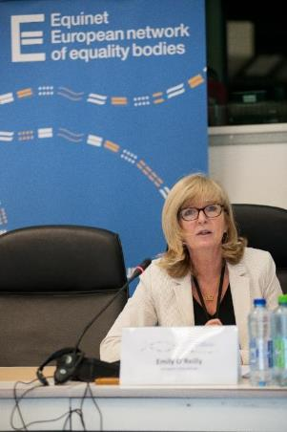  
Emily O’Reilly**, European Ombudsman kicked off her keynote speech by recognizing that equality bodies, similarly to Ombudspersons, are key institutions in ensuring equal treatment. Important challenges remain in many fields and for many disadvantaged groups and the European Ombudsman, as the ‘Ombudsman of the EU institutions’, has over the year dealt with complaints about maladministration of EU institutions and bodies for instance on the grounds of gender, age, or disability. In one of these cases an employee of the European Parliament received a derogation from the obligatory rotation to another position, and possibly workplace, on account of her caring for a child with disabilities. A few years later the employer tried to revoke the exception granted to the complainant, claiming that keeping such a derogation would be tantamount to undermining equal treatment vis-à-vis other employees. The European Ombudsman in her opinion took the opposite view, urging the Parliament to keep the derogation in place.

Ms. O’Reilly placed the right to equal treatment in the context of fundamental rights, noting that a failure to act in line with equal treatment is necessarily a serious and particular breach of fundamental rights. Therefore, and especially in the context of the refugee crisis and the rise of radical ideas and politics, it is all the more worrying that it is seemingly often politics and not international legal instruments that dictate the approach to questions of equality and human rights. Ms. O’Reilly referred to Article 1 of the EU’s Charter of Fundamental Rights protecting human dignity as the cornerstone of good administration as well as of equality and the work of equality bodies.

Finally, Ms. O’Reilly recalled that having a good legal framework is not enough, respect for the law is essential, and for that proper enforcement mechanisms are needed. Ombudsmen and equality bodies occupy a central role in such enforcement mechanisms as public institutions that are independent, easily accessible and provide a link between the ‘little citizen and the big state’. The EU network of ombudsmen coordinated by the European Ombudsman, as well as Equinet play an important role by providing a platform for national Ombud institutions and equality bodies to meet, discuss and learn from each other.

In the ensuing discussion with the audience Ms. O’Reilly shared her experiences concerning her role as independent mechanism for the EU under the UN Convention on the Rights of Persons with Disabilities (CRPD), referring to complaints of certain European Schools not providing inclusive education to children with disabilities. While the monitoring, protecting and promoting the implementation of the UN CRPD may be challenging, this new mandate broadened the possibilities for the European Ombudsman. Other issues discussed with the audience included the segregation of Roma children in education and violence against women in the context of the EU’s proposed accession to the Council of Europe’s Istanbul Convention.

## SESSION 1 – SETTING THE SCENE: CHALLENGES IN THE FIELD OF EQUALITY LAW

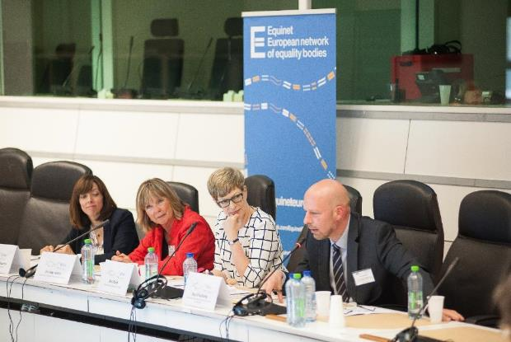

***Session 1*** *– Strong equality legislation already exists in Europe but reaching its full impact is hindered by the lack of effective implementation. This session discussed issues and factors hindering effective implementation and promising practices in overcoming these obstacles.*

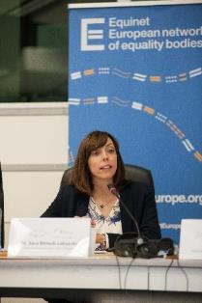**Dr. Sara Benedi Lahuerta** from the University of Southampton delivered a presentation on the existing legal framework in the field of equal treatment, also identifying some of the gaps and challenges.

She noted that apart from the well-known directives on equal treatment EU legislation on working time, parental leave, the protection of pregnant workers, part-time and fixed-term workers is also part of a wider European framework guaranteeing equal treatment. This protection would be further strengthened with the adoption of current legislative proposals such as the Horizontal Directive.

After laying out the key EU legal instruments Ms. Benedi Lahuerta pointed to some practical challenges and shortcomings of the EU’s protection of equal treatment.

First, current EU legislation provides uneven levels of protection leading to a hierarchy of discrimination grounds. These differences cannot be justified as they are largely a result of political negotiations and a gradual historical development of EU legislation. Importantly from the point of view of the institutional infrastructure for equality, EU legislation currently only requires the setting up of equality bodies for the grounds of sex and race or ethnic origin. Again, there seems to be no plausible justification for this and it creates a mismatch between the objectives and the enforcement mechanisms of the legislation.

Second, high levels of under-reporting exist for all grounds of discrimination. Given the focus of EU legislation on individual complaints and remedies, this also leads to a situation where the stated objectives of the law can hardly be successfully fulfilled.

Third, as equal treatment legislation is a relatively young discipline in most EU Member States, courts and all legal professionals seem to grapple with challenges in properly understanding and interpreting key concepts of the law such as direct and indirect discrimination or the shift of the burden of proof.

Four, the mandate, powers and duties of equality bodies are not sufficiently clarified in EU law and this means that while equality bodies hold a great potential to contribute to equality in practice, this potential can be in certain cases limited by the practical challenges and a lack of clear standards. Such challenges might include limited resources, limited institutional and financial independence, limited accessibility for victims of discrimination, and limited legal powers.

Ms. Benedi Lahuerta proposed that these challenges could be successfully tackled by strengthening EU substantive legislation, putting more emphasis on the enforcement of legislation (including by introducing standards for equality bodies) and on the implementation at national level.

**Dr. Sara Benedi Lahuerta’s presentation is available** [**here**](http://www.equineteurope.org/IMG/ppt/sbl_equinet_conference_presentation_final_4.ppt)**.**

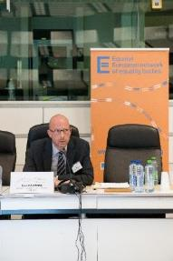**Paul D’Auchamp**, the Deputy Regional Representative for Europe of the UN Office of the High Commissioner for Human Rights started his presentation by referring to the UN Human Rights framework and the fact that most international human rights instruments have already been ratified by all EU Member States, even if important gaps remain.

Mr. D’Auchamp considered the EU’s secondary legislation in the field of equal treatment to be of crucial importance but also noted the incomplete EU legal framework with the current hierarchy of discrimination grounds and that this issue would be tackled with the adoption of the Horizontal Directive. He challenged the misunderstanding that the implementation of the Horizontal Directive would result in high costs, noting that considerable costs would only be incurred by accessibility measures and those are already required and binding for all but one Member State under the UN CRPD. Furthermore, he noted the disparity with the EU’s external action encouraging the adoption of robust anti-discrimination legislation in third countries and recalled that the UN CRPD Committee’s Concluding Observations on the European Union also recommended the adoption of the Horizontal Directive.

Turning to the role of equality bodies, Mr. D’Auchamp mentioned that the UN Human Rights Council might soon discuss a resolution concerning equality bodies on the initiative of Belgium. He underlined equality bodies’ high potential, but reminded of the myriad of challenges they are facing, from threats to their independence to a weak mandate and powers, and a limited capacity to take a proactive approach by promoting equality. Therefore, equality bodies need standards, guaranteeing their independence, resources, capacity and mandate. The UN Human Rights Council

As part of the wider institutional architecture for equality and human rights, he encouraged equality bodies to cooperate with National Human Rights Institutions in order to maximize their use of resources and impact.

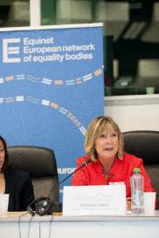 **Christine Lüders**, Head of the German Federal Anti-Discrimination Agency (FADA, an Equinet member) noted that while important gaps remain in equality legislation and its implementation, it is important to recognise that the EU equal treatment directives have been a resounding success, not the least resulting in the setting up of equality bodies all around Europe. Therefore, it is all the more important to continue the work on adopting the Horizontal Directive.

A large-scale survey in Germany showed increasing rights-awareness: six out of ten respondents attempt to act and claim their rights when they experience discrimination. However, they often find it difficult to enforce their rights and when they do, the level of sanctions remains very low.

Ms. Lüders presented the role of FADA and other equality bodies in advising legislators by putting certain questions on their agenda and proposing amendments based on their experience and expertise. An example of this is FADA’s work supported by renowned legal scholars to bring about the rehabilitation of persons who still have a criminal record from decades ago simply on account of their sexual orientation.

Ms. Lüders underlined that in order for FADA and other equality bodies to fulfill their potential in an often difficult or outright hostile context, there is a need to adopt European standards for equality bodies that are strong enough to weather political storms. These standards would ensure independence, resources, but also a sufficiently wide mandate and strong powers, the importance of which is demonstrated by FADA’s lack of power to take cases to court. This means that individuals need to go through long and costly procedures to claim their rights and also that a willing individual is needed to clarify legislation.

## SESSION 2 - The contribution and potential of equality bodies

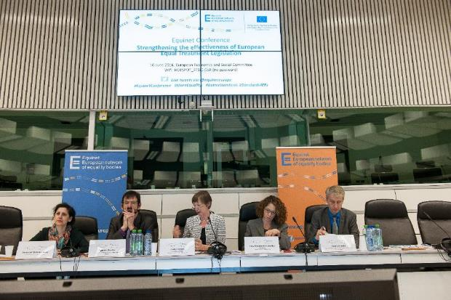

***Session 2 –*** *Equality bodies are essential factors in making equality legislation effective and impactful. Their potential spans from advice, promotion and monitoring to enforcement and sanctioning. However, the lack of clear and strong standards for the setting up, independence and operations of equality bodies often hinders the realisation of their full potential. This session discussed the potential of equality bodies and the standards and safeguards they need in order to fulfil this potential.*

**Professor Maleiha Malik** from King’s College London started with a reminder of our crucial responsibility as even in countries far away from the continent they are looking at Europe as the source of best practice in equality legislation, policies and practices.

Ms. Malik expressed her opinion that equality bodies are uniquely placed to deal with all forms of discrimination, including structural discrimination and to provide leadership on key issues. They are also important to provide effective pathways to justice in a context where legal aid provided by the state is not or not sufficiently available or is even cut back.

Equality bodies also have a key role as institutions of trust. They’re at the intersections between the state and vulnerable groups and they need to build relationships of trust and confidence with both.

Looking at the British Equality and Human Rights Commission as a case study, she emphasized the need for making all equality bodies more independent to tackle for instance using budgeting or appointments as an indirect way of exercising influence over the equality body.

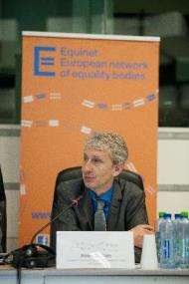**Andreas Stein**, head of the Equality Legislation unit in the European Commission’s Directorate General for Justice and Consumers noted that the picture of equality bodies in the EU is extremely heterogeneous in terms of size, resources, mandate or independence.

Assistance to victims of discrimination is at the core of what equality bodies do. This assistance in itself puts victims in a much stronger position and can have a huge impact in addressing issues around access to justice and under-reporting. Independent reports, surveys and recommendations are less often talked about, even though there is a huge potential in these to influence political processes, decisions and practices. When the Commission investigates the implementation of Union law in Member States, they are using equality bodies and their work as a cherished source of information.

The question of independence is not always black or white. For instance, if the equality body has very close links with a Ministry, this could provide an advantage of knowing about all new government proposals and having an influence on it. At the same time this comes at the cost of not being always able to object to government decisions.

Enforcing the equality body-related provisions of the Directives is a priority for the Commission and this can include investigations, pilot letters, and infringement procedures on the mandate, independence, and resources. The European Commission supports equality bodies not the least by funding Equinet, as a huge source of help for sharing good practices and challenges. The Commission also puts its political weight behind equality bodies, highlighting their importance, in a systematic way by including references to this in policy documents, implementation reports, and more. An example of this is the Commission’s [Strategic Engagement for Gender Equality](http://ec.europa.eu/justice/gender-equality/document/files/strategic_engagement_en.pdf).

Mr. Stein opined that the Equinet Working Paper on Developing Standards for Equality Bodies is a gold standard, even though there are limits to what the European Commission can enforce legally. As a personal vision, he suggested that the US legal system can be a source of inspiration and ambition and at a more pragmatic level he proposed a framework where every Member State has an equality body that can either litigate or decide cases in a legally binding way.

**Tena Šimonović Einwalter**, member of the European Commission against Racism and Intolerance (ECRI) and Deputy Ombudswoman of Croatia outlined the important work that has already been done by ECRI and the Council of Europe on equality bodies. ECRI’s General Policy Recommendation No. 2 on specialised bodies was adopted in 1997, to ensure the existence of equality bodies and provide standards for them. It provides some key principles for how equality bodies should be set up, including their legal basis, functions and responsibilities, diversity in composition, accountability, and accessibility.

In June 2014 ECRI decided to update its GPR No. 2, and in December 2014 it decided to update the relevant parts of GPR No. 7 (on national legislation to combat racism and racial discrimination) as well. At the end of June 2016 a working group will be set up for conducting the review. This will be followed in 2017 by a seminar with specialised bodies focusing on standards for equality bodies.

Beyond this important work, ECRI also puts a focus on equality bodies in its periodic country reports, scrutinizing the existence of a body, its mandate, independence, functions and responsibilities, investigation powers, assistance to victims, right to initiate court proceedings, accessibility, and cooperation with other bodies.

At the wider Council of Europe level, the 2016 report of the Secretary General emphasised the vital role of specialised bodies, and called attention to the fact that equality bodies in many Council of Europe Member States lack independence, resources or a clear mandate.

Finally, Ms. Šimonović Einwalter also mentioned the Opinion on specialised bodies published by the Council of Europe Commissioner for Human Rights in 2011 as an authoritative guidance on setting up strong equality bodies.

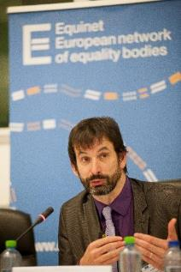

**Patrick Charlier**, Director of UNIA, the Belgian Interfederal Centre for Equal Opportunities noted that equality bodies’ mandate covers not only independent assistance to victims of discrimination and the investigation of discrimination claims, but also the promotion of equality, the preparation of studies, recommendations on draft laws and action plans.

He recalled that at the moment there are no European level standards for the setting up of equality bodies. This could be problematic for consistency between countries and in a context where equality bodies experience threats to their independence, and a limited mandate, powers and resources. Mr. Charlier emphasised the central role the European Commission could and should play in protecting the strengthening equality bodies.

While at UN level the Paris Principles give guidance for the setting up and operations of NHRIs, they are not applicable for equality bodies and their specific situation. There are standards from ECRI and the Commissioner for Human Rights in the Council of Europe, but they are not legally binding.

Equinet published its Working Paper on Developing Standards for Equality Bodies on the eve of the conference, with the ambition to provide a basis for discussions on this topic. The first main theme of the Equinet Working Paper is Mandate that has to be as broad as possible, including equality, diversity, and non-discrimination. The second theme is Independence that has to cover legal status, and both structural and operational independence. The third theme is effectiveness, including physical resources, staff and financial resources. The fourth theme is institutional architecture to ensure that equality bodies are able to cooperate with other stakeholders and to play a central role in equality and non-discrimination work.

Mr. Charlier emphasised that such standards are necessary to ensure that equality bodies are able to fulfill their potential in effectively promoting equality and combating discrimination.

In the ensuing discussion with the audience the panelists shared their view on the links and differences between the UN Paris Principles and the Equinet Working Paper. While many similarities were acknowledged, panelists opined that there are important differences in how the documents are structured; in that the Paris Principles are less focused on assistance to individual victims. In addition, it was emphasised that the institutional architecture and the context has changed a lot in the past well over 20 years, something that also has to be taken into account.

**Patrick Charlier’s presentation is available** [**here**](http://www.equineteurope.org/IMG/pptx/charlier.pptx)**.**

## SESSION 3 – Looking forward: Towards more effective equal treatment legislation

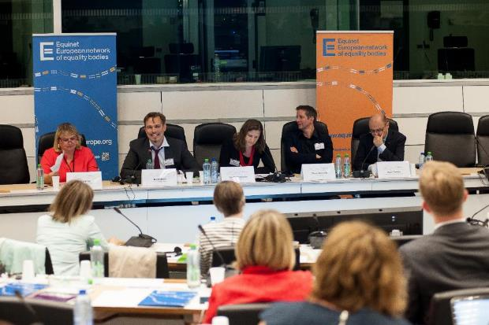

***Session 3*** *- Equality and non-discrimination are key founding values and general principles of the EU. However, currently equality law does not cover all areas where the EU has legislative competence, resulting in a hierarchy of rights. Furthermore, as discussed in previous sessions, already existing legislation does not always live up to its potential due to the lack of effective implementation. This session aimed at setting out a vision for a comprehensive and effective equal treatment legislation in Europe.*

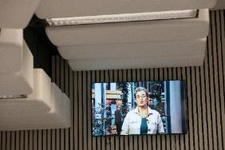**Ulrike Lunacek**, Vice-President of the European Parliament and rapporteur on the Horizontal Directive contributed via a video message, underlining the importance and value of existing EU equal treatment legislation and calling for the quick adoption of the Horizontal Directive. This is necessary to complement and complete the existing framework and provide protection on the grounds of age, disability, religion and belief and sexual orientation outside the field of employment.

The Parliament’s recent report on the Employment Framework Directive (2000/78/EC) emphasizes that protection from discrimination in the field of employment and occupation can only be effective if discrimination is also outlawed in other fields of life, such as education, goods and services or social protection.

Ms. Lunacek underlined the importance of giving a mandate to all European equality bodies to promote equality and combat discrimination on all grounds and all fields. Equality bodies have the potential and should act as key actors of change for equality. She closed her message with a vision of an equal Europe where no one has to live their life in fear due to any protected characteristic.

**Ulrike Lunacek’s video message is available** [**here**](https://youtu.be/02sPaE_-kUE)**.**

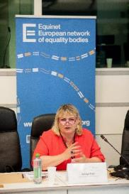**Soraya Post**, a Member of the European Parliament informed participants of her continued engagement on the topic, including a recent discussion with Swedish local anti-discrimination agencies on the missing gaps in anti-discrimination legislation.

She also pointed to the problem of EU equal treatment legislation not guaranteeing equal protection on all grounds of discrimination and called for common minimum standards at European level. MEP Post noted as a good practice that many EU Member States go beyond the minimum requirements of EU legislation and encouraged others to do so.

According to MEP Post another key issue and obstacle is the implementation of existing legislation, an example of which is that despite strong protection measures for Roma they remain subject to discrimination in all walks of life. Therefore, MEP Post proposed that the European Commission could be even more rigorous when assessing the transposition and implementation of EU laws and starting infringement procedures.

Finally, she underlined the importance of creating an environment of trust between public authorities, including equality bodies, and groups subject to discrimination. The European Parliament’s Anti-Racism and Diversity Intergroup was mentioned as a strong platform to fight against discrimination and where the European Parliament, equality bodies and civil society can cooperate.

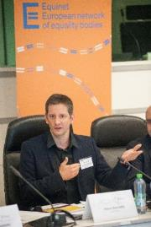

**Pierre Baussand**, the Director of Social Platform emphasised the important difference between the ambition for equality and for non-discrimination. While underlining its importance, he opined that the adoption of the Horizontal Directive in itself would not be sufficient to ensure equality as it would only provide a tool to combat discrimination. However, combatting the negative phenomenon of discrimination and having to rely on individual complainants and cases is insufficient to bring about genuine positive change and substantive equality. The UN Convention on the Rights of Persons with Disabilities is a good example of a changing logic, introducing a more positive, proactive and holistic approach. At EU level the European Pillar of Social Rights could be an important step towards adopting this logic.

In the face of staggering inequalities, Mr. Baussand welcomed Equinet’s recent perspective on economic and social rights and called attention to the clear and crucial links between discrimination and socio-economic status. This calls for the need to introduce protection from discrimination on the ground of socio-economic status in EU legislation.

Finally, Mr. Baussand invited equality bodies and NGOs to work even closer together on issues of equality and non-discrimination.

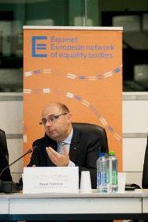

**Pavel Trantina**, President of the European Economic and Social Committee’s SOC section expressed his and the EESC’s support to the observations and conclusions regarding ways to develop and strengthen EU equality legislation. In particular, he underlined the importance of economic and social rights and the need to challenge discrimination on the basis of socio-economic status.

The EESC contributes to the consultation on the European Pillar of Social Rights and in preparation of this they organise missions to all 28 Member States. They intend to comment on what legislative and non-legislative actions should be included and what areas should be covered by the Pillar.

As regards the Horizontal Directive, the EESC noted as an issue that consecutive amendments in recent years introduced provisions that are not in line with the UN Convention on the Rights of Persons with Disabilities and called on Member States and the European Commission to ensure that the CRPD is respected and the UN CRPD Committee’s recommendations are followed.

Mr. Trantina emphasised that the enforcement of existing legislation is a crucial task for the European Commission and the EESC as well as equality bodies are important partners in this. Legislation can only be useful if it is properly implemented.

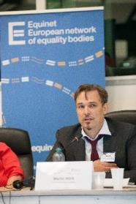**Martin Mörk**, Deputy Ombudsman and Head of Litigation at the Equality Ombudsman in Sweden concentrated in his presentation on ensuring that legislation is effective. Equality legislation might have gaps, but it is essentially good legislation. However, better enforcement and stronger sanctions are needed.

Mr. Mörk set out the prevention of discrimination as the primary aim of equality legislation, while its secondary aim is to provide relief for victims of discrimination. However, at the moment compensation levels in discrimination cases are very low in most cases, while the cost of legal action is often prohibitive. On top of this, proving discrimination in individual cases is often very difficult.

Therefore, Mr. Mörk suggested that the current model of relying mostly on individual victims to bring cases forward is not only unsustainable, but also deeply immoral. Equality bodies should have wider powers to act ex officio, on their own motion to tackle these issues.

Mr. Mörk also put forward the need to introduce stronger sanctions. Contrasting sanction levels in discrimination cases with the high sanctions under data protection or competition laws, it often appears as if the low sanctions in equality law in conjunction with a settlement based approach to damages (not demanding any admission of guilt from the offenders), make profitable discriminatory practices affordable and severely weaken the impact and importance of the legislation.

Finally, Mr. Mörk opined that institutions, such as equality bodies, that are set up to enforce the legislation and apply the sanctions need to be strengthened and made more independent. This is an urgent and viable task, especially in light of strong EU legislation already setting a high standard for instance for data protection authorities.

## CLOSING ADDRESS

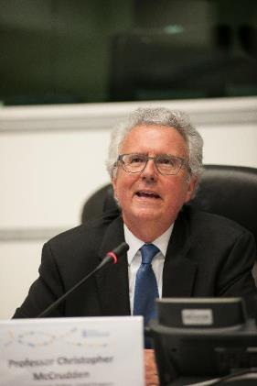

**Professor Christopher McCrudden** from Queen’s University Belfast delivered a closing address, concluding with some proposals to strengthen the effectiveness of European equal treatment legislation.

Professor McCrudden distinguished standards-setting from standard implementation. He looked at areas where legislative initiatives are already on the table (e.g. the horizontal directive or gender balance on company boards), but also where new initiatives might be necessary in light of international law obligations or the possible need to introduce new discrimination grounds, such as socio-economic status. A key issue for consideration is whether expanding EU legislation is necessary and useful and if there is a trade-off between expanding coverage and effective implementation of existing standards.

Professor McCrudden noted the absence of detailed guidance on standard implementation in the EU Equal Treatment Directives. As the Directives have an ambition both for individual and for group justice and wider societal effect, there appears to be a mismatch between the declared aims and the enforcement tools provided to achieve those aims. This led to extremely heterogeneous national approaches to enforcement and similarly varied mandates for equality bodies.

There are some clear concerns about the effectiveness of national mechanisms to achieve individual justice as well as group justice. Some of the reasons include the need for a committed individual complainant, the difficulty of proving discrimination, the lack of awareness, and the inadequacy of remedies on one side and the absence of mechanisms to tackle institutional discrimination and the lack of equality data on the other side. None of these concerns are new, they have been with us for a long time. Good practice examples need to be used, but there is no silver bullet and all good practice examples also have disadvantages and risks. All European Institutions and Member States have a responsibility in increasing the effectiveness of the legislation.

Professor McCrudden argued that in a context of the political developments across Europe and the challenges to existing equality law and the role of the CJEU, the European Commission could take a more interventionist approach in scrutinizing the effectiveness of the domestic enforcement of European equality law. In particular, the European Commission could usefully fund Equinet, provide political support to equality bodies and launch infringement procedures if legal provisions relating to equality bodies are breached. Proposing new legislation requiring equality bodies to cover all grounds and fields could also be considered as well as dedicated legislation on remedies in equal treatment cases. In the absence of new legislation, soft law initiatives could also be an option, e.g. in the form of Commission Recommendations.

Finally, Professor McCrudden welcomed the Equinet Working Paper on Developing Standards for Equality Bodies as a “gold standard”, bringing the debate forward. Some difficult issues remain to be further discussed, such as the exact meaning of independence, the role and capacity of equality bodies often overwhelmed with too many tasks, the relationship between EU standards and CoE/UN standards, or the possible need for going further and developing legally-binding standards.

In conclusion, Professor McCrudden called for implementation at the national level to be more effective. The diversity of national legal systems is not a problem in itself and Member States can learn from each other’s good practices. However, the European Commission needs to scrutinize existing EU-level standards and should consider the development of standards of good practice regarding equality bodies.

**Professor McCrudden’s presentation is available** [**here**](http://www.equineteurope.org/IMG/pptx/mccrudden.pptx)**.**

1. [European Commission Report on the application of Council Directive 2000/43/EC (2014) and Council Directive 2000/78/EC (2014)](http://ec.europa.eu/justice/discrimination/files/com_2014_2_en.pdf)