**Summary Report**

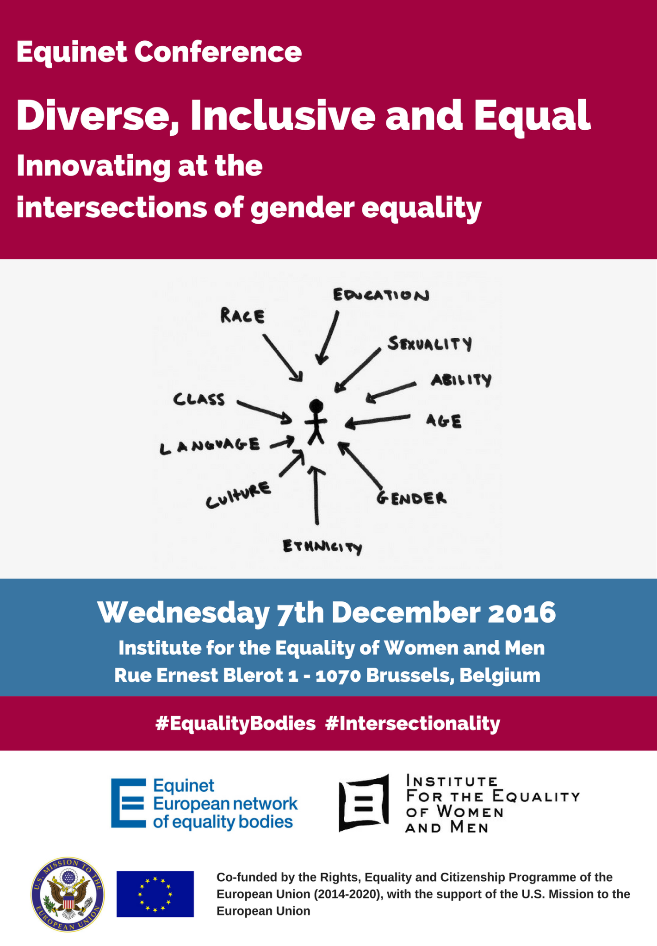

**Table of Contents**

**Equinet & Conference Background** 3

**Conference Agenda** 4

**Conference Summary** 6

Opening Session 6

Keynote Speech 7

SESSION 1: Setting the Scene – Challenges in applying intersectionality in discrimination cases 8

SESSION 2: Overcoming legislative gaps & understanding intersectionality and multiple discrimination 10

SESSION 3: Looking Forward - Avenues for addressing intersectional discrimination 12

Closing Session 14

Equinet warmly thanks the **Institute for the Equality of Women and Men** for hosting the conference and the chairs, speakers and participants for having contributed to the success of this event.

**Seminar organization:** Jessica Machacova & Katrine Steinfeld

**Seminar Support:** Equinet Secretariat Team

**Summary:** Silvana Roebstorf

**Formatting:** Jessica Machacova

**Photo credits:** Thierry - all rights reserved

# EQUINET & CONFERENCE BACKGROUND

**Equinet** is the **European Network of Equality Bodies**, a membership organisation bringing together [46 equality bodies from 34 European countries](http://www.equineteurope.org/-Equinet-Members-) including all EU Members States.

Equality bodies are public organisations assisting victims of discrimination, monitoring and reporting on discrimination issues, and promoting equality. They are legally required to do so in relation to one, some or all the grounds of discrimination covered by European Union law – **gender, race and ethnicity, age, sexual orientation, religion or belief, and disability**.

Equinet promotes equality in Europe through supporting and enabling the work of national equality bodies. It supports equality bodies to be independent and effective as valuable catalysts for more equal societies.

Tackling intersectional discrimination and ensuring an approach to **promoting equality that takes account of multiple identities** is a pervasive challenge both for European non-discrimination law, and for equality bodies seeking to protect the groups in the most vulnerable positions. In order to strengthen equality bodies’ strategic approach to addressing intersectional discrimination and to promoting equality on an intersectional basis, as well as to continue raising awareness on intersectional discrimination in the European agenda, Equinet’s working groups on Policy Formation and Gender Equality have cooperated to draft a [Perspective on Innovating at the Intersections - Equality Bodies Tackling Intersectional Discrimination](http://www.equineteurope.org/IMG/pdf/equinet_perspective_2016_-_intersectionality_final_web.pdf).

The findings of the Perspective, which place the experiences of equality bodies working with intersectionality centre stage, formed the basis of this conference. **Equality bodies are on the front line in the work of promoting equality and combating discrimination.** They have practical experience, learning and expertise both in handling complaints from victims of discrimination, as well as in promoting equality in their national contexts.

Intersectional discrimination, as first described by Kimberlé Crenshaw (1989), addressed the particular experience of disadvantage lived by African-American women in the United States. The experiences of women informed the origins of the academic concept, and women continue to stand at the intersections of multiple relationships of disadvantage today.

In seeking to ensure that equality and non-discrimination are a reality for all in Europe today, the conference aims to put the focus on **groups often rendered invisible in existing legal frameworks and jurisprudence**. By tracing the historical roots of the concept and addressing the challenges in rendering an intersectional approach to equality a reality, it aims to share lessons learned and ways forward in ensuring that equal treatment legislation is meaningful for all, and show how equality bodies can contribute to it.

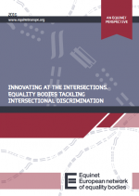The conference provided a platform to **share the challenges** in addressing intersectional discrimination, as well as **good practice examples** and **possible avenues for working pragmatically toward combating intersectional discrimination and reaching persons at the intersections.**

# CONFERENCE AGENDA

|  |  |  |
| --- | --- | --- |
| **OPENING SESSION** | | |
| **09:30 – 09:50** | **OPENING ADDRESS**  **Evelyn Collins,** Chair of the Equinet Executive Board and Chief Executive of the Equality Commission for Northern Ireland**Liesbet Stevens**, Deputy Director, Institute for the Equality of Women and Men | |
| **09:50 – 10:30** | **KEYNOTE ADDRESS**  Intersectionality’s persistent challenge to anti-discrimination law: the problem of the comparator | **Professor** **Suzanne B. Goldberg**, Columbia Law School, New York, U.S. *(video message)* |
| **10:30 – 10:50** | **Questions & Answers** |  |
| **10:50– 11:15** | **Coffee Break** | |
| **SESSION 1**  **Setting the Scene – Challenges in applying intersectionality in discrimination cases**  **Chair:** Evelyn Collins,Chair of the Equinet Executive Board & Chief Executive of the Equality Commission for Northern Ireland | | |
| A low number of EU member states have provisions for multiple discrimination in their legislation, yet all equality bodies effectively work on these cases. In spite of prevailing challenges in tackling intersectional discrimination directly, equality bodies and courts have found ways to incorporate considerations of intersectionality in their legal practices. | | |
| **11:15 – 11:30** | **Overview of current EU legislation: state of play and challenges** | **Professor Dagmar Schiek**, Queen's University of Belfast |
| **11:30 – 11:45** | **Intersectionality in national legislations: The U.S. Perspective** | **Peggy R. Mastroianni**, U.S. Equal Employment Opportunity Commission (EEOC) |
| **11:45 – 12:00** | **On the ground: legal challenges in the work of equality bodies** | **Kosana Beker**, Assistant to the Commissioner for Protection of Equality, Commissioner for Protection of Equality, Serbia and Equinet Board Member |
| **12:00 – 12:20** | **Questions & Answers** | |
| **12:20 – 13:20** | **Lunch break** | |
| **SESSION 2**  **Overcoming legislative gaps and understanding intersectionality and multiple discrimination**  **Chair:** Sandra Konstatzky, Equinet Board Member & Deputy Director, Ombud for Equal Treatment, Austria | | |
| Despite the challenges in addressing intersectional discrimination in litigation, this area is nevertheless more developed than other avenues for addressing intersectional discrimination. Research, positive duties and promotional outreach programs have been identified by Equinet members as effective ways to address intersectional discrimination. | | |
| **13:20 – 13:35** | **Presentation of the Equinet Perspective** | **Niall Crowley**, Independent Expert and author of the Equinet Perspective |
| **13:35 – 13:50** | **Looking for evidence: presentation of the findings of the project “Forgotten Women: the impact of Islamophobia on Muslim women”** | **Julie Pascoët,** Senior Advocacy Officer, ENAR – European Network against Racism |
| **13:50 – 14:05** | **Informing policy makers: the work of the German equality body** | **Nathalie Schlenzka,** Deputy Head, Research Unit, Federal Anti-Discrimination Agency (FADA), Germany |
| **14:05 – 14:30** | **Questions & Answers** | |
| **14:30– 15:00** | **Coffee Break** | |
| **SESSION 3 – Panel Discussion**  **Looking Forward - Avenues for addressing intersectional discrimination**  **Moderator:** Petr Polák, Equinet Board Member & Head of the Division of Equal Treatment, Public Defender of Rights, Czech Republic | | |
| What are possible avenues for better addressing intersectional discrimination in the future? What can equality bodies, non-governmental organisations, decision makers and practitioners do? | | |
| **15:00 – 16:30** | **Participants:**   * **Marre Karu,** European Institute for Gender Equality (EIGE) * **Theresa Hammer**, Legal Advisor, Ombud for Equal Treatment, Austria & Moderator of Equinet Working Group on Gender Equality * **Joanna Maycock**, Secretary General, European Women’s Lobby * **Alexandra Timmer**, Acting specialist coordinator gender equality –European network of legal experts in gender equality and non-discrimination | |
| **CONCLUDING SESSION** | | |
| **16:30 – 17:00** | **Anne Gaspard**, Equinet Executive Director | |

# CONFERENCE SUMMARY

## Opening Session

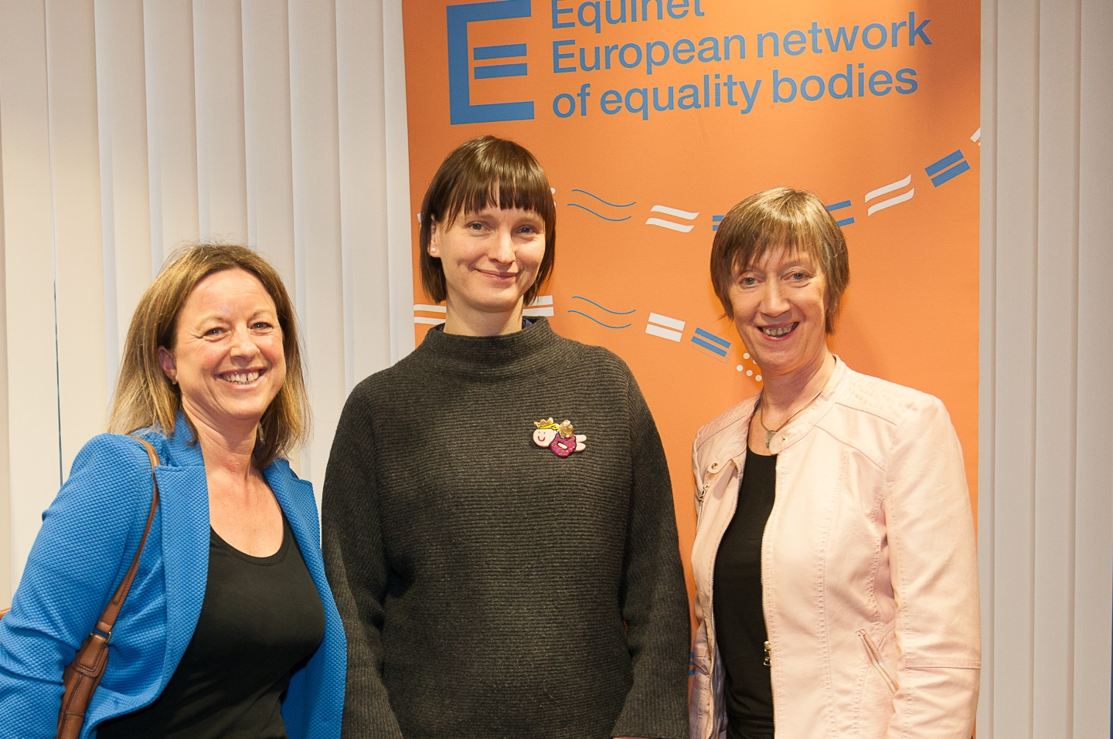

*From left to right: Anne Gaspard (Equinet Executive Director), Liesbet Stevens (Deputy Director of the Institute for the Equality of Women and Men, Belgium) and Evelyn Collins (Equinet Chair and Chief Executive of the Equality Commission for Northern Ireland)*

**Evelyn Collins**, Equinet Chair and Chief Executive of the [Equality Commission for Northern Ireland](http://www.equineteurope.org/Northern-Ireland-Equality-Commission-for-Northern-Ireland), opened the conference by welcoming the participants and speakers, introducing the agenda and reinforcing the need of adopting an intersectional perspective to promoting equality. She reminded the participants that each and every one of them carries multiple identities, such as a gender, a racial and ethnic background, a religion and belief or lack thereof, a sexual orientation and a socio-economic status and that it is these multiple identities that are often not taken account of in discrimination cases.

**Liesbet Stevens**, Deputy Director of the [Institute for the Equality of Women and Men](http://www.equineteurope.org/Institute-for-Equality-of-Women) in Belgium, explained that the work of the Institute most often relates to cases of discrimination on the grounds of gender in the field of employment and the access to goods and services, and that intersectional aspects of discrimination cases are nascent aspect of their work. Ms. Stevens used the two so-called headscarf cases[1] before the Court of Justice of the European Union to demonstrate that multiple identities of people are often not taken into account in discrimination cases. In the headscarf cases employees were asked to take off their headscarves at work and subsequently filed discrimination cases on the ground of religion, without sufficiently linking the discriminatory behaviour against them to other grounds, such as their gender.

## Keynote Speech

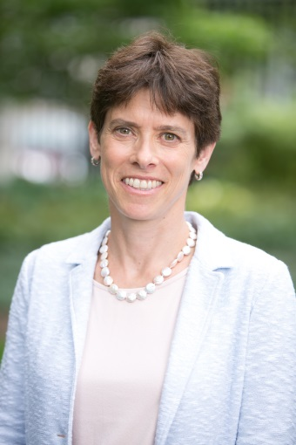

**Professor** **Suzanne B. Goldberg**, from Columbia Law School, delivered a key note speech at the opening of the conference. In her speech she focused on the **history of the concept of intersectionality**, case-law from the US on intersectional discrimination[2] and **challenges in dealing with intersectional claims**.

Professor Goldberg explained that in the legal literature the topic of intersectional discrimination arose in the early 90s. She noted that a recent study found persons bringing intersectional claims are twice as likely to lose, which is why claims are usually brought on one ground of discrimination only; thereby disregarding a person’s identity as a whole.

The main reason for the low success rate of intersectional claims is the fact that American courts use so-called *comparators* for testing whether discrimination occurred or not. While intersectional discrimination claims are generally difficult to prove, Professor Goldberg argues using a comparator is causing a crisis in American anti-discrimination law due to the difficulty of finding a suitable comparator in many situations. A suitable comparator is a person that is in exactly the same position as the individual bringing the discrimination claim, but has been treated differently due to certain characteristics. The difficulty of finding such a comparator naturally increases in intersectional claims. Professor Goldberg explained that small sample sizes and a lack of data can lead to situations in which there simply is no comparator, therefore ruling out the possibility of bringing a successful case. For example, in the employment context, persons in high level positions usually have unique responsibilities, which are not comparable to anyone else’s. Also particular features about the person bringing a claim can make it difficult to find a comparator. To illustrate this, Professor Goldberg used a case in which a pregnant woman was fired one day before going on maternity leave for allegedly being too late to work too often. The woman lost her case because she was unable to find a comparator that was not fired one day before going on maternity leave while also struggling with tardiness.

Professor Goldberg offered two possible ways to increase the success rate of intersectional discrimination cases. First, she explained that using a **hypothetical comparator**, which is not possible in the US but is in some European jurisdictions, would make it easier for victims to prove discrimination. Second, she argues that using the **contextual circumstances** in which a discriminatory act took place would make it easier for victims to prove the discriminatory intent of the perpetrator.

Selected Articles on intersectional discrimination written by Professor Goldberg: ‘[Discrimination by Comparison](http://www.yalelawjournal.org/article/discrimination-by-comparison)’ - Yale Law Journal (2011) and ‘[Intersectionality in Theory and Practice](https://books.google.be/books?id=N_OqVnI_z_kC&pg=PA124&lpg=PA124&dq=Intersectionality+in+Theory+and+Practice+goldberg&source=bl&ots=H_LEPAbXm7&sig=M_Os-yjQnQPdE7ScFYrhODL1hD8&hl=nl&sa=X&ved=0ahUKEwi6-cfr6bTRAhUIKsAKHdwbC6oQ6AEIKDAB#v=onepage&q=Intersectionality%20in%20Theory%20and%20Practice%20goldberg&f=false)’ - Chapter 5 in Intersectionality and Beyond Law, Power and the Politics of Location (2008)

Professor Suzanne B. Goldberg’s video speech is available [here](http://www.equineteurope.org/Equinet-Conference-Diverse-Inclusive-and-Equal-Innovating-at-the-intersections).

## SESSION 1: Setting the Scene – Challenges in applying intersectionality in discrimination cases

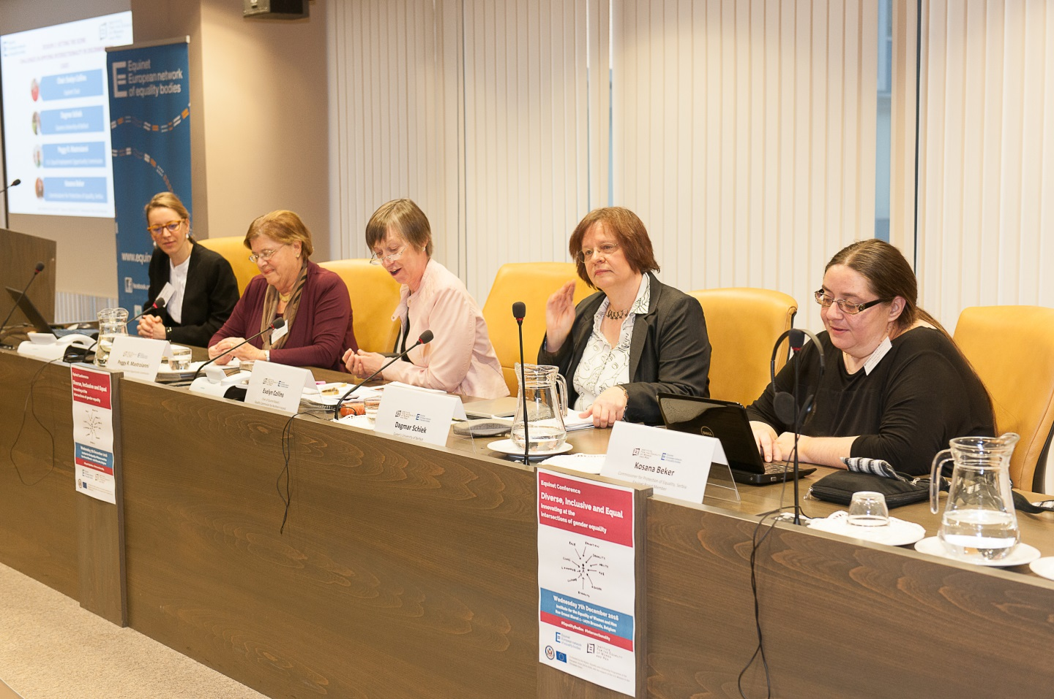

*From left to right: Katrine Steinfeld (Equinet), Peggy Mastroianni (US Equal Employment Opportunity Commission), Evelyn Collins (Equinet Chair and Chief Executive of the Equality Commission for Northern Ireland), Dagmar Schiek (Queen’s University of Belfast), Kosana Beker (Commissioner for Protection of Equality, Serbia)*

Only a low number of EU Member States have provisions relating to multiple discrimination in their national legislation, yet all equality bodies effectively work on these cases. In spite of prevailing challenges in tackling intersectional discrimination, equality bodies and courts have found ways to incorporate considerations of intersectionality in their legal practices. This session allowed conference participants to learn about challenges in dealing with intersectional discrimination cases from a European, American and national perspective.

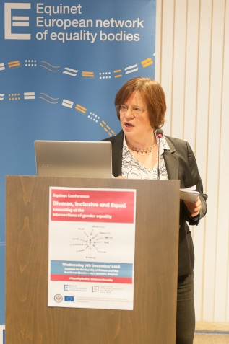**Professor Dagmar Schiek** from [Queen's University of Belfast](http://www.qub.ac.uk/), focused on the **European perspective of dealing with intersectional claims** and started her presentation by introduced the foundation of European anti-discrimination law. She explained that, in her opinion, advocates should always aim to use several grounds in discrimination cases, since this automatically reduces instances in which discriminatory behaviour can be justified.

According to Professor Schiek, a major barrier to successful intersectional cases is the fact that **people fighting for equality are not working together** (she illustrated using the example of gender experts, disability lobbyists and people in the anti-racism movement all working on their topics separately). She also explained that the concept of intersectional discrimination is still not consistently mentioned in **EU legislation**. The concept of multiple discrimination is, for example, mentioned in the recitals of the Race Equality Directive and the Employment Equality Directive, but not the Gender Equality Directive.

In order to adapt the concept of intersectionality to the legal mind-set, Professor Schiek proposes to focus on fewer grounds of discrimination. According to her, 21 protected grounds in European anti-discrimination law are too many and one should focus on the very core of discrimination: sex and gender, race and ethnicity and disability. She suggests that while other grounds of discrimination should not be forgotten, they should rather be regrouped around the above mentioned categories. Professor Schiek also introduced intersectional cases that have been or currently are in front of the Court of Justice of the European Union, including the two so-called headscarf cases (more details can be found in the presentation).

Professor Dagmar Schiek’s presentation is available [here](http://www.equineteurope.org/Equinet-Conference-Diverse-Inclusive-and-Equal-Innovating-at-the-intersections).

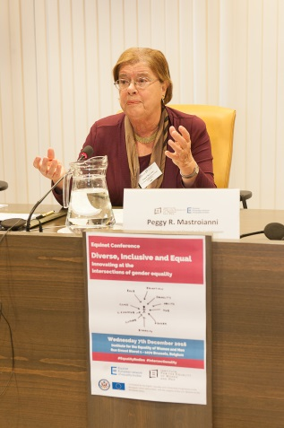**Peggy R. Mastroianni** from the [U.S. Equal Employment Opportunity Commission (EEOC)](https://www.eeoc.gov/) provided conference participants with an **introduction to the work of the EEOC**. She explained that the EEOC has 53 offices across the country, 21000 employees, a budget of 360 million dollars per year and deals with about 90.000 charges on an annual basis. While the EEOC has the power to engage in litigation, cases are usually mediated, investigated and preferably settled before reaching that stage.

At the EEOC all individuals filing a claim need to fill out the same form and tick boxes on the grounds they believe to have been discriminated against. While most people generally tick more than one box, Ms. Mastoianni explained that the idea of intersectional claims rarely originate from the individuals themselves and that it is the EEOC that advises them whether to go forward with an intersectional claim or not.

At the EEOC most multiple discrimination cases concern race and national origin, religion and national origin, colour and national origin or age and disability. Ms Mastroianni also described some intersectional cases dealt with by the EEOC, which can be found online in the list of cases provided.

Peggy R. Mastoianni’s list of cases is available [here](http://www.equineteurope.org/Equinet-Conference-Diverse-Inclusive-and-Equal-Innovating-at-the-intersections).

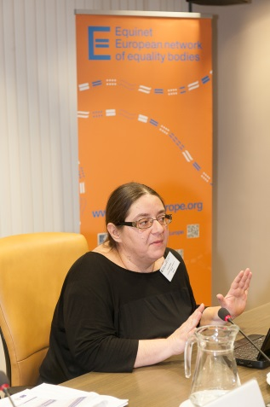**Kosana Beker** gave an overview of the **legal challenges in the work of equality bodies** in dealing with intersectional discrimination cases, informed by her own work at the [Commissioner for the Protection of Equality in Serbia](http://www.equineteurope.org/Commissioner-for-the-Protection-of). After introducing the work of the Commissioner for the Protection of Equality, she explained that the newly adopted Law on the Prohibition of Discrimination from 2009 covers 22 grounds[3] on which discrimination is prohibited. The law also mentions multiple or intersectional discrimination, but does not make a difference between the two concepts, which according to Ms. Beker can be the **result of a lacking equivalent word for intersectional discrimination in the Serbian language**. According to her, the law distinguished between direct, indirect and severe forms of discrimination, with multiple and intersectional discrimination classifying as severe forms of discrimination. Case examples and challenges faced by judges in dealing with multiple or intersectional discrimination cases can be found in Ms. Beker’s presentation.

Kosana Beker’s presentation is available [here](http://www.equineteurope.org/Equinet-Conference-Diverse-Inclusive-and-Equal-Innovating-at-the-intersections).

# SESSION 2: Overcoming legislative gaps & understanding intersectionality and multiple discrimination

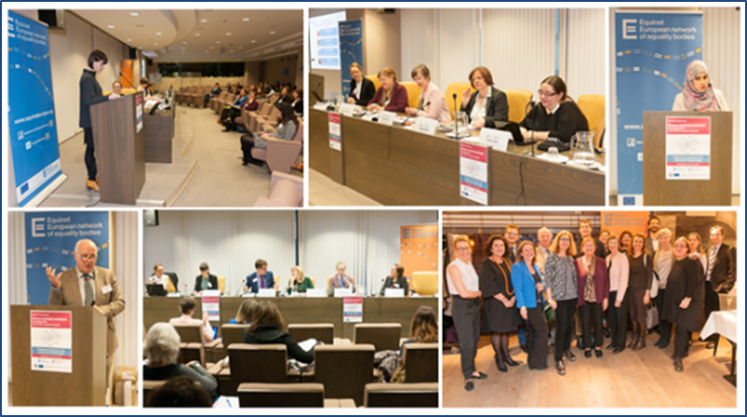

Research, positive duties and promotional outreach programs have been identified by Equinet members as effective ways to address intersectional discrimination. This session introduced the Equinet perspective ‘[*Innovating at the Intersections: Equality Bodies tacking Intersectional Discrimination*](http://www.equineteurope.org/Equinet-Perspective-Innovating-at-the-Intersections-Equality-Bodies-tackling)‘ to the conference participants, as well as some good practice examples in addressing intersectional and multiple discrimination claims by national equality bodies and research conducted on the topic by non-governmental organisations.

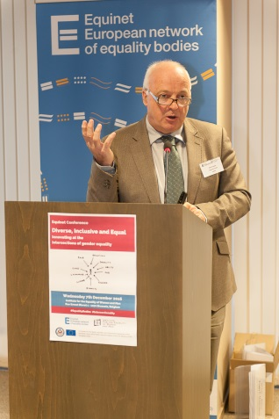**Niall Crowley**, Independent Expert and author of the Equinet Perspective ‘[*Innovating at the Intersections: Equality Bodies tacking Intersectional Discrimination*](http://www.equineteurope.org/Equinet-Perspective-Innovating-at-the-Intersections-Equality-Bodies-tackling)’, introduced the key finding of the report. Mr. Crowley started by explaining that intersectional discrimination is a recent concept and, as such, still very underdeveloped in theory and practice but holds a potential to stimulate innovation in the work of equality bodies. He described three strands of action that have emerged on this issue: multiple discrimination or discrimination on a number of grounds; multiple identity or groups of people at the intersections; and intersectionality with the focus on structures of power.

Mr. Crowley then shared the learnings from the survey that laid the foundation for the perspective and involved 23 equality bodies from 21 jurisdictions. The survey suggested amongst other things that some equality bodies have taken a strategic approach in opening up a focus on intersectionality, by for example dedicating a working year to prioritise a focus on the topic (Germany) or by joint research work to build an understanding of how best to respond to groups at the intersections. (Britain, Ireland and Northern Ireland).

The perspective highlights significant casework being done on this issue but limited initiatives in promoting good practice and communicating on intersectionality. In the survey, equality bodies often stressed the complexity of intersectional cases, as well as national legal provisions that are ill-equipped to sufficiently address this discrimination. Internal barriers within equality bodies, such as limited human and financial resources, were also identified as barriers to dealing with intersectionality.

Naill Crowley’s presentation is available [here](http://www.equineteurope.org/Equinet-Conference-Diverse-Inclusive-and-Equal-Innovating-at-the-intersections).

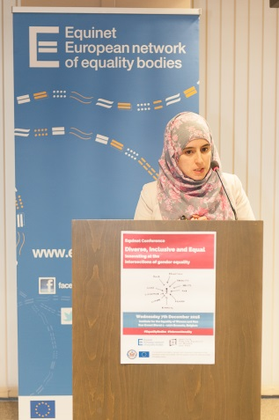**Julie Pascoët**, Senior Advocacy Officer at the [European Network against Racism](http://www.enar-eu.org/) (ENAR), introduced the findings of their project ‘[Forgotten Women: the impact of Islamophobia on Muslim women’](http://www.enar-eu.org/Forgotten-Women-the-impact-of-Islamophobia-on-Muslim-women).

The project is an example of combined effort of the anti-racism and feminist movement working together with the aim of raising awareness on the position of Muslim women in Europe. The project has been carried out in 8 EU Member States[4] and focused on the prevalence of hate speech, hate crime and violence against women in these countries.

Ms. Pascoët explained that in all countries the underreporting of discrimination cases against Muslim women is a great challenge, which just adds to the general lack of disaggregated data on the topic. Reasons for this differ, but include next to a feeling of insecurity and fear also the normalisation of the discriminatory behaviour by society.

The project also concluded that it is often difficult to file multiple discrimination cases, since laws and policies on gender equality often fail to take account of realities only faced by Muslim women. Specific statistics and case examples, as well as recommendations for people working on the topic at European and national level can be found in Ms. Pascoët’s presentation.

Julie Pascoët’s presentation is available [here](http://www.equineteurope.org/Equinet-Conference-Diverse-Inclusive-and-Equal-Innovating-at-the-intersections).

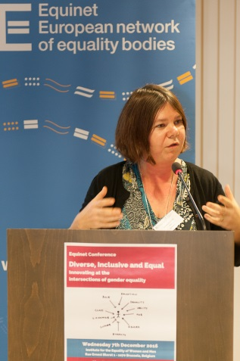**Nathalie Schlenzka** presented the work and good practice examples in the field of intersectional discrimination from the [Federal Anti-Discrimination Agency (FADA) in Germany](http://www.equineteurope.org/Federal-Anti-Discrimination-Agency). She focused on three of their initiatives.

First, Ms. Schlenzka introduced a Joint Report of FADA and the competent Commissioners in the Federal Government and the German Bundestag, which was presented to the German Bundestag in 2010. The report addressed some definitional questions and gave an overview of the legal concept of multiple discrimination and the amount of cases actually filed. It also included specific recommendations, which can be found in the presentation.

Second, Ms. Schlenzka introduced the so-called FADA Themed Years, which were implemented in 2012 and aimed to raise awareness on issues of intersectional discrimination in relation to the main discrimination dimension the year is focusing on. In 2016, for example, the general theme was religion and ideology, while 2017 is focusing on sexual identity. The themed years are accompanied by different activities, such as symposiums, action weeks or the drafting of specific fact sheets.

Third, Ms. Schlenzka introduced the study "Discrimination in Germany" which was commission by the FADA. Among other data, the study measures intersectional discrimination and is aimed at responding to the lack of data on the topic.

Nathalie Schlenzka’s presentation is available [here](http://www.equineteurope.org/Equinet-Conference-Diverse-Inclusive-and-Equal-Innovating-at-the-intersections)

# SESSION 3: Looking Forward - Avenues for addressing intersectional discrimination

The Panel Discussion gathered speakers from equality bodies, EU institutions and representatives of civil society organisations and focused on questions such as: What are possible avenues for better addressing intersectional discrimination in the future? What can equality bodies, non-governmental organisations, decision makers and practitioners do to raise awareness about intersectional discrimination?

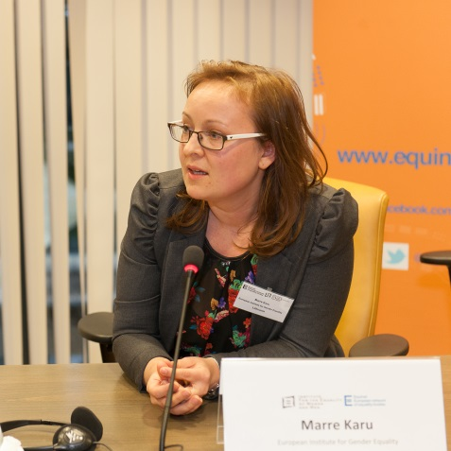**Marre Karu** from the [European Institute for Gender Equality (EIGE)](http://eige.europa.eu/) introduced the Gender Equality Index from 2012 and highlighted that the new Index of 2017 will include intersecting inequalities. Ms. Karu explained that the current index covers 28 different variables across six areas: **work, time, knowledge, power, health and money**. She highlighted that the intersectional components in the new index will cover the intersections between gender and other characteristics, such as migrant background, family type, disability, education and age group. Ms. Karu also introduced some data, for example the intersections of age and gender relating to the poverty or social exclusion rate by age of men and women, clearly showing that in all age groups women are experiencing a higher degree of poverty or social exclusion, with the gap particularly widening after reaching the age of 65. Analyses of other intersections, such as gender and education, can be found in Ms. Karu’s presentation.

Marre Karu’s presentation is available [here](http://www.equineteurope.org/IMG/pdf/session_3_marre_karu.pdf).

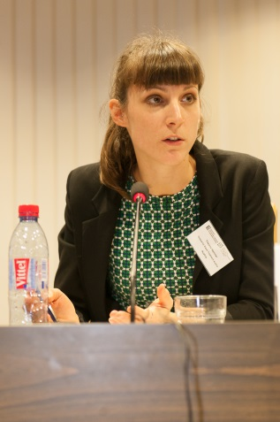**Theresa Hammer** from the [Austrian Ombud for Equal Treatment](http://www.equineteurope.org/Ombud-for-Equal-Treatment) and [Moderator of Equinet’s working group on Gender Equality](http://www.equineteurope.org/-Thematic-Working-Groups-) shared examples of the work on intersectional discrimination of the Ombud. Ms. Hammer explained that the Ombud receives many complaints from Muslim women who were forced to take off their headscarves in the employment context. According to her, reaching settlements in these cases has been successful; however, barriers remain in the field of litigation since it is difficult to build a successful case.

The Ombud is also frequently confronted with cases of migrant men who are not allowed to enter bars or clubs. Ms. Hammer explained that the wording in Austrian anti-discrimination laws places too much focus on the intention and motive of the perpetrator, instead of the individual characteristics of the victim. Furthermore, there are also institutional barriers within equality bodies that make the work on intersectional discrimination difficult since on the one hand not all equality bodies have a mandate to deal with all grounds, and on the other hand usually different departments handle cases on one ground only, making it therefore difficult for intersectional claims to be developed. Another question is whether the victims or the legal advisor should be responsible for identifying the grounds on which to bring a claim; since the success rate decreases with the amount of grounds a claim is filed under.

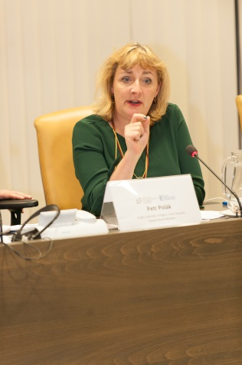**Joanna Maycock** from the [European Women’s Lobby](http://www.womenlobby.org/?lang=en) explained that the topic of intersectional discrimination has been an area of their work since 2000. A recent project focused on the experience of violence against refugee women, therefore combining discrimination on the ground of gender with other grounds, such as race and ethnic origin, religion and nationality. Furthermore, the Women’s Lobby adapted to an innovative model of short staff swaps with organisations focusing on other grounds of discrimination, such as the European Network against Racial Discrimination (ENAR). These staff swaps allow staff members from both organisations to learn about each other’s work in very practical terms, while at the same time fostering a better understanding of the intersectional aspects of discrimination and their own work. Ms. Maycock also talked about the current political environment and the fact that multiple identities, which all of us possess, can give us certain powers and privileges on the one hand, but on the other hand also render us vulnerable to discrimination depending on the environment we are in.

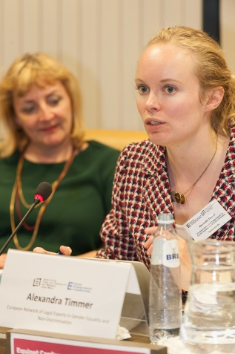**Alexandra Timmer** from the[European Network of Legal Experts in gender equality and non-discrimination](http://www.equalitylaw.eu/) introduced the main conclusions of the report on [Intersectional Discrimination in EU gender equality and non-discrimination law](http://ec.europa.eu/justice/gender-equality/document/files/intersectionality.pdf). Ms. Timmer explained that there are reasons why single ground approaches in discrimination have flaws. First, as has been pointed out earlier, everyone has multiple identities (for example an age, gender, racial and ethnic background, religion or lack thereof, disability or lack thereof, etc.). Second, a single ground approach to discrimination assumes that all groups are homogeneous. Experiences by white women for example are not a universal character for gender oppression, since the experiences of black women are different. Third, a single ground approach to discrimination ignores the role of power in structuring relationships. This means that a substantive equality approach requires a power analysis, since discrimination is not symmetrical but operates to create or entrench domination by some over others. The report argues for example that ‘black men are in a position of power in relation to their gender, but not in relation to their colour’ and ‘white women are in a position of power in relation to their colour, but not their gender’. Fourth, Ms. Timmer explained that focusing on single groups only can lead to stereotyping, which can cause inequalities and increase discrimination by itself.

## Closing Session

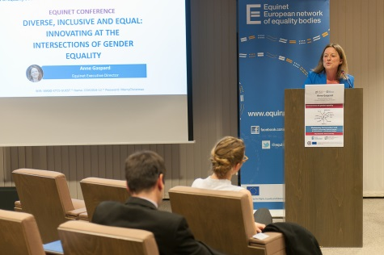Equinet Executive Director **Anne Gaspard** closed the conference by thanking the hosts, speakers and participants for their contributions. She highlighted that intersectional discrimination is a topic that affects all of us, which is why the concept of intersectionality needs to be used more in order to promote equality. She also stressed that equality bodies have an important role to play, through researching and collecting data on the topic, but also by making the topic of intersectional discrimination understandable for national policy and decision makers as well as other stakeholders. For that purpose, Ms. Gaspard stressed that the legal work is not the only way equality bodies can engage on the topic of intersectional discrimination.

1. [Case C-188/15](http://curia.europa.eu/juris/document/document.jsf?text=&docid=181584&pageIndex=0&doclang=en&mode=lst&dir=&occ=first&part=1&cid=156375) and [Case C-157/15](http://curia.europa.eu/juris/document/document.jsf?text=&docid=179082&pageIndex=0&doclang=en&mode=lst&dir=&occ=first&part=1&cid=156432), judgments to be delivered on 15 March 2017.
2. To be found on her speech online, approximately between minutes 14:00 – 25:00.
3. The 22 protected grounds are: race, skin colour, ancestors, citizenship, national affiliation or ethnic origin, language, religious or political beliefs, sex, gender identity, sexual orientation, financial status, birth, genetic characteristics, health status, disability, marital and family status, previous convictions, age, appearance, membership in political, union and other organisations and any other real or presumed personal characteristics.
4. Belgium, Denmark, France, Germany, Italy, Netherlands, Sweden and United Kingdom.