**FIGHTING DISCRIMINATION ON**

**GROUNDS OF RACE & ETHNIC**

**ORIGIN**

*Summary Report*



9 - 10 NOVEMBER 2016

Office of the Commissioner for Fundamental Rights

Nádor u. 22, 1051 Budapest, Hungary

**CONTENT**

**EQUINET & SEMINAR BACKGROUND** 3

**SEMINAR AGENDA** 4

**SEMINAR SUMMARY** 8

OPENING SESSION 8

SESSION 1 – CONTEXT AND CHALLENGES 9

WORKSHOP 1 – CONTEXT AND CHALLENGES THROUGH CASE-LAW IDENTIFIED BY EQUALITY BODIES 11

WORKSHOP 2 & Session 2 – CASE STUDIES OF DISCRIMINATION AGAINST ROMA & RESPONDING TO DISCRIMINATION AGAINST ROMA 13

SESSION 3 – GOOD PRACTICES TO COMBAT DISCRIMINATION ON THE GROUNDS OF RACE AND ETHNIC ORIGIN 15

WORKSHOP 3 – DISCUSSING GOOD PRACTICES AND IDENTIFYING NEEDS 17

CLOSING SESSION 19

Equinet warmly thanks the **Office of the Commissioner for Fundamental Rights** for co-hosting the seminar and the chairs, speakers and participants for having contributed to the success of this event.

**Seminar organization:** Tamas Kadar & Silvana Roebstorf

**Seminar Support:** Equinet Secretariat Team

**Summary:** Silvana Roebstorf

*Co-funded by the Rights, Equality and Citizenship Programme of the European Union (2014-2020)*

# EQUINET & SEMINAR BACKGROUND

**Equinet is the European Network of Equality Bodies**, a membership organisation bringing together [46 equality bodies](http://www.equineteurope.org/-Equinet-Members-) from 34 European countries including all EU Members States.

Equality bodies are public organisations assisting victims of discrimination, monitoring and reporting on discrimination issues, and promoting equality. They are legally required to do so in relation to one, some or all the grounds of discrimination covered by European Union law – **gender, race and ethnicity, age, sexual orientation, religion or belief, and disability**.

Equinet promotes equality in Europe through supporting and enabling the work of national equality bodies. It supports equality bodies to be independent and effective as valuable catalysts for more equal societies.

The ‘Fighting Discrimination on the Grounds of Race and Ethnic Origin’ seminar follows a report on [Making equality legislation work for Roma and Travellers](http://www.equineteurope.org/Making-equality-legislation-work,79) (2010), a [Factsheet on Equinet’s work for the rights of Roma people](http://www.equineteurope.org/Publication-pzori-poizrpiezpoirez) (2011), a [Perspective on Equality bodies combating discrimination on the ground of racial or ethnic origin](http://www.equineteurope.org/Equality-Bodies-Combating) (2012), a [legal analysis on the implementation of the EU’s race and general framework directives](http://www.equineteurope.org/Report-on-the-Implementation-of) (2013), and a [report on positive action measures](http://www.equineteurope.org/Positive-Action-Measures) (2014).

The seminar drew its focus from the work of equality bodies and Equinet on discrimination related to race and ethnic origin. It aimed to:

* **Build capacity** among Equinet members to combat discrimination on the ground of race and ethnic origin, including a focus on discrimination against Roma people
* **Offer a platform** to discuss good practices and promising tools
* **Discuss** **issues** of multiple discrimination where race and ethnic origin intersect with other grounds such as gender, religion or belief

# SEMINAR AGENDA

|  |
| --- |
| **EQUINET SEMINAR**  **Fighting discrimination on grounds of race & ethnic origin** |
| **Wednesday 9th and Thursday 10th November 2016** |
| **LOCATION: Office of the Commissioner for Fundamental Rights, Nádor u. 22, 1051 Budapest, Hungary** |
|  |
| **BACKGROUND INFORMATION AND CONTEXT** |
| Discrimination on the basis of one’s race and ethnic origin remains one of the most often experienced form of inequality and one that features prominently in the work of equality bodies. In many European countries racial and ethnic minorities, and in particular Roma people, remain the most disadvantaged and persecuted group in society.  In a context where public sentiment is often hostile towards racial and ethnic minorities and institutional discrimination and the under-reporting of incidents are common, the challenges around managing the refugee crisis and ensuring the inclusion of migrants also risk to render the public discourse more hostile and discrimination more widely accepted.  In recent years Equinet has published a number of reports collecting and analysing the work of equality bodies and other stakeholders in the field of discrimination on the basis of race and ethnic origin. A report on [Making equality legislation work for Roma and Travellers](http://www.equineteurope.org/Making-equality-legislation-work,79) (2010) was followed by a [Factsheet on Equinet’s work for the rights of Roma people](http://www.equineteurope.org/Publication-pzori-poizrpiezpoirez) (2011), a [Perspective on Equality bodies combating discrimination on the ground of racial or ethnic origin](http://www.equineteurope.org/Equality-Bodies-Combating) (2012), a [legal analysis on the implementation of the EU’s race and general framework directives](http://www.equineteurope.org/Report-on-the-Implementation-of) (2013), and a [report on positive action measures](http://www.equineteurope.org/Positive-Action-Measures), including on this ground (2014). Equinet is also closely following the work around the EU Framework for National Roma Integration Strategies and the work conducted in the European Commission’s High-level group on Racism and Xenophobia.  Equinet is a member of the Operational Platform for Roma Equality (OPRE), set up together with the Council of Europe, the EU’s Agency for Fundamental Rights, and the European Network of NHRIs. In June 2016 OPRE issued a [joint statement on evictions of Roma and Travellers in Europe](http://www.equineteurope.org/Press-Release-Stop-Evictions-of-Roma-and-Travellers) (also signed by OSCE-ODIHR and the UN OHCHR).  In 2016, Equinet’s Working Group on Equality law has developed a paper discussing the key legal issues and challenges, and the available tools and good practices in tackling discrimination on the ground of race and ethnic origin. |
| **OBJECTIVES** |
| The Seminar aims to:   * Build capacity among Equinet members to combat discrimination on the ground of race and ethnic origin, including a focus on discrimination against Roma people * Offer a platform to discuss good practices and promising tools * Discuss issues of multiple discrimination where race and ethnic origin intersect with other grounds such as gender, religion or belief |
| **PARTICIPANTS** |
| This Equinet seminar is dedicated to an audience of approximately **45 equality body staff members** with responsibilities in **dealing with race equality issues**. The seminar agenda allows for participation of persons with different professional backgrounds, in particular of **legal experts** and **policy experts**. |

|  |  |
| --- | --- |
| **AGENDA** | |
| **Day 1 - Wednesday 9 November** | |
| 08:30 – 09:00 | Registration and welcome coffee |
| **OPENING SESSION** | |
| 09:00 – 09:30 | Speakers:   * **László Székely**,Commissioner for Fundamental Rights, Hungary * **Elisabeth Sándor-Szalay**, Deputy Commissioner for Fundamental Rights, Ombudsman for the Rights of National Minorities, Hungary * **Evelyn Collins**,Equinet Chair |
| 09:30 – 11:00 | **SESSION 1 – Context and challenges**  This session will provide a starting point by discussing the phenomenon of racism as the underlying cause of racial discrimination and effective ways of responding to racism. It will discuss the definitional challenges of race and ethnicity differing by country, the legal, institutional and societal context in which such discrimination takes place and the main challenges for equality bodies and other stakeholders. |
|  | Chair: **Evelyn Collins**,Equinet Chair  Speakers:   * **Jayne Hardwick**, Equality and Human Rights Commission, Great Britain, and Moderator of Equinet’s Working Group on Equality Law * **Mutuma Ruteere**,United Nations Special Rapporteur on contemporary forms of racism, racial discrimination, xenophobia and related intolerance (video message) * **Elisabeth Sándor-Szalay**, Deputy Commissioner for Minority Rights, Office of the Commissioner for Fundamental Rights, Hungary * **Sami Nevala,** Fundamental Rights Agency (FRA) |
| **11:00 – 11:30** | **Coffee break** |
| 11:30 – 13:00 | **WORKSHOP 1 - Context and challenges through case law identified by equality bodies**  This workshop session will provide an opportunity to discuss discrimination on the basis of race and ethnic origin in the different fields of the equality bodies’ mandate. Challenging cases from the experience of equality bodies will be used to trigger the discussions. Discussion groups will report back to the plenary, identifying some key challenges in the given field. |
|  | Facilitators:   * **Adél Lukovics**, Equal Treatment Authority, Hungary – *Education* * **Imane El Morabet**, Interfederal Centre for Equal Opportunities, Belgium – *Media* * **Tamas Kadar**, Equinet Secretariat, Brussels – *Employment* * **Edina Tordai**, Office of the Commissioner for Fundamental Rights, Hungary - *Housing* |
| **13:00-14:00** | **Lunch** |
| 14:00-15:30 | **WORKSHOP 2 – Case studies on discrimination against Roma**  This workshop session will provide an opportunity to discuss challenging cases of discrimination against Roma with external experts. The experts will moderate the discussions around cases from different fields, such as education, housing, hate speech, or multiple discrimination. |
|  | Facilitators:   * **Michel Verschraegen**, European Commission – *Education* * **Oana-Luiza Taba**, European Court of Human Rights - *ECtHR case law, including hate crime and hate speech* * **Lidia Balogh**, Hungarian Academy of Sciences Centre for Social Sciences Institute for Legal Studies - *Multiple discrimination and gender issues* * **Tatjana Perić**, OSCE ODIHR – *Housing* |
| **15:30-16:00** | **Coffee break** |
| 16:00-17:00 | **SESSION 2 – Responding to discrimination against Roma**  This session will focus on the particular experience of and challenges faced by Roma as the largest and one of the most discriminated ethnic minorities in Europe. Speakers will be the external experts from workshop 2. They will share the main findings of the discussion groups in session 2 and will offer their thoughts on good practices and ways forward. |
|  | Chair: **Elisabeth Sándor-Szalay**, Deputy Commissioner for Fundamental Rights, Ombudsman for the Rights of National Minorities, Hungary  Speakers:   * **Michel Verschraegen**, European Commission - *Education* * **Oana-Luiza Taba**, European Court of Human Rights - *ECtHR case law, including hate crime and hate speech* * **Lidia Balogh**, Hungarian Academy of Sciences Centre for Social Sciences Institute for Legal Studies - *Multiple discrimination and gender issues* * **Tatjana Perić**, OSCE ODIHR – *Housing* |
| **17:00**  17:30 | **End of first day**  After the end of the first day participants that are interested will be given a tour of the Parliament (departure directly from the seminar venue) |
| **20:00** | **Dinner**  Dunapark restaurant (Pozsonyi út 38, 1137 Budapest)  Meeting at 19:45 in the Hotel Lobby (NH Budapest City, 1137, Budapest, Vígszínház u 3.) |
| **DAY 2 – 10 November 2016** | |
| 09:15-10:30 | **SESSION 3 – Good practices to combat discrimination on the grounds of race and ethnic origin**  This session will feature good practices and initiatives by equality bodies to combat discrimination on the grounds of race and ethnic origin. Good practices will be presented from the following fields: strategic litigation, awareness raising, cooperation with other stakeholders and training. |
|  | Chair: **Veronika Bazalová**, Office of the Public Defender of Rights, Czech Republic  Speakers:   * **Lindsey Reynolds**, Equality and Human Rights Commission, Scotland - *Strategic litigation* * **Chrysoula Malisianou**, Défenseur des Droits, France - *Awareness raising* * **Cornelia Amon-Konrath**, Austrian Ombud for Equal Treatment - *Cooperation with stakeholders* * **Barbara Bos**,Netherlands Institute for Human Rights, Netherlands *- Training* |
| 10:30-11:00 | **Coffee Break** |
| 11:00-12:30 | **WORKSHOP 3 – Discussing good practices and identifying needs**  Participants will discuss good practices and how these can be adapted to their own situation and needs. Each discussion group will be facilitated by an external expert, who will also provide examples and will stimulate the debate. Participants will prepare a list of actions to be implemented by equality bodies and other stakeholders in the given field to combat racial discrimination. The list of actions of each group will be presented in plenary. |
|  | Facilitators:   * **Lilla Farkas**, European University Institute, Italy - *Strategic litigation* * **Laszlo Milutinovits**, European Youth Centre Budapest, Hungary *- Awareness raising and education* * **Mariana Berbec***,* Open Society Foundation, Hungary *– NGO Cooperation and Roma empowerment* * **Barbara Bos**, Netherlands Institute for Human Rights, Netherlands - *Training* |
| 12:30-13:00 | **Concluding session** |
|  | Presentation of list of actions by the workshop groups  Closing:   * **Elisabeth Sándor-Szalay**, Deputy Commissioner for Fundamental Rights, Ombudsman for the Rights of National Minorities, Hungary * **Anne Gaspard**, Equinet Executive Director |
| 13:00-14:00 | **Lunch and end of the seminar** |

# SEMINAR SUMMARY

## OPENING SESSION

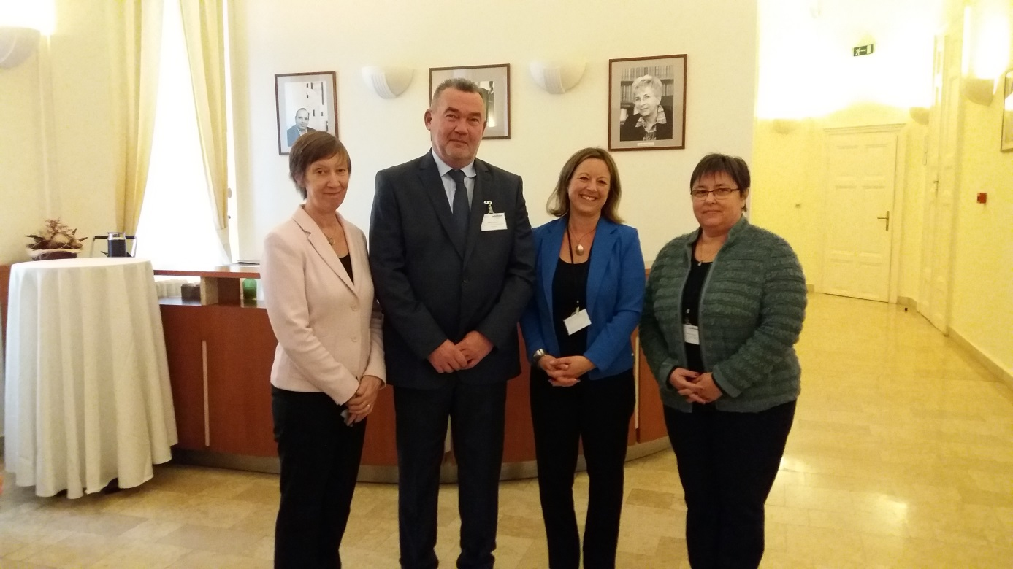

**László Székely**, **Commissioner for Fundamental Rights in Hungary**, opened the seminar by reinforcing the concept of a community of shared values and the importance of the adherence to the rule of law. He emphasized that despite the positive developments in Europe in the fields of protecting human rights and facilitating equal treatment, there are several areas where Member States continue to face challenges. In many European countries racial and ethnic discrimination of minorities, in particular Roma people, continues to exist. Discrimination against Roma is rooted in prejudices present in society and forms part of a complex set of problems related to welfare, education, employment and housing issues. This discrimination often ends up making the affected persons victims of hate crimes.

**Elisabeth Sándor-Szalay, Deputy Commissioner for Fundamental Rights and Ombud for the Rights of National Minorities in Hungary**, introduced the work and mandate of the [Office of the Commissioner for Fundamental Rights](http://www.equineteurope.org/Parliamentary-Commissioner-for-the). She explained that Hungarian national legislation recognises 13 national minorities. She also pointed out that problems affecting the whole of Europe can only be tackled at European level and that the seminar is an excellent opportunity for leading European experts to share their knowledge with the members of European equality bodies.

**Evelyn Collins, Equinet Chair and Chief Executive of the Equality Commission for Northern Ireland**, continued by stressing that although Europe faces a general increase of xenophobia and hostile public sentiment and discourse against racial and ethnic minorities, national and international institutions and organisations should not be deterred from continuing their work based on the firm ground of shared values. She continued by introducing the work of Equinet on fighting discrimination on the basis of Race and Ethnic origin and encouraged the seminar participants to comment on the draft version of the discussion paper on *Fighting Discrimination on the Grounds of Race and Ethnic Origin*, which was sent to all participants before the seminar and handed out in the seminar packs.

## SESSION 1 – CONTEXT AND CHALLENGES

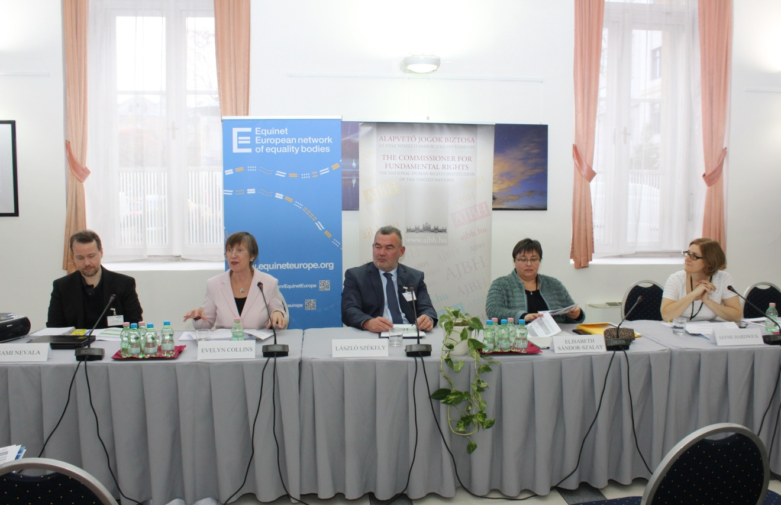

***Session 1*** *aimed at setting the scene by discussing the phenomenon of racism as the underlying cause of racial and ethnic origin discrimination and effective ways of responding to it. The definitional challenges of race and ethnicity differing by country were addressed, the legal, institutional and societal context in which such discrimination takes place was introduced and the main challenges for equality bodies and other stakeholders were highlighted.*

**Jayne Hardwick, Equality and Human Rights Commission, Great Britain, and Moderator of Equinet’s Working Group on Equality Law**, introduced the draft discussion paper on *Fighting Discrimination on the Grounds of Race and Ethnic Origin* drafted by Equinet’s working group on Equality Law. She gave an overview of the legal framework relating to racial and ethnic origin discrimination in the European Union. Then she presented some key findings of the discussion paper, highlighting that the work of equality bodies shows that complaints in the field have reached a new peak in Europe, pointing to an increase in hate speech and aggressive discourse around migrant and refugee issues and an overall negative media portrayal of asylum seekers. She also raised concerns about the general negative political discourse around migrant and refugee issues resulting in an increase in racist behaviour by the general population. Ms. Hardwick continued by presenting the findings on discrimination against Roma people in the field of housing, which is a specific focus of the discussion paper. She also explained that there is no adequate protection at European level in cases where discrimination based on racial and ethnic origin intersects with other grounds of discrimination (multiple discrimination). She highlighted legal challenges and obstacles equality bodies face in fighting discrimination on the grounds of race and ethnic origin and pointed to different tools and good practice examples used by equality bodies to detect such discrimination.

**Jayne Hardwick’s presentation is available** [**here**](http://www.equineteurope.org/Equinet-Seminar-Fighting-discrimination-on-grounds-of-race-and-ethnic-origin)**.**

**Mutuma Ruteere, United Nations Special Rapporteur on contemporary forms of racism, racial discrimination, xenophobia and related intolerance**, could not personally attend but prepared a speech prior to the seminar, which was read out to the participants. In his speech he highlighted that without the work of national equality bodies, his role as UN Special Rapporteur would be much less effective. He pointed out that equality bodies play an important role in promoting policy and institutional change in organisations and in enhancing the wider institutional infrastructure as well as cooperation and engagement with civil society organisations and other stakeholders. Mr. Ruteere also emphasised that more ethnically disaggregated data is needed to record occurrences of racial discrimination and progress made in combating racial discrimination needs to be monitored better. He also highlighted that effective tools for assessing the effectiveness of measures taken are crucial for combatting racial discrimination and the importance of an appropriate mandate and tools for equality bodies, enabling them to carry out their tasks in the most efficient manner.

**Mutuma Ruteere’s speech is available** [**here**](http://www.equineteurope.org/Equinet-Seminar-Fighting-discrimination-on-grounds-of-race-and-ethnic-origin)**.**

**Elisabeth Sándor-Szalay, Deputy Commissioner for Fundamental Rights and Ombudsman for the Rights of National Minorities in Hungary**, introduced the mandate of the Office of the Commissioner for Fundamental Rights and explained that it has the competence to hear and consider individual complaints, to provide assistance to individuals, to initiate investigations ex-officio, to make recommendations and follow-up on their implementation and to use alternative dispute resolutions to settle conflicts. There is however no power to initiate third party interventions or to enforce the recommendations made. Ms. Sándor-Szalay raised the concern that discrimination on the grounds of race and ethnic origin often occurs in the field of education, which is why in Hungary the first three levels of the education system have been scrutinized in recent years to obtain a clearer picture of the discrimination actually occurring. It showed that especially Roma children face direct and indirect discrimination in education. Direct discrimination because they are often physically placed in different classrooms and indirect discrimination because Roma children are often misdiagnosed and subsequently placed in special needs schools.

**Elisabeth Sándor-Szalay’s presentation is available** [**here**](http://www.equineteurope.org/IMG/pdf/equinet_szse_prezentacio_20161109.pdf)**.**

**Sami Nevala, Head of Statistics and Surveys at the European Union Agency for Fundamental Rights**, introduced the data collection and data coverage of the [European Union Minorities and Discrimination Survey (EU-MIDIS II)](http://fra.europa.eu/en/publication/2016/eumidis-ii-roma-selected-findings), which has interviewed over 25,000 persons across the EU-28, including some 7,900 Roma. He explained that the data will be used to populate different indicators, such as the Roma inclusion indicators as well as providing Roma-specific data on selected Europe 2020 indicators. He also highlighted that the EU-MIDIS II data will allow for direct comparability with selected results of EU-MIDIS I and other surveys, therefore giving a clear indication of different trends. He explained, that the EU-MIDIS II survey has a broader scope compared to previous surveys, focusing for example also on issues of multiple discrimination, social situation and living conditions, and discrimination in everyday context such as leisure activities and in public transportation. Furthermore, EU-MIDIS II distinguishes between more types of discrimination compared to other surveys. Mr. Nevala also explained the challenges faced in collecting data for large scale surveys taking place in all EU Member States, stating that some countries allow for very limited access to data that is needed for sampling purposes, while others make no official sources such as population registers available for survey sampling. In both cases the data collection takes much more time and is more expensive, which has an impact on efforts to monitor progress in EU Member States. The first [EU-MIDIS II data](http://www.equineteurope.org/80-of-Roma-are-at-risk-of-poverty-new-FRA-survey-finds) focusing on Roma [was presented on 29 November 2016](http://fra.europa.eu/en/publication/2016/eumidis-ii-roma-selected-findings) at the Roma Platform meeting; more results will be published during the next year.

**Sami Nevala’s presentation is available** [**here**](http://www.equineteurope.org/IMG/pdf/sami.pdf)**.**

## WORKSHOP 1 – CONTEXT AND CHALLENGES THROUGH CASE-LAW IDENTIFIED BY EQUALITY BODIES

***Workshop 1*** *provided an opportunity for seminar participants to discuss discrimination on the basis of race and ethnic origin in the different fields of the equality bodies’ mandate. Challenging cases from the experience of equality bodies were used to trigger the discussions. The seminar participants were split into four working groups, focusing on education, media, employment and housing, and reported back in plenary.*

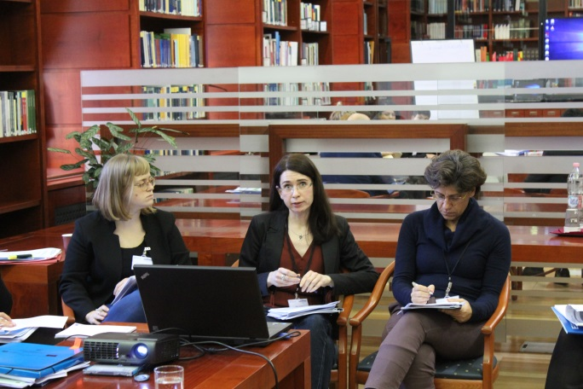The working group on education was facilitated by **Adél Lukovics** from the Equal Treatment Authority in Hungary. After explaining the mandate of the Equal Treatment Authority, Ms. Lukovics explained that the Hungarian Equal Treatment Act is currently being revised as a response to the infringement proceedings initiated by the European Commission against Hungary. In the current version of the Act, school segregation that does not result in any disadvantage does not constitute discrimination in public education when the segregation can be justified by religious or ethnic origin reasons. Nevertheless, she stressed that in the Authority’s point of view it is important that the right to education has an explicit reference to Roma children living in Hungary in the amended text of the Act. The working group discussions revealed that in many countries Roma children are especially affected by discrimination in the field of education and still put in separate classrooms or special needs schools. The working group participants also talked about challenges in collecting data on discrimination in the field of education because it usually affects hard to reach communities or national legislation does not allow for the collection of data relating to race and ethnic origin. The working group also discussed the difficulty of establishing inclusive schools for reasons such as proximity to one’s residence, the lack of minority children speaking and understanding the national language and resistance of the mainstream population to let their children attend schools with a high prevalence of children belonging to racial or ethnic minorities.

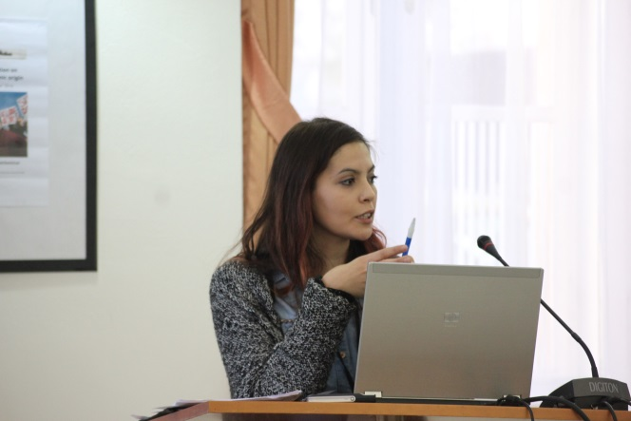The working group on media was facilitated by **Imane El Morabet** from Unia (Interfederal Centre for Equal Opportunities) in Belgium. She started the workshop by showing different cartoons, tweets and articles to demonstrate how powerful the media can be in shaping people’s negative opinions and perceptions. The seminar participants discussed subsequently how they would react to statements clearly inciting hatred and racism. The working group participants stated that hate speech in the field of media is often not covered in the mandate of their equality bodies, since the topic rather falls into the area of criminal law. Suggested measures to counteract discrimination on the basis of race and ethnic origin in the field of media involved naming and shaming the actor, training journalists, media editors and other people working in the field of media on European non-discrimination legislation and imposing stronger sanctions in cases of violations. The working group also discussed the thin line between hate speech and an individual’s right to freedom of expression and concluded that positive role models are needed to overcome negative stereotypes and racist behaviour. The discussion of good practice examples from the work of equality bodies showed that they often engage in training sessions for employers working in the public sphere, such as the police or public prosecutors and in different awareness raising campaigns, such as the setting up of an online platform to report incidents of hate crimes.

**Imane El Morabet’s presentation is available** [**here**](http://www.equineteurope.org/Equinet-Seminar-Fighting-discrimination-on-grounds-of-race-and-ethnic-origin)**.**

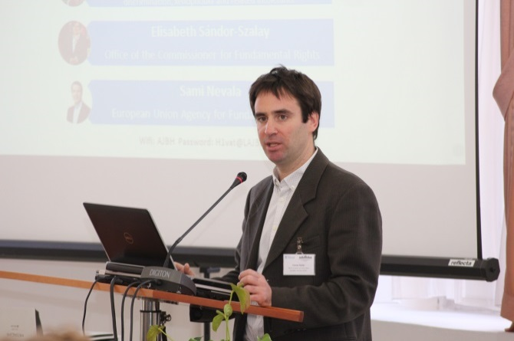The working group on employment was facilitated by **Tamas Kadar** from the Equinet Secretariat. The working group discussed challenges faced in handling cases of discrimination on the grounds of race and ethnic origin in the field of employment, such as proving that discrimination actually occurred, especially in the recruitment stage or during job interviews. The fact that courts are reluctant to shift the burden of proof in favour of the victim, leaving the victim with the duty to prove that discrimination has actually occurred, which often is an impossible task, was also discussed. The working group participants raised the concern that cases of discrimination on the grounds of race and ethnic origin in the field of employment rarely lead to effective and dissuasive sanctions for employers or compensation for the victims. One key outcome of the working group discussion was also that cases of harassment in the employment context seem to have increased with the migration and refugee situation.

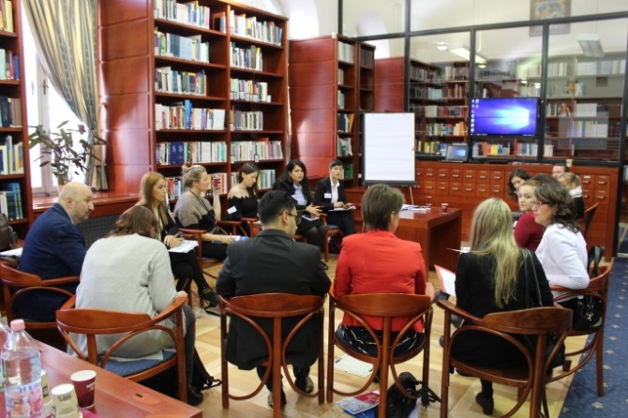The working group on housing was facilitated by **Edina Tordai** from the Office of the Commissioner for Fundamental Rights in Hungary. The working group started with a brainstorming activity, linking discrimination in the field of housing to the physical segregation from the mainstream population, therefore hindering the active participation of the segregated community in society. Segregation also leads to a lack of involvement of authorities in the segregated areas, which results in inadequate access to municipal services such as schools, health care and roads for example. The working group then addressed cases in which people of Roma origin were unable to find housing on the private housing market because house owners or real estate agencies wouldn’t work with them and cases in which the inability of registering an official address denied them access to social benefits. The working group concluded that it is crucial for national, regional and local authorities to implement anti-discrimination laws correctly and to train all stakeholders working in the field on how to apply these laws in practice. Working group participants also highlighted the importance of creating alternative long-term housing solutions for Roma people living in settlements that are being removed, as often the Roma community has no other possibility than recreating new informal settlements.

## WORKSHOP 2 & Session 2 – CASE STUDIES OF DISCRIMINATION AGAINST ROMA & RESPONDING TO DISCRIMINATION AGAINST ROMA

***Workshop 2*** *provided an opportunity for the seminar participants to discuss challenging cases of discrimination against Roma together with external experts. The working groups were facilitated by the external experts on cases from different fields: education, housing, hate speech, and multiple discrimination.*

***Session 2*** *focused on the particular experience of and challenges faced by Roma as the largest and one of the most discriminated ethnic minorities in Europe. The external experts that facilitated workshop 2 shared the main findings of the discussion groups and offered their thoughts on good practices and ways forward.*

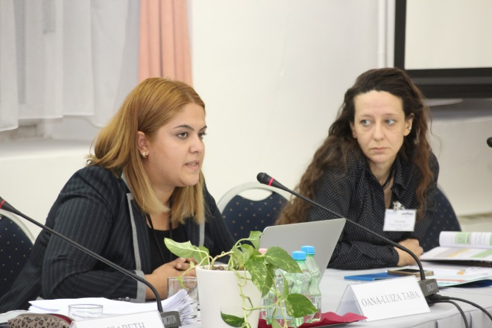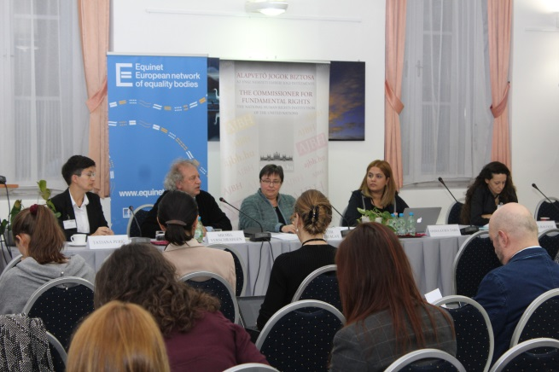The working group on education was facilitated by **Michel Verschraegen** from the European Commission. He started the working group by explaining the legal framework applying to discrimination in the field of education. He pointed out that the European Commission has little competence to act and can only engage in promotional activities or initiate infringement proceedings against countries that are in breach of EU law. While pointing out that progress has been made as more and more Roma children attend primary school, he underlined the importance of overcoming school segregation of Roma children for future generations and reinforced the important role of equality bodies in providing information of the situation on the ground. After talking about the infringement proceedings against Hungary, the Czech Republic and Slovakia, the working group discussed cases of Roma discrimination in the field of education before equality bodies, challenges in ending school segregation and shared good practice examples. The working group participants also stated that they expect the European Commission to be stricter on governments where there is clear evidence that Roma children are discriminated against and to provide practical solutions on how to close the gap between the law and the situation on the ground.

The working group on case law of the European Court of Human Rights was facilitated by **Oana-Luiza Taba** from the European Court of Human Rights. Working group members reported that they use the case-law of the ECtHR in their work to substantiate their decisions, to formulate recommendations, in public statements or other publications, for amicus curiae submissions, to support arguments in litigation, when giving legal advice to individuals or in training events organised for the national police, judges, prosecutors or other stakeholders. The working group members also discussed the difficulties in handling cases of hate speech and hate crime, since it often falls within the ambit of criminal law and therefore outside the competence and mandate of equality bodies. Furthermore, social media and internet portals are often placed abroad and therefore the perpetrator is hard to identify. Concern was also raised because there is no concrete indication of the occurrence of hate speech and hate crimes since many cases are never reported. In the end Ms. Taba highlighted the strong impact strategic litigation can have and encouraged equality bodies to establish contact between national non-governmental organisations and experienced lawyers interested in pursuing cases.

**Oana-Luiza Taba’s presentation is available** [**here**](http://www.equineteurope.org/Equinet-Seminar-Fighting-discrimination-on-grounds-of-race-and-ethnic-origin)**.**

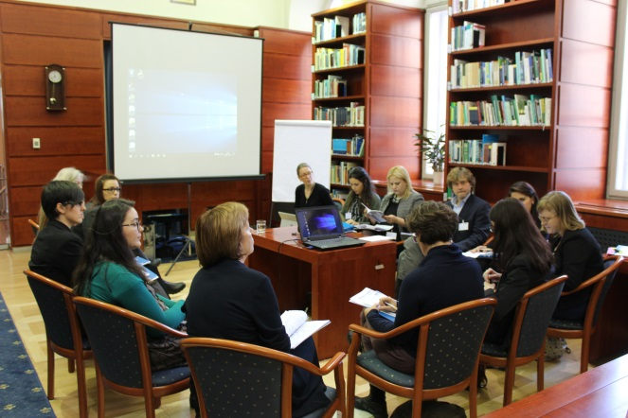The working group on multiple discrimination and gender issues was facilitated by **Lidia Balogh** from the Hungarian Academy of Sciences Centre for Social Sciences Institute for Legal Studies. After talking about different definitions of multiple discrimination and how the concept relates to intersectionality, cases in which Roma women became victim of multiple discrimination were discussed. The working group participants raised concern that public authorities and the police often do not take complaints by Roma women seriously and that this is why Roma women are usually very reluctant to file a complaint in the first place. Furthermore, there is not only a lack of regulation of the concepts of multiple discrimination and intersectional discrimination at European level, but also at national level of European Member States, therefore ignoring the vulnerable situation Roma women can find themselves in. The problem of under regulation is not only faced by Roma women, but also other individuals who are discriminated against on more than one ground. . However, participants claimed also that while the concept of intersectionality is an important analytical tool in social sciences to understand certain phenomena, and intersectionality should be taken into account when designing social inclusion policies, the relevance of this concept may be limited when it comes to anti-discrimination litigation.

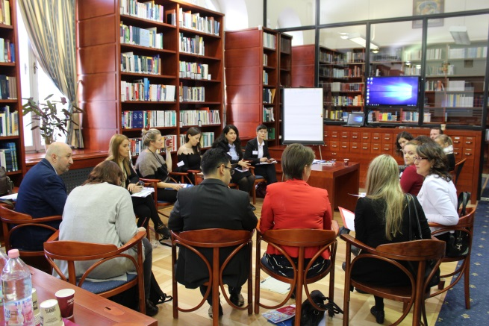The working group on housing was facilitated by **Tatjana Perić** from the OSCE Office for Democratic Institutions and Human Rights (ODIHR). At the beginning of the discussions Ms. Perić introduced the mandate of the OSCE and explained their active ‘monitoring role’ which enables them to conduct research in a country. She introduced ODIHR’s most recent field visits to the city of Miskolc in Hungary, which took place in 2015 and 2016. In Miskolc, a Roma settlement was planned to be destroyed in order to build a soccer stadium instead. To avoid the Roma population from moving to neighbouring cities, cities close by adopted local decrees denying them the possibility of applying for social housing or social benefits. More information can be found in ODIHR’s [report](http://www.osce.org/odihr/262026). The working group discussions revealed that many equality bodies handle cases of discrimination against Roma in the field of housing and that the community is often evicted without the provision of alternative housing solutions. Since in most cases the recommendations of equality bodies are not legally enforceable, they raise awareness of the problem through issuing different opinions. The experience of the OSCE and equality bodies has shown that direct visits of Roma settlements and direct communication is key for gaining the trust of the communities and of utmost importance for gathering evidence and obtaining their stories.

## SESSION 3 – GOOD PRACTICES TO COMBAT DISCRIMINATION ON THE GROUNDS OF RACE AND ETHNIC ORIGIN

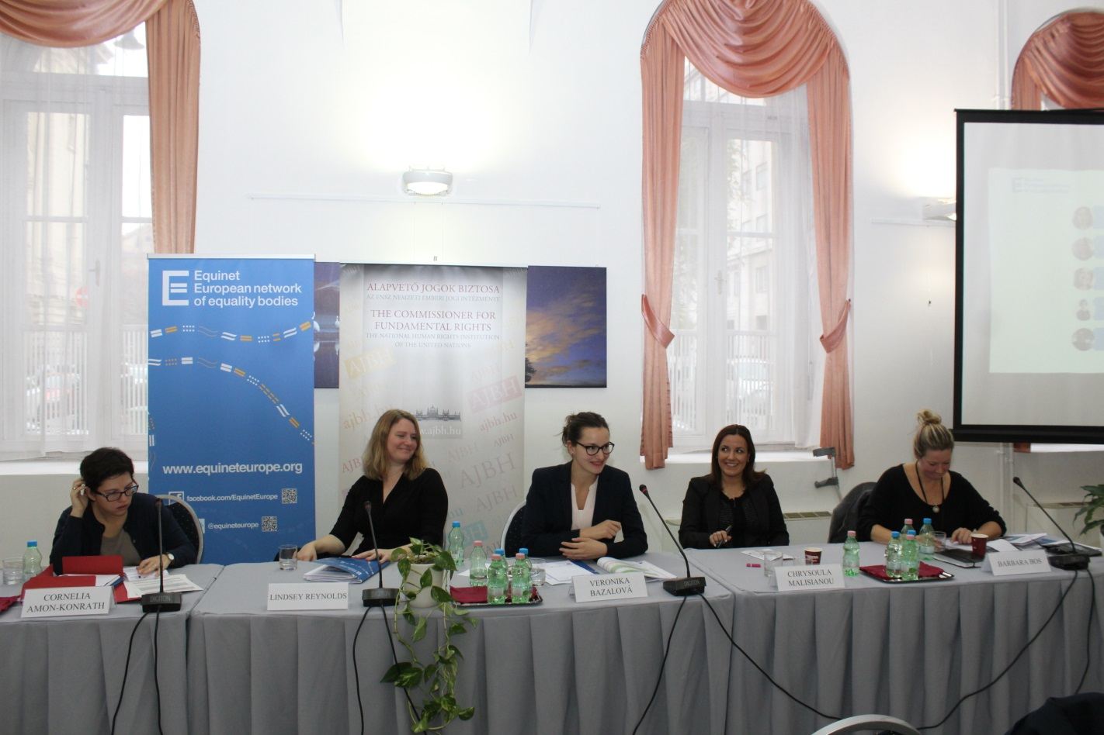

***Session 3*** *focused on good practices and initiatives by equality bodies to combat discrimination on the grounds of race and ethnic origin. Good practices were presented from the fields of strategic litigation, awareness raising, cooperation with other stakeholders and training initiatives.*

**Lindsey Reynolds** from the Equality and Human Rights Commission in Scotland gave a presentation on good practices to combat discrimination on the grounds of race and ethnic origin in the field of strategic litigation. After explaining the mandate and legal powers of the Equality and Human Rights Commission (EHRC), she introduced their strategic litigation programme, which was developed with the involvement of different stakeholders. She explained that the EHRC rarely takes a case at first instance, since there is a high risk that the facts of the case are still being disputed rather than strategically important questions of practice or the law. Ms. Reynolds explained that when deciding to take a case, factors such as the extent of the opportunity to clarify or strengthen the law, the extent of the opportunity to ensure better understanding of rights and obligations, the opportunity to improve the compliance with the law or the opportunity to address widespread or systematic breaches of the law where litigation by others has failed, are taken into account. She also gave examples of strategic litigation cases taken by the EHRC in the field of discrimination on the grounds of race and ethnic origin.

**Lindsey Reynold’s presentation is available** [**here**](http://www.equineteurope.org/Equinet-Seminar-Fighting-discrimination-on-grounds-of-race-and-ethnic-origin)**.**

**Chrysoula Malisianou** from the Defender of Rights in France gave a presentation on the topic of good practices to combat discrimination on the grounds of race and ethnic origin in the field of awareness rising. She explained that the Defender of Rights developed a web platform to report cases of racist behaviours ([Egalité contre racisme)](http://egalitecontreracisme.fr/), offers different brochures to victims of discrimination to inform them about their rights and possible steps to take as a victim of discrimination and organises trainings for different stakeholders to increase their awareness of rights and obligations. She explained that especially the online platform launched in September 2015 is well perceived, widely used, and highlighted that it contains 85,000 materials used by its partners to fight efficiently against racism. She pointed out that initiatives like these are a good way to engage in preventative activities notably in areas where equality bodies have no jurisdiction. Ms. Malisianou also talked about the importance of having the necessary tools to react properly to discrimination on the grounds of race and ethnic origin. She explained that the Defender of Rights is doing this through surveys aimed at anticipating the prevalence of discrimination, reports highlighting the type of discrimination different groups face, enquiries and testing operations proving discrimination is actually occurring, as well as large scale data collection showing in which part of the country groups of different racial and ethnic backgrounds find themselves in particularly vulnerable situations.

**Chrysoula Malisianou’s presentation is available** [**here**](http://www.equineteurope.org/Equinet-Seminar-Fighting-discrimination-on-grounds-of-race-and-ethnic-origin)**.**

**Cornelia Amon-Konrath** from the Austrian Ombud for Equal Treatment gave a presentation on the topic of good practices to combat discrimination on the grounds of race and ethnic origin in the field of cooperation with stakeholders. After explaining the mandate and main activities of the Austrian Ombud for Equal Treatment, she outlined current and past cooperation engagements with different stakeholders, such as the Public Employment Service, enterprises, service providers, trade unions, non-governmental organisations and the judiciary. She explained that it is of great importance to identify what the cooperation with different stakeholders is aiming at and how the Ombud can contribute in a meaningful way before establishing contact. The Public Employment Service is responsible for placing job announcements and assisting in the recruitment process, which is why the Ombud established contact. They now train the staff of the Public Employment Service on how to assist in a recruitment process free from discrimination. As part of the training, various topics were addressed, such as language requirements or the treatment of persons wearing a headscarf.

**Cornelia Amon-Konrath’s presentation is available** [**here**](http://www.equineteurope.org/Equinet-Seminar-Fighting-discrimination-on-grounds-of-race-and-ethnic-origin)**.**

**Barbara Bos** from the Netherlands Institute for Human Rights gave a presentation on the topic of good practices to combat discrimination on the grounds of race and ethnic origin in the field of training. She introduced their training on the role of stereotypes in the access to the labour market, which is aimed at employers in order to prevent discrimination based on social psychological principles. Ms. Bos explained that knowledge of legislation is not sufficient in combating discrimination and that experience and studies have shown that most people do not want to discriminate, indeed even believe they do not discriminate, but in fact still do. The training is aimed at helping people understand why discrimination occurs and to demonstrate through practical activities how the brain works. She pointed out that it should be seen as the first step towards realising that discrimination is actually taking place, and concrete follow-up measures are needed afterwards to change a person’s behaviour and eliminate discrimination and bias. She highlighted the importance of staying in touch with the participants after the training and reminding them of their commitment and possible follow-up strategies.

**Barbara Bos’ presentation is available** [**here**](http://www.equineteurope.org/Equinet-Seminar-Fighting-discrimination-on-grounds-of-race-and-ethnic-origin)**.**

## WORKSHOP 3 – DISCUSSING GOOD PRACTICES AND IDENTIFYING NEEDS

***Workshop 3*** *provided the participants the opportunity to discuss good practices and how these can be adapted to their own situation and needs. Each discussion group was facilitated by an external expert, who also provided examples from their own work to stimulate the debate. Participants prepared a list of actions to be implemented by equality bodies and other stakeholders in the given field to combat racial discrimination, which was presented to all seminar participants in plenary.*

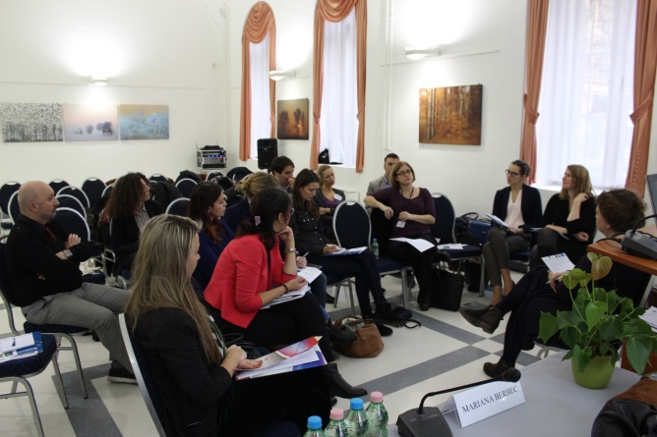The working group strategic litigation was facilitated by **Lilla Farkas** from the European University Institute in Italy. The workshop discussed the goals of strategic litigation, noting that it could be issue-driven, prioritising reaching legal clarity and legal reform on difficult issues, or client-driven, aiming to assist victims of the most blatant violations of equal treatment. Participants looked at the different fora where strategic litigation can take place (national courts, Court of Justice of the EU, European Court of Human Rights), and the allies equality bodies can work with when sourcing cases and litigating. Ms. Farkas argued that Equinet as a network of equality bodies could take an active role in strategic litigation at the European level. Participants discussed different ways of achieving this, including the submission of third-party interventions to the European Court of Human Rights (with Equinet already working on a pilot project to this end), or getting involved in litigation at the national level in order to have the standing to be involved in cases referred to the Court of Justice of the EU.

**Lilla Farkas’s presentation is available** [**here**](http://www.equineteurope.org/Equinet-Seminar-Fighting-discrimination-on-grounds-of-race-and-ethnic-origin)**.**

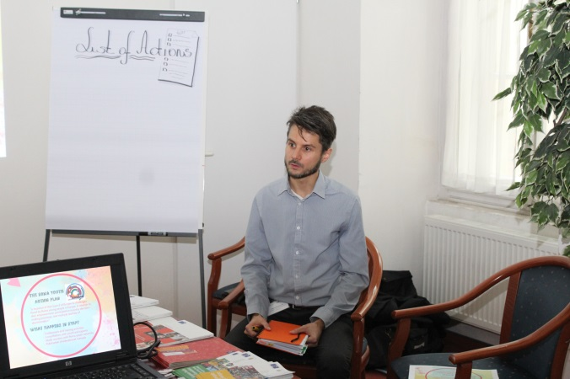The working group on awareness raising and education was facilitated by **Laszlo Milutinovits** from the European Youth Centre in Budapest. After explaining the role of the European Youth Centre and their important work in the field of human rights education, Mr. Milutinovits introduced different initiatives aimed at raising rights awareness and reducing discrimination, such as the No Hate Speech campaign and the Roma Youth Action Plan. Working group participants then shared their own initiatives in the field and developed action points on how to engage in successful awareness raising campaigns.

1. It is important to gather knowledge of the society a person lives and works in in order to identify a target group.
2. The needs of the target group need to be identified, for example through public consultations with relevant stakeholders.
3. Equality bodies need to have the necessary internal expertise to develop the campaign.
4. Partnerships with other actors, such as non-governmental organisations, the media, employers or schools should be established to give the campaign greater visibility.
5. The campaign needs to be produced and shared with relevant stakeholders.

**Laszlo Milutinovits’s presentation is available** [**here**](http://www.equineteurope.org/IMG/pdf/milutinovits.pdf)**.**

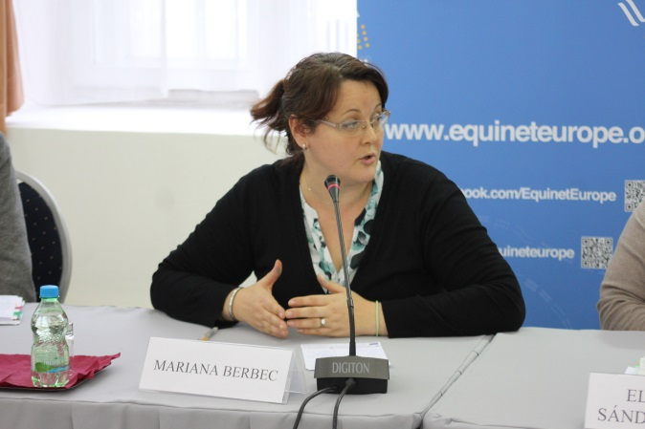The working group on NGO cooperation and Roma empowerment was facilitated by **Mariana Berbec** from Open Society Foundation in Hungary. After explaining Open Society Foundation’s work in the field, participants discussed the synergies between cooperation with NGOs and Roma empowerment. Based on their experience at national level, the working group participants created a list of important points to keep in mind when cooperating with NGOs.

* Finding the time for face-to-face meetings with relevant partners and groups instead of mere email exchange or telephone calls,
* Translating relevant documents and case decisions into the language of the target group when dealing with minorities,
* Joining other organisations in awareness raising campaigns for greater visibility,
* Using storytelling,
* Organising capacity-building activities, and
* 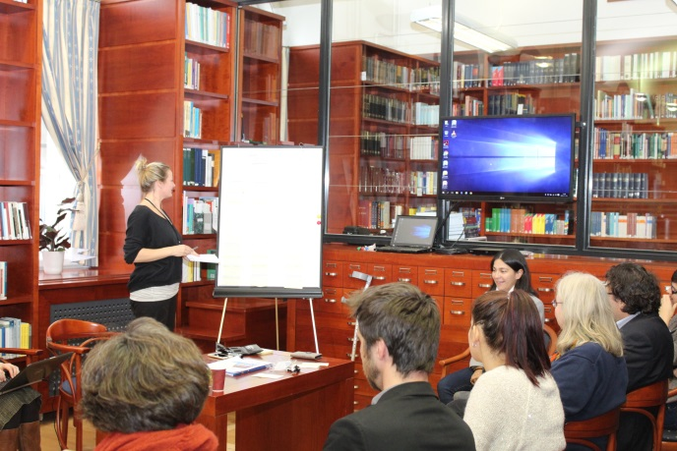Encouraging organisations to make use of traineeships to overcome the lack of human resources while at the same time offering young people the possibility to learn and gain experience.

The working group on training was facilitated by **Barbara Bos** from the Netherlands Institute for Human Rights. Having explained the training on stereotypes during Session 3, working group participants shared their own experience from trainings conducted in the past. While equality bodies are engaged in different interesting training initiatives, the importance on following up on the actual impact in the weeks after the training is of great importance for its overall success. An important consideration for increasing the impact of trainings is also to hire a professional trainer to conduct the training. The main challenges identified in providing training to different stakeholders were the limited time for which the training is usually foreseen, the importance of making the training specific enough to be useful and to follow-up on its impact and track the changes that result from the training itself.

## CLOSING SESSION

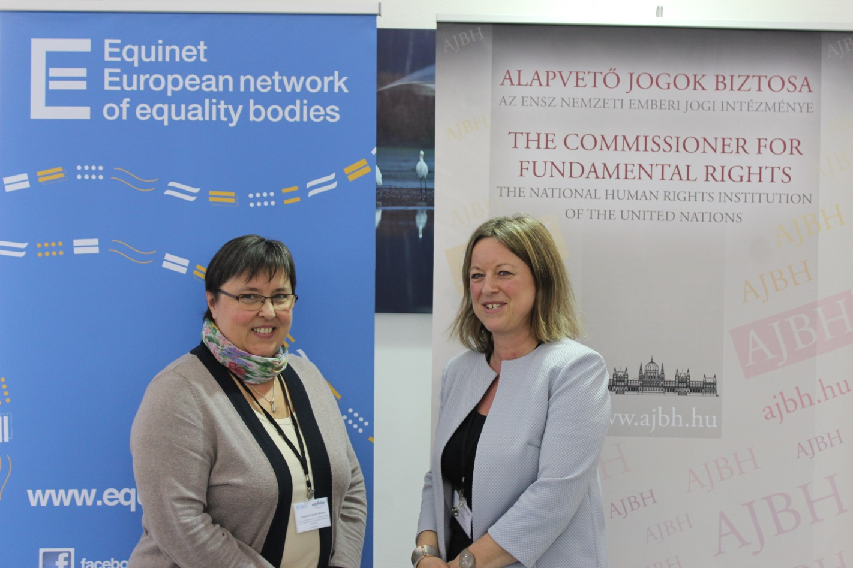

**Elisabeth Sándor-Szalay**, Deputy Commissioner for Fundamental Rights and Ombudswoman for the Rights of National Minorities in Hungary closed the seminar by thanking the participants for their active participation and everyone organising the Seminar for their involvement. She summarized some key issues raised during the presentations and workshops and reminded the participants of the crucial role equality bodies play in combating discrimination on the grounds of race and ethnic origin within their national context.

**Anne Gaspard**, Equinet Executive Director, thanked the participants and the speakers of the Seminar and addressed a particularly warm thank you to the Office of the Commissioner for Fundamental Rights for co-hosting and providing crucial support for the organization of the Seminar. Ms. Gaspard also thanked the working group *Equality Law* for drafting the discussion paper on *Fighting Discrimination on the Grounds of Race and Ethnic Origin* and highlighted some important developments and upcoming events in the work and governance of Equinet.