EQUINET CONFERENCE
Diverse, Inclusive and Equal: Innovating at the intersections of gender equality

Wednesday 7th December 2016 (09:30 – 17:00)

LOCATION: Institute for the Equality of Women and Men
Rue Ernest Blerot 1 - 1070 Brussels, Belgium

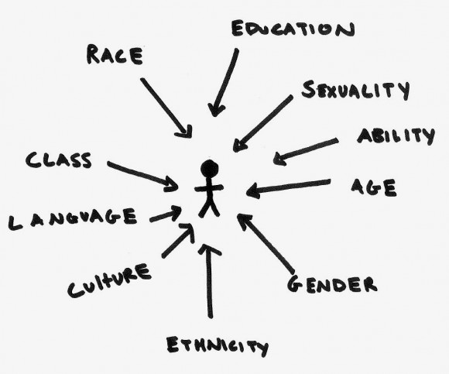

TRAVEL GUIDE

EQUINET TRAVEL COSTS COVERAGE AND REIMBURSEMENTS

FLIGHTS UP TO 300 EURO!

It is the policy of Equinet to cover the costs (flights, local transportation, subsistence…) incurred by participants from member organizations and speakers during its events.

In order to control flight costs, Equinet will cap reimbursement of participants’ flights at 300 EURO, unless prior booking authorization has been granted by the Equinet Secretariat for a more expensive ticket. If you are unable to find a flight cheaper than 300 EURO, please contact the Equinet Secretariat for assistance:

Yannick Godin
Tel: +32.2.212.31.82
yannick.godin@equineteurope.org

Reimbursements are only possible when an original Equinet reimbursement form has been correctly filled in and sent to the Equinet Secretariat.

ORIGINAL expenses proofs (receipts, invoices…) and Boarding passes (both ways) have to be attached to the reimbursement form for the expenses to be taken into account.
Any undocumented expense will be disregarded.

In order to facilitate internal processing, we would kindly request participants to send their reimbursement forms to the Equinet Secretariat as soon as possible. Any form receive after the final deadline for documents submission (23 December 2016) might be disregarded.

IF EQUINET HAS BOUGHT YOUR AIR TICKET, PLEASE MAKE SURE TO SEND YOUR ORIGINAL BOARDING PASSES BACK BY REGULAR MAIL!
VENUE


The meeting will be held on Wednesday 7 December from 09:30 to 17:00 in Room STORCK at Institute for the Equality of Women and Men.
Address:
Rue Ernest Blerot 1
1070 Brussels
Belgium

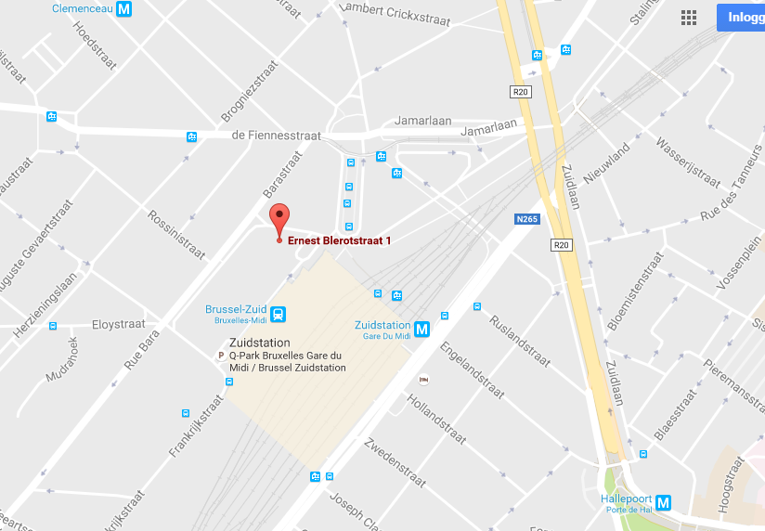

WELCOME AND REGISTRATION
The event is taking place in room STORCK. Someone from the Equinet Secretariat will accompany you to the room.

Lunch and refreshments will be provided during the event.

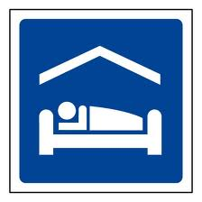
ACCOMMODATION

Most Equinet Members’ representatives will be hosted at:

Park Inn
Place Marcel Broodthaers 3
1060 Brussels
Tel: +32 (2) 535 14 00

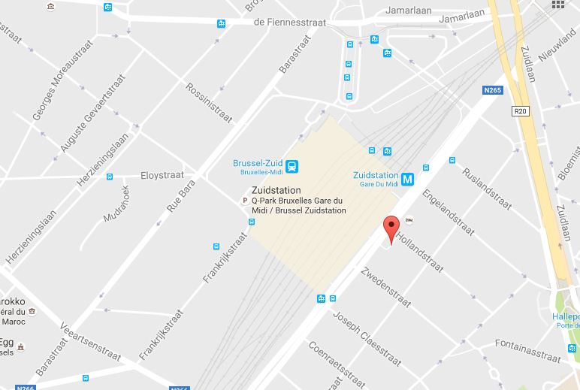

Others will stay at the Pullman Midi Station, which is located inside the Midi train station and in front of the meeting venue building:

Pullman Midi Station
Place Victor Horta 1
1060 BRUSSELS
BELGIUM
Telephone: (+32)25289800
Email: H7431@accor.com
DIRECTIONS TO HOTEL


Directions from Airports & Train Stations to Hotel

Arriving by Train
From ‘Gare Central’ (Central station)
There are direct trains from Gare Central to Gare du Midi, which take less than 10 minutes and go several times an hour.
You can also take metro 1 or 5 (Direction Weststation or Erasmus) and change at Beekkant metro station and into metro 2 or 6 (Direction Elisabeth) until Place Marcel Broodthaers. The Park Inn Hotel is located on Place Marcel Broodthaers 3. The trip will take about 20 minutes.
From ‘Gare du Midi’ (South Railway station)

The Park Inn Hotel is located on Place Marcel Broodthaers 3, right next to Gare du Midi. The Pullman lies inside the station, towards the Horta exit.


Brussels International Airport (Zaventem)
Through Gare du Midi Train Station (20-25 minutes):
You can take the train at the Airport and stop at Gare du Midi (25 minutes). Trains go several times an hour. The Park Inn Hotel is located on Place Marcel Broodthaers 3, right next to Gare du Midi. The Pullman lies inside the station, towards the Horta exit.

Brussels South Charleroi Airport

Every 30 minutes a shuttle coach leaves the airport to take you to the main Brussels railway station (Brussels Midi). Shuttle tickets are sold outside the airport terminal. You can also buy tickets in advance and at a better price online. For more information see http://www.charleroi-airport.com/en/raccourcis-booking/brussels-city-shuttle/

The Park Inn Hotel is located on Place Marcel Broodthaers 3, right next to Gare du Midi. The Pullman lies inside the station, towards the Horta exit.

DIRECTIONS FROM THE HOTELS TO THE VENUE

The venue (Institute for the Equality of Women and Men, Rue Ernest Blerot 1) is only a short walk from the Park Inn Hotel where participants will be accommodated, on the other side of the Gare du Midi Railway station. From the Pullman, you just need to exit the hotel on Place Victor Horta and walk 50 meters straightforward.

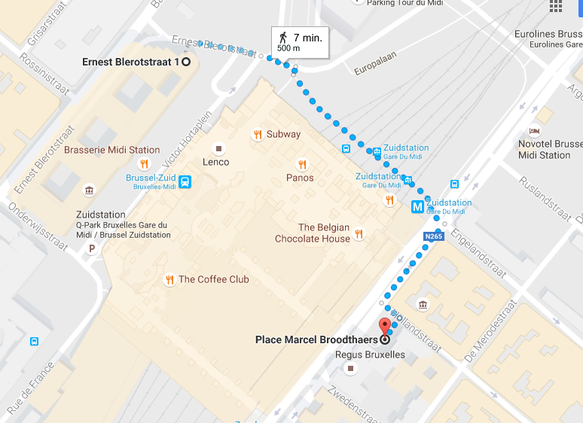

Participants are encouraged to use public transport. The use of taxis can only be reimbursed by Equinet in exceptional circumstances.

Further Questions?  Contact the Equinet Secretariat | Yannick Godin (Administration and Finance Officer)  Tel: + 32 472 69 60 65  Email: Yannick.Godin@equineteurope.org  Katrine Steinfeld (Policy Officer)  Tel: +32 465 51 86 98  Email: Katrine.Steinfeld@equineteurope.org

