

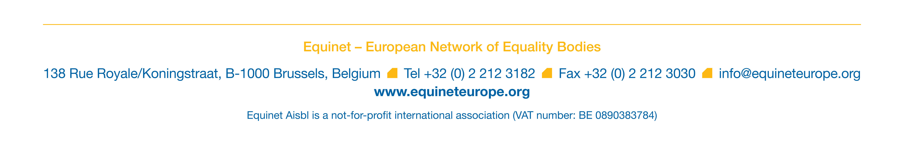
EQUINET ANNUAL GENERAL MEETING
29-30 SEPTEMBER 2016

DELEGATION OF VOTING RIGHTS (PROXY VOTING)

Ms / Mr

First Name:
Family Name:
Position:
Name of Organisation:
Country:

Hereby confirms that:

- Our organization will not be represented at the Equinet Annual General Meeting (AGM) 2016.

- In conformity with the Equinet statutes, our organization has decided to delegate its voting rights at the Equinet AGM 2016.

- Contact has been made with the following person who will be attending the Equinet AGM 2016 as a representative of another Equinet Member Organization and who has accepted our request to vote on our behalf and according to our instructions:

Ms / Mr

First Name:
Family Name:
Position:
Name of Organisation:
Country:

Please send this document correctly filled-in, signed and dated by no later than 27 September 2016 at 1 p.m.

- by email to Jessica.machacova@equineteurope.org
- by fax to: +32 2 212 30 30

Signature Date / / 2016

