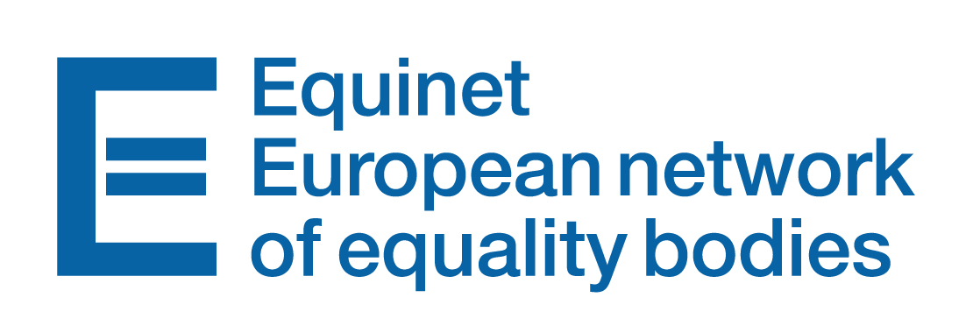
DRAFT AGENDA
EQUINET TRAINING SESSION
“Communicating Equality: Social media for equality bodies”
Thursday 13th October and Friday 14th October
Location: TBC, Dublin, Ireland
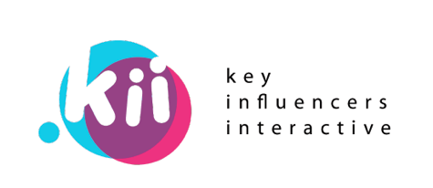

Training session delivered by

OBJECTIVES OF THE TRAINING SESSION
The training session aims to:
- Help Equinet members to use social media in a more strategic way
- Share best practice and learn from ideas from both the public and commercial sphere
- Outline the possibilities of social media tools (monitoring, publishing, analysis)
- Learn about new trends and platforms
- Get an introduction to the paid social media channels
- Learn how to deal with negative aspects of social media

AGENDA
13 OCTOBER 2016
08:45 – 09:00 | Welcome and registration of participants
09:00 – 09:15 | Opening address
09:15 - 09:45 | Presentation of the programme and Tour de Table  Adam Zbiejczuk and Jaroslav Faltus, Key Influencers Interactive
09:45 – 11:00 | SESSION 1: How to approach social media in a strategic way  - Planning your social media schedule  - Setting the work flow  - Reporting on social media use  - Including social media in a general communication strategy
11:00 – 11:30 | Coffee Break
11:30 – 12:45 | SESSION 2: Trends in social media  - The new possibilities of social media  - Trends on Facebook  - How to use paid ads on Facebook efficiently  - Business Manager, FB Pixel  - New social media platforms
12:45 – 13:45 | Lunch
13:45 – 15:00 | SESSION 3: Catchy content and trends  - What kind of content is king?  - Identifying the trends  - Working with Ambassadors  - Killer content plan
15:00 – 15:30 | Coffee Break
15:30– 16:15 | SESSION 4: Other Social Media Platforms  - Twitter  - Linked In  - Youtube
16:15 – 17:30 | WORKSHOP 1: Practices of Equality Bodies  Members are invited to share examples of their social media work (successes and challenges)
17:30– 17:45 | Summary of Day 1 and any other updates
 | Social Event
14 OCTOBER 2016
09:00 – 10:15 | SESSION 5: Successful Campaigns  - Contests and campaigns in social media and beyond  - How to target different audiences  - Best practices (Tips & tricks)
10:15– 11:20 | SESSION 6: Tackling negativity & Monitoring  - Fighting negative comments on your pages  - Monitoring social media
11:20 – 11:40 | Coffee Break
11:40 – 12:40 | WORKSHOP 2: Let’s try the tools
12:40 – 13:20 | SESSION 7: Manual on Social Media for Equality Bodies  - Group discussion about how they would to further develop the manual
13:20 – 13:30 | Conclusions  - Final questions from participants
13:30 -14:30 | Goodbye Lunch

