European Journalist Award on Diversity 2016

**Confluence - collaborative Platform**

**Guidelines**

Introduction: The tool - Confluence 2

What is a wiki? 2

Why use a wiki? 2

How to post your articles 3

STEP 1: Create an account or use your existing ECAS account 3

STEP 2: send your ECAS UID to the following address 3

How to find my ECAS UID? 3

STEP 3: Connect to confluence 4

Go to the following link : 4

STEP 4: Post your articles and comment if needed 4

Clic on your country 4

Add content by adding a link or a file 5

Add comment if needed 5

Helpdesk 5

# Introduction: The tool - Confluence

## What is a wiki?

A wiki is a website which allows collaborative modification of its content and structure directly from the web browser.

Example of wiki: Wikipedia

## Why use a wiki?

<https://youtu.be/xu6p6bPjokc>

# How to post your articles in 4 steps

## STEP 1: Create an account or use your existing ECAS account

* Create an ECAS account: https://ecas.ec.europa.eu/cas/eim/external/register.cgi
* Go to <https://webgate.ec.europa.eu/fpfis/wikis/display/EUJournalistAward>
* Discuss and post!

## STEP 2: send your ECAS UID to the following address

[EJAD_helpdesk@tipik.eu](mailto:EJAD_helpdesk@tipik.eu)

You will be added to the team.

### How to find my ECAS UID?

* Login to your ECAS account: https://ecas.ec.europa.eu/cas/login
* Click on My account
* Click on My ECAS account detail

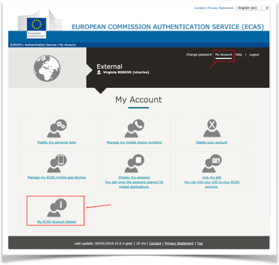

* Copy your Unique identifier at the Commission (uid)

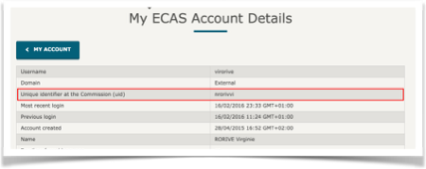

## STEP 3: Connect to confluence

### Go to the following link :

<https://webgate.ec.europa.eu/fpfis/wikis/display/EUJournalistAward/European+Journalist+Award+Home>

## STEP 4: Post your articles and comment if needed

Add content in your country section

### Click on your country

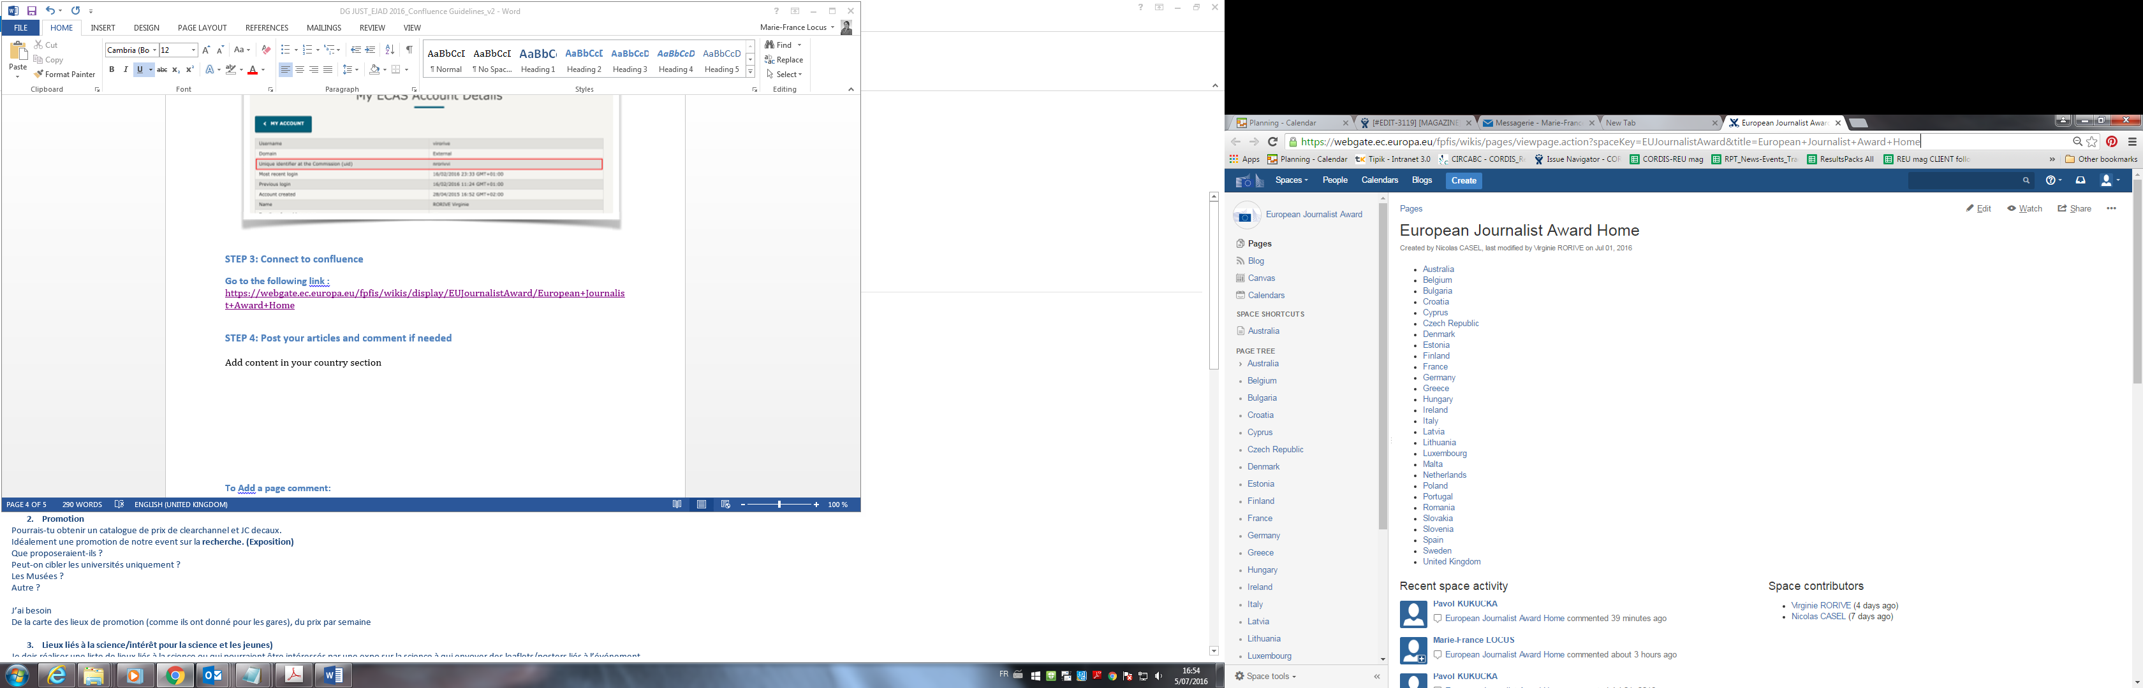

### Add content by adding a link or a file

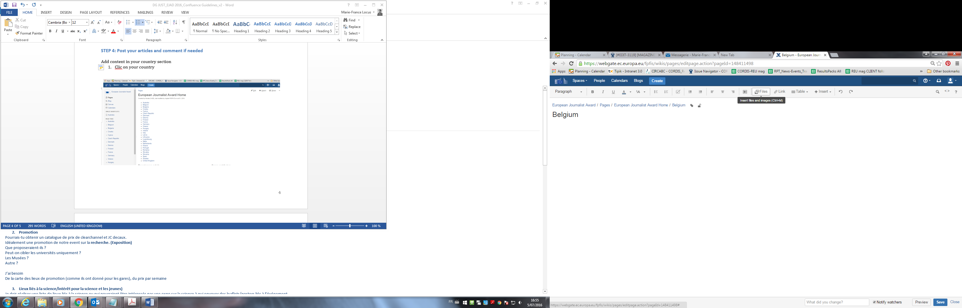

### Add comment if needed

##### To Add a page comment:

* **Type your comment** in the comment field at the bottom of the page
* Optionally, choose **Preview** to see how your comment will appear
* By default, Watch this page is ticked (This means you'll start receiving notifications about the page. Uncheck it if you don't want to watch the page.)
* Choose **Save** (Ctrl+S or ⌘+S)
* Other users can **reply** and/or **like** your comment

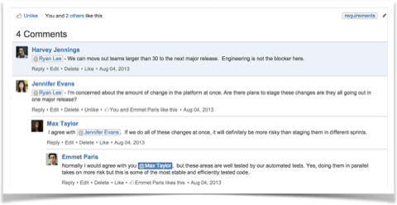

# Helpdesk

EJAD_Helpdesk@tipik.eu