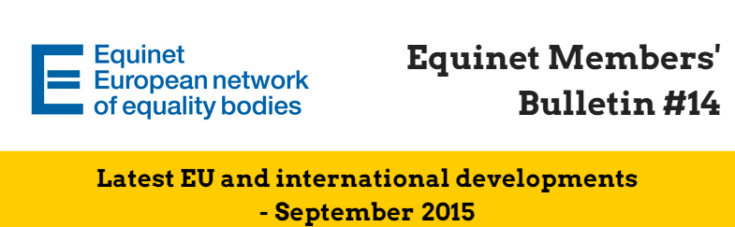**Dear Equinet Members,**This Members’ Bulletin gathers **the latest European Union (EU) and international developments**. It aims to give you an **overview of relevant policy and legal developments**, as well as latest calls for interest, funding opportunities and upcoming events. We very much hope this members’ bulletin will be useful in your day-to-day work and we would be grateful if you could **disseminate it among your colleagues**. Your feedback is also greatly appreciated. Should you have any comments or further questions, **please do not hesitate to contact Jessica Machacova, Equinet Project Officer** ([Jessica.machacova@equineteurope.org](mailto:Jessica.machacova@equineteurope.org) / 0032 2 212 31 80).

**Equinet Members’ Bulletin on latest EU and international developments – Table of contents**

***(Ctrl + Click to follow the link)***

**Highlight 1: The European Commission issues new roadmap on Work-Life Balance**

**Highlight 2: EU Commissioner for Justice, Consumers and Gender Equality Vera Jourova meets with Equinet** **Chair and Executive Director**

**Thematic Policy Developments**

* General
* Gender Equality
* Disability
* Age

**Publications, funding opportunities and events**

* General information
* Gender Equality
* Religion and Belief

# Highlight 1: The European Commission issues new roadmap on Work-Life Balance

On the 28th of August 2015, the European Commission issued a **Roadmap** entitled: ‘*New start to address the challenges of work-life balance faced by working families*’. The publication of this document by the EC follows the **withdrawal**, in July 2015, of the **2008 draft Maternity Leave Directive**, given the lack of progress by the co-legislators and despite the Commission's continuous and intensive efforts to facilitate an agreement.

*“The main reason behind the initiative is to address the low participation of women in the labour market by modernising and adapting the current EU legal and policy framework to today's labour market to allow for parents with children or those with dependent relatives to better balance caring and professional responsibilities”*

The roadmap is based on a **mix of legislative and non-legislative measures** to reach this objective, and offers notably to generalise ‘the existing rights to request flexible working arrangements to both parents and women and men with caring responsibilities and strengthening the enforcement of those rights’ or to launch a comprehensive policy framework ‘to address a wider range of policies that will support parents’ participation in the labour market’.

- Read [our full article](http://www.equineteurope.org/The-European-Commission-s-new) **on the Roadmap**  
- Access the Roadmap [here](http://ec.europa.eu/smart-regulation/roadmaps/docs/2015_just_xxx_maternity_leave.en.pdf)   
- Read about **our Seminar held in Tallinn** in July 2015 ‘Work-Life Balance and Pregnancy and Parenthood related Discrimination’ [here](http://www.equineteurope.org/Work-Life-Balance-and-Pregnancy-682)   
- Read **Equinet’s Perspective** “Equality Bodies promoting a better Work-Life Balance for all” [here](http://www.equineteurope.org/Equality-Bodies-promoting-a-better)

# Highlight 2: EU Commissioner for Justice, Consumers and Gender Equality Věra Jourová meets with Equinet Chair and Executive Director

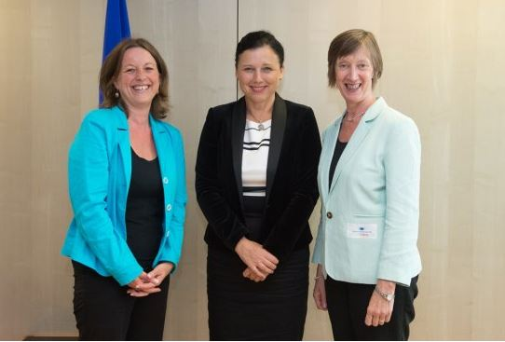

On 27th August 2015, Equinet Chair **Evelyn Collins**, Executive Director **Anne Gaspard** and Project Officer **Jessica Machacova** met the EU Commissioner for Justice, Consumers and Gender Equality **Věra Jourová.**

This introductory meeting aimed to **present the role of Equinet and equality bodies and exchange on current EU priorities in relation to equality and non-discrimination**.

[Věra Jourová](http://ec.europa.eu/commission/2014-2019/jourova_en) started the meeting by **presenting current EU priorities** and in particular, the [new **Roadmap on Work-Life Balance**](http://ec.europa.eu/smart-regulation/roadmaps/docs/2015_just_xxx_maternity_leave.en.pdf) published by the European Commission in July 2015. Other policy priorities mentioned were the proposals on the [**EU Equal Treatment Directive**](http://www.equineteurope.org/Joint-appeal-for-European) and [**Women on Boards Directive**](http://ec.europa.eu/justice/newsroom/gender-equality/news/121114_en.htm).

Evelyn Collins presented the crucial **role of equality bodies as watchdogs for equality in implementing the EU legislation and assisting citizens that are victims of discrimination**. She underlined the **need for clear standards for equality bodies** in order to secure their independence and powers.

Equinet warmly thanks Commissioner Jourová and her cabinet for the meeting and very much looks forward to continuing this fruitful cooperation in the future.

Read our **full article** on the meeting [here](http://www.equineteurope.org/EU-Commissioner-for-Justice).

# Thematic Policy Developments

## General

**EUROPEAN COMMISSION: President of the European Commission Jean-Claude Juncker delivers first State of the Union speech**

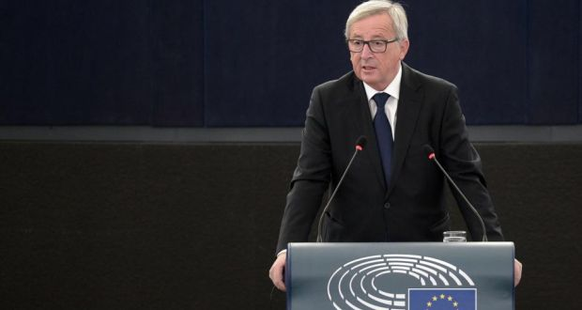On 9th September 2015, Jean-Claude Juncker, President of the European Commission, delivered **the first State of the Union speech** in front of the European Parliament in Strasbourg, France. On this occasion, Jean-Claude Juncker called on Member States to further cooperate on asylum policies and to adopt the relocation plan of 160,000 refugees which will be discussed at the Extraordinary Council of Interior Ministers on Monday, 14th September.

**The full text of the speech is available** [**here**](http://europa.eu/rapid/press-release_SPEECH-15-5614_en.htm)**.**

**EUROPEAN PARLIAMENT: Resolution of 8th September 2015 on the Situation of Fundamental Rights in the EU (2013-2014)**

On 8th September 2015, the European Parliament adopted the final version of the report on the Situation of Fundamental Rights in the EU 2013-2014. The report calls on the European Commission to adopt **an internal strategy on fundamental rights** in the “near future”. It also urges the Council of the EU to adopt the **horizontal Equal Treatment Directive** as soon as possible.

**On two occasions, the report makes specific references to equality bodies**:

* “Point BK. Whereas the effectiveness of specialised institutions such as **national human rights institutions or equality bodies is important to help citizens better enforce their fundamental rights** to the extent that Member States apply EU law;”
* “Point 143. Calls on the EU institutions and the Member States to recognise that long-term investment in social inclusion is beneficial, as it tackles the high cost of discrimination and inequality; calls on the Member States for appropriate public investment to sustain education and healthcare and ensure that access to justice and redress in cases of discrimination are not put in **danger by drastic funding cuts in equality bodies’ budgets**; calls on EU and national institutions not to undermine social inclusion by budgetary measures affecting the functioning of community-based organisations working for equality;”

**The full report is available** [**here.**](http://www.europarl.europa.eu/sides/getDoc.do?pubRef=-//EP//TEXT+TA+P8-TA-2015-0286+0+DOC+XML+V0//EN&language=EN) **A summary of the report can also be found** [**here**](http://www.europarl.europa.eu/oeil/popups/summary.do?id=1397436&t=d&l=en)**.**

**COUNCIL OF THE EUROPEAN UNION: Publication of the updated proposal of Horizontal/Equal Treatment Directive**

A consolidated version of the proposal for a Council Directive on implementing the principle of equal treatment between persons irrespective of religion or belief, disability, age or sexual orientation has been made public. It is available [here](http://data.consilium.europa.eu/doc/document/ST-9010-2015-INIT/en/pdf).

## Gender Equality

**EUROPEAN PARLIAMENT: Resolution of 9th September 2015 on empowering girls through education in the EU**

On 9th September 2015, the European Parliament adopted the final version of the report **“Empowering girls through education in the EU”**. The report provides recommendations to the EU and Member States to include a gender equality perspective in all educational systems. It calls on Member States to **address gender stereotypes, ensure equal access to education and develop an intercultural approach to education**.

**The full text of the report can be found** [**here**](http://www.europarl.europa.eu/sides/getDoc.do?pubRef=-//EP//TEXT+TA+P8-TA-2015-0312+0+DOC+XML+V0//EN&language=EN)**.**

## Disability

**UNCRPD – the UN Committee publishes its first concluding observations to the EU**

**On 27th and 28th August 2015, the UN Committee held a Constructive Dialogue with the EU delegation on the EU’s work on the UN Convention on the Rights of Persons with Disabilities (UN CRPD), the first international human rights treaty ever ratified by the EU.**

**According to the FRA, ‘***This session is particularly important for the EU. It marks the first time that the Union has been reviewed by a UN human rights treaty body. Not only that, it marks an important step in gaining the feedback the EU needs to ensure that the rights of persons with disabilities are fully implemented in all its Member States*.’

The EU delegation consisted of **Michel Servoz**, Director-General of the Commission’s DG Employment, Social Affairs and Inclusion, and his colleagues of the **UN CRPD focal point of the European Commission**, the **Disability Unit of DG Employment, Social Affairs and Inclusion**. 20 representatives out of the 28 Member States of the EU were also present as observers.

In September 2015, the UN Committee published its concluding observations. Among the main recommendations addressed to the EU, we can mention:

*“17. The Committee recommends that the European Union regularly update the* ***Declaration of Competence*** *and its list of instruments to include recently adopted instruments and those instruments that have no specific reference to disability but that are relevant to persons with disabilities.”*

“19**.** *The Committee recommends that the European Union adopt its proposed* ***horizontal Equal Treatment Directive*** *extending protection from discrimination to persons with disabilities, including by the provision of reasonable accommodation, to all areas of competence. Furthermore, the Committee recommends that the European Union ensure discrimination in all aspects based on disability is prohibited, including multiple and intersectional discrimination.”*

“29. *The Committee recommends that the European Union take efficient measures for prompt adoption of an amended* ***European Accessibility Act*** *that is aligned to the Convention, as elaborated in the Committee’s General comment No. 2 (2014) on accessibility, including effective and accessible enforcement and complaint mechanisms. It further recommends that the European Union ensure participation of persons with disabilities, through their representative organisations, in the process of adoption of the Act.”*

“77. *The Committee recommends that the European Union take measures to decouple the European Commission’s roles - by its removal from the* ***independent monitoring framework*** *- to ensure full compliance with the* ***Paris principles****, and that the latter has adequate resources to perform its functions. It further recommends that the European Union consider the establishment of an inter-institutional coordination mechanism and designation of focal points in each EU institution, agency and body.”*

As a next step, within one year, the European Commission has to provide written information on the measures taken to implement the recommendations **17, 29 and 77**. The EU has to submit its next periodic implementation report **by January 2019.**

The full **concluding recommendations** can be found [here](http://tbinternet.ohchr.org/_layouts/treatybodyexternal/Download.aspx?symbolno=CRPD%2fC%2fEU%2fCO%2f1&Lang=en).   
An **internal note** summarising main recommendations is available on the [Equinet Members’ Area](http://www.equineteurope.org/Internal-Equinet-Note-recent-EU).

## Age

**EUROPEAN PARLIAMENT: Resolution of 9th September 2015 on the Report on the implementation, results and overall assessment of the 2012 European Year for Active Ageing and Solidarity between Generations**

On 9th September 2015, the European Parliament adopted the final version of the report on the implementation, results and overall assessment of the 2012 European Year for Active Ageing and Solidarity between Generations.

**The full report can be found** [**here**](http://www.europarl.europa.eu/sides/getDoc.do?pubRef=-//EP//TEXT+TA+P8-TA-2015-0309+0+DOC+XML+V0//EN&language=EN)**.**

# Publications, funding opportunities and events

## General information

**CALL FOR TENDERS** – [European Union Agency for Fundamental Rights (FRA): Data collection and research services on fundamental rights issues: FRANET Lot 26 Sweden](http://fra.europa.eu/en/call-for-tender/2015/data-collection-and-research-services-fundamental-rights-issues-franet-lot-26?_cldee=YW5uZS5nYXNwYXJkQGVxdWluZXRldXJvcGUub3Jn&urlid=0) *(Deadline: 30th September 2015)*

**CALL FOR PROPOSALS** – European Commission: [Action grants to support transnational projects on promoting the quality of the national justice systems](http://ec.europa.eu/justice/grants1/calls/2015_action_grants/just_2015_jacc_ag_qual_en.htm) *(Deadline: 13th October 2015)*

**CALL FOR PROPOSALS** – European Commission:[Action grants to support projects to enhance the rights of persons suspected or accused of crime](http://ec.europa.eu/justice/grants1/calls/2015_action_grants/just_2015_jacc_ag_proc_en.htm) *(Deadline: 28th October 2015)*

**SAVE THE DATE – European Commission: 6th EU Diversity Charters Annual Forum - 'Multipliers and actors in diversity management: moving to the next level' (28th October 2015, Luxembourg, Luxembourg)** “This years' Forum will focus on **multipliers in diversity management and the role that actors like public sector and media play in it**. The Annual Forum brings together around 150 diversity experts, public sector and media representatives from the EU Member States to discuss the benefits of diversity in the workplace and how to develop the diversity management further.”   
More information is available [here](http://ec.europa.eu/justice/events/diversity-annual-forum-2015/index_en.htm).

**SAVE THE DATE** **- Next meetings of the FRA and the Council of Europe-FRA-EQUINET-ENNHRI Platforms**

* **Thursday 15th October 2015** – Thematic Platform Social Rights (Council of Europe, Strasbourg, France) *(preceded by the meeting of Equinet Policy Formation Working Group on Wednesday 14th October)*
* **Thursday 19th and Friday 20th November** - FRA meeting with national stakeholders (Vienna, Austria)
* **Thursday 3rd and Friday 4th December 2015** – Operational Platform for Roma Equality (OPRE – Council of Europe, Strasbourg, France)

## Gender Equality

**CALL FOR PROPOSALS –** European Commission: [Action grants to support transnational projects to combat sexual harassment and sexual violence against women](http://ec.europa.eu/justice/grants1/calls/2015_action_grants/just_2015_rdap_ag_sexv_en.htm)*(Deadline: 13thOctober 2015)*

**PUBLICATION – European Parliament: Study on Maternity, Paternity and Parental leave**Upon request by the FEMM (Women’s Rights and Gender Equality) Committee, the Policy Department C: Citizens' Rights and Constitutional Affairs has developed a number of figures **visualizing duration of and compensation rates of previous incomes during maternity, paternity and parental leave in the Member States of the European Union**. The study is available [here](http://www.europarl.europa.eu/RegData/etudes/STUD/2015/509999/IPOL_STU(2015)509999_EN.pdf).

**PUBLICATION** – **European Parliament: Reports on the policy on gender equality in Poland, Belgium, Czech Republic, France, Germany, Latvia, Slovenia and Sweden.**   
Upon request by the FEMM Committee, the European Parliament published six new reports covering the recent developments in gender equality policies in [Czech Republic](http://www.europarl.europa.eu/RegData/etudes/IDAN/2015/510009/IPOL_IDA(2015)510009_EN.pdf), [France](http://www.europarl.europa.eu/RegData/etudes/IDAN/2015/510024/IPOL_IDA(2015)510024_EN.pdf), [Germany](http://www.europarl.europa.eu/RegData/etudes/IDAN/2015/510025/IPOL_IDA(2015)510025_EN.pdf), [Latvia](http://www.europarl.europa.eu/RegData/etudes/IDAN/2015/510008/IPOL_IDA(2015)510008_EN.pdf), [Slovenia](http://www.europarl.europa.eu/RegData/etudes/STUD/2015/510010/IPOL_STU(2015)510010_EN.pdf) and [Sweden](http://www.europarl.europa.eu/RegData/etudes/STUD/2015/510011/IPOL_STU(2015)510011_EN.pdf).   
The Gender Equality papers on [Poland](http://www.europarl.europa.eu/RegData/etudes/IDAN/2015/510023/IPOL_IDA(2015)510023_EN.pdf) and [Belgium](http://www.europarl.europa.eu/RegData/etudes/IDAN/2015/519192/IPOL_IDA(2015)519192_EN.pdf) were also updated.

**PUBLICATION - Council of Europe: New brochure on European Standards on Gender Equality and Women’s Rights**The Gender Equality Unit has published a [new brochure](http://www.coe.int/t/dghl/standardsetting/equality/01ataglance/standards-mechanisms/Fachsheet%20Key%20standards.pdf) bringing together the main Council of Europe instruments on gender equality and women’s rights. The brochure is accessible [here](http://www.coe.int/t/dghl/standardsetting/equality/01ataglance/standards-mechanisms/Fachsheet%20Key%20standards.pdf).

## Religion and Belief

**SAVE THE DATE – European Commission Annual Colloquium on Fundamental Rights, Brussels, 1st and 2nd October 2015**

The Vice President of the European Commission, **Frans Timmermans**, in cooperation with EU Commissioner for Justice, Consumers and Gender Equality, **Věra Jourová**, will host the first Annual Colloquium on fundamental rights in the EU.

For this first edition the central theme will be: ‘**Tolerance and respect: preventing and combating antisemitic and anti-Muslim hatred in Europe**’.

The Colloquium will be held in Brussels and will bring together a selected number of high level participants from across the EU: national Ministers, representatives of leading NGOs and international institutions, MEPs and renowned academics and philosophers. **Christine Lüders**, Director of the German Federal Anti-Discrimination Agency and **Evelyn Collins**, Chair of the Equinet Executive Board and Chief Executive of the Equality Commission for Northern Ireland, have been invited to attend this important event as speaker and as rapporteur, respectively.

**More information on the Colloquium as well as the latest draft agenda can be found** [**here**](http://ec.europa.eu/justice/events/colloquium-fundamental-rights-2015/index_en.htm)

## Sexual Orientation and Gender Identity

**PUBLICATION – United Nations – Office of the High Commissioner for Human Rights – Factsheet on the rights of intersex people**   
In the context of the “Free & Equal” Campaign, the Office of the UN High Commission for Human Rights published [a factsheet](https://www.unfe.org/en/actions/intersex) on the rights of intersex people.