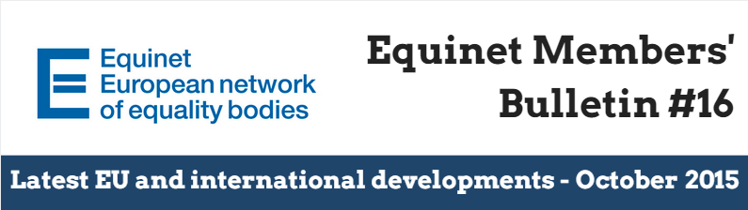

**Dear Equinet Members,**This Members’ Bulletin gathers **the latest European Union (EU) and international developments**. It aims to give you an **overview of relevant policy and legal developments**, as well as latest calls for interest, funding opportunities and upcoming events. We very much hope this members’ bulletin will be useful in your day-to-day work and we would be grateful if you could **disseminate it among your colleagues**. Your feedback is also greatly appreciated. Should you have any comments or further questions, **please do not hesitate to contact Jessica Machacova, Equinet Project Officer** ([Jessica.machacova@equineteurope.org](mailto:Jessica.machacova@equineteurope.org) / 0032 2 212 31 80).

**Equinet Members’ Bulletin on latest EU and international developments – Table of contents**

***(Ctrl + Click to follow the link)***

**Highlight: Latest Updates - Discrimination on the Ground of Religion or Belief**

* 1st and 2ndOctober 2015: First Annual Colloquium on Fundamental Rights on combatting antisemitism and anti-Muslim hatred
* FRA publishes overview on Anti-Semitism in the EU
* Equinet Perspective “A Growing Agenda: The Work of Equality Bodies on the Ground of Religion or Belief”
* Equinet Seminar “A question of faith. Religion and belief in the work of equality bodies”

**Thematic Policy Developments**

* General information

**Publications, funding opportunities and events**

* General information
* Gender Equality
* Disability
* Age

**Recent case-law**

* European Court of Justice (ECJ)
* European Court of Human Rights (ECHR)

# Highlight: Latest Updates - Discrimination on the Ground of Religion or Belief

## 1st and 2nd October 2015: First Annual Colloquium on Fundamental Rights on combatting antisemitism and anti-Muslim hatred

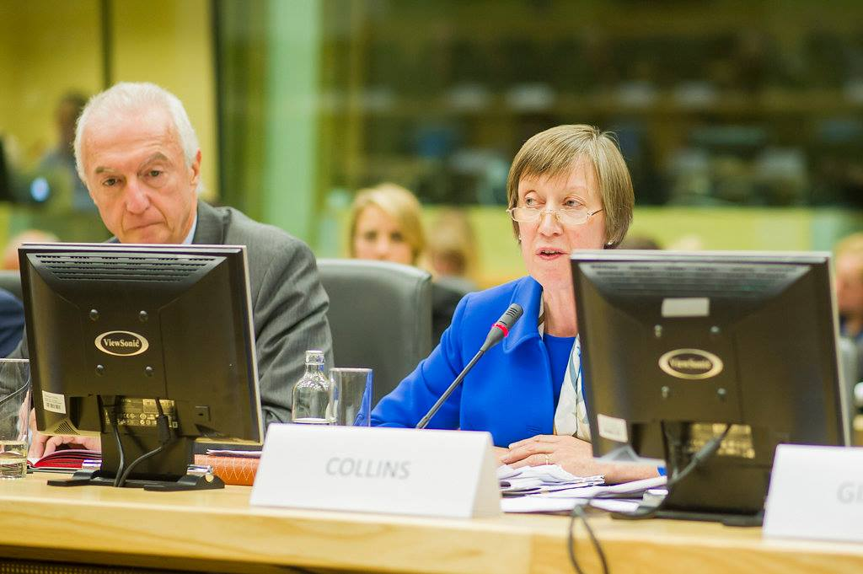On **1-2 October**, the European Commission hosted the [first Annual Colloquium on Fundamental Rights](http://ec.europa.eu/justice/newsroom/fundamental-rights/news/151001_en.htm), in Brussels. First Vice-President **Frans Timmermans** and Commissioner **Věra Jourová** lead discussions **on how to fight antisemitism and anti-Muslim hatred in Europe** and foster tolerance and respect in our societies.

The Colloquium aimed at **improving mutual cooperation and greater political engagement** for the promotion and protection of fundamental rights in Europe. It sought to strengthen dialogue between the EU and international institutions, policy makers, academia and civil society, and deepen the understanding of challenges for fundamental rights on the ground.

During his opening speech, Frans Timmermans announced that **he will designate two coordinators on Islamophobia and antisemitism**.

During the session on ‘fostering equality legislation and promoting non-discrimination policies’, **Christine Lüders** (Head of Federal Anti-Discrimination Agency - **FADA**, Germany​) highlighted the work of FADA, including supporting individuals with complaints, a pilot project for depersonalised applications as well as the importance of **adoption of the horizontal equal treatment directive** and **the development of EU wide common standards for equality bodies.**

**François Sant’Angelo (Interfederal Centre for Equal Opportunities, Belgium)** and **Jacques Toubon (Defender of Rights, France)** participated and intervened in other sessions on hate speech and hate crime.

Equinet Chair **Evelyn Collins** was the rapporteur of this session to the plenary. She also highlighted the important role of equality bodies, the contribution of equality bodies to casework and research, the growing number of complaints linked to religion and belief, as well as the need of a comprehensive legal framework with the horizontal directive and the importance of common standards for equality bodies.

Finally, **Věra Jourová** Commissioner for Justice, Consumers and Gender Equality announced that she will press ahead to have the Directive on equal rights adopted, and that equality bodies play a crucial role, including in the areas of better implementation of equality legislation and raising awareness about anti-discrimination.

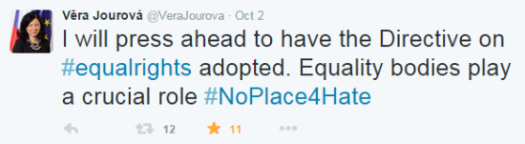

## Equinet Perspective “A Growing Agenda: The Work of Equality Bodies on the Ground of Religion or Belief”

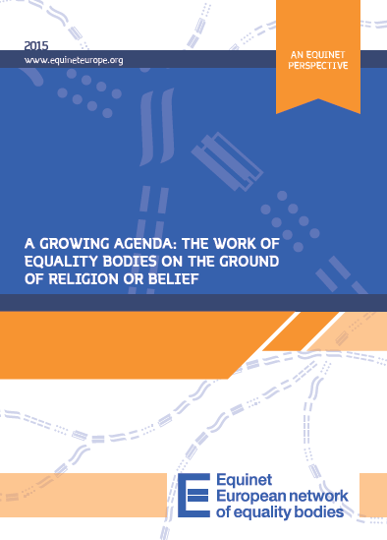As highlighted by Executive Director **Anne Gaspard** in her intervention, the Colloquium coincides with the release of **Equinet’s newest perspective** [‘A Growing Agenda: The Work of Equality Bodies on the ground of Religion or Belief'.](http://www.equineteurope.org/A-Growing-Agenda-The-Work-of?var_mode=calcul)

The ground of religion or belief is growing in importance in the work of equality bodies. This is seen as principally due to a growing number of discrimination complaints and requests for guidance on this ground, but also due to the changing composition of societies with migration, the growing presence of minority religions, and the increasing hostility of public discourse.

This perspective aims to explore and communicate the strategic approaches developed by equality bodies on the ground of religion or belief; the body of work carried out on the ground of religion or belief; and the implications and learning from this work.

## Equinet Seminar “A question of faith. Religion and belief in the work of equality bodies”

In relation to this focus on religion and belief, **Equinet is also organizing a seminar on this issue**. On **9** **and 10 November 2015**, Equinet will host the Seminar ["A question of faith. Religion and belief in the work of equality bodies"](http://www.equineteurope.org/Equinet-Seminar-A-question-of) in **London** (UK). The seminar will take stock of legal and political developments, as well as remaining challenges in ensuring freedom of religion and combating religious or faith-based discrimination at European and national levels. It will analyse the role of and challenges for equality bodies in addressing issues of religion and belief by discussing good practices in the use of their legal, research, communication and promotional functions.

**Equinet members can register to the Seminar by 15th October 2015** [**via this link**](http://form.jotformpro.com/form/52421359239961)**.**

## 

## FRA publishes overview on Anti-Semitism in the EU

This report compiles **available data on antisemitic incidents collected by international, governmental and non-governmental sources**, covering the period 1 January 2004– 31 December 2014, where data are available. No official data on reported antisemitic incidents were available for seven Member States at the time this report was compiled: Bulgaria, Estonia, Hungary, Italy, Lithuania, Malta and Portugal.

**For downloading the survey, click** [**here**](http://fra.europa.eu/en/publication/2015/antisemitism-overview-data-available-european-union-2004-2014)

# Thematic Policy Developments

## General information

**Michael O’Flaherty appointed as new FRA Director**

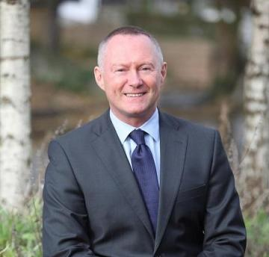Michael O'Flaherty has been appointed as the new Director of the EU Agency for Fundamental Rights (FRA).

*His profound human rights expertise and wealth of experience on the national, European and international stage will strengthen FRA’s role as a major player in shaping the fundamental rights landscape across the EU’ s*aid FRA Management Board Chairperson Frauke Lisa Seidensticker.

Michael O'Flaherty is currently a Professor of Human Rights Law at National University of Ireland Galway in Ireland, as well as Director of the Irish Centre for Human Rights. He has also been a member of the United Nations’ Human Rights Committee, and has been active in the field of human rights for over 20 years, nationally and internationally. He has been a senior expert for Ireland as part of FRA’s multidisciplinary research network, FRANET, since 2014.

**For more information, click** [**here**](http://fra.europa.eu/en/press-release/2015/michael-oflaherty-become-new-fra-director)

**The FRA launches Clarity, an interactive online tool to help people with their fundamental rights problems**

Clarity has been created by the EU Agency for Fundamental Rights (FRA) and stands for the ‘**Complaints, Legal Assistance and Rights Information Tool for You’**. It allows users to easily access information on non-judicial bodies dealing with their particular fundamental rights issue(s) in a given EU Member State.

If someone feels that their fundamental rights have been violated, they may not know who to turn to for assistance. By answering a few questions**, Clarity lists those bodies, such as equality bodies or national human rights institutions**, which may be able to **provide assistance in the given situation**. It may also provide direct contact through the tool itself or through the full contact details listed for each body.

**For more information, click** [**here**](http://fra.europa.eu/en/news/2015/online-help-hand-your-fundamental-rights-issues) **To access Clarity, click** [**here**](https://fra.europa.eu/clarity/en/tool)

# Publications, funding opportunities and events

## General information

**PUBLICATION New flash EU Barometer survey on the Charter of Fundamental Rights**

The goal is to establish whether **public awareness on the Charter**, which has been quite low, has improved over time. Specifically the survey has been designed to:

* Identify the level of awareness of the Charter itself, and when it does and does not apply
* Find out where people would turn to if they feel their rights enshrined in the Charter of Fundamental Rights are violated
* Determine what aspects of the Charter need greater explanation and information.

**To read the whole survey, click** [**here**](http://ec.europa.eu/public_opinion/flash/fl_416_en.pdf)

**PUBLICATION New EU Barometer survey on discrimination**

Three previous Eurobarometer surveys examining discrimination have been conducted in the past: in 2006, 2009 and 2012. **The 2015 survey repeats several questions asked in previous years in order to provide insight into the evolution of perceptions, attitudes, knowledge and awareness of discrimination in the European Union**. A number of new questions have been added to further explore social acceptance of some groups at risk of discrimination.

**To read more about the survey and downloading it, click** [**here**](http://www.equineteurope.org/Discrimination-in-the-EU-in-2015)

**PUBLIC CONSULTATION** **on EU Citizenship: ‘Share your opinion on our common values, rights and democratic participation’ (Deadline: 7 December 2015)**

This public consultation by the European Commission is aimed at all EU citizens, organisations and other stakeholders interested in advancing EU citizenship.

The Commission wants to know about any obstacles citizens might be facing in their daily lives living, studying, working, shopping or simply travelling within the EU. They would also like to hear ideas about how to remove these obstacles and make it simpler for citizens to enjoy their EU citizenship rights in their daily lives.

**For more information on the public consultation, click** [**here**](http://ec.europa.eu/justice/newsroom/citizen/opinion/150826_en.htm)

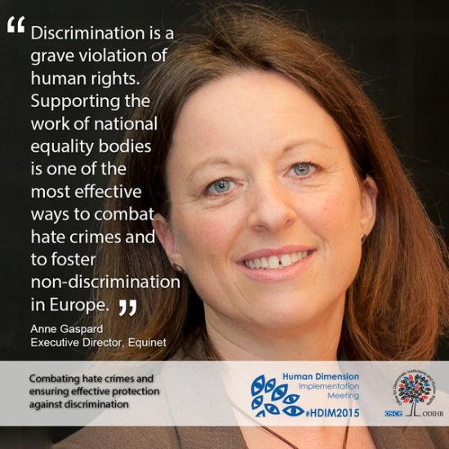**EVENT Equinet’s participation at OSCE Human Dimension Implementation Meeting, taking place from 21November to 2 October 2015.**

The Human Dimension Implementation Meeting (HDIM) is organized every year by the OSCE Office for Democratic Institutions and Human Rights (ODIHR) as a platform for 57 OSCE participating States, Partners for Co-operation, OSCE structures, civil society, international organizations and other relevant actors to take stock of the **implementation of the OSCE human dimension commitments**, discuss associated challenges, share good practices and make recommendations for further improvement.

On 29 September, Anne Gaspard, Equinet Exectuvie Director moderated **Working Session 12 - Combating hate crimes and ensuring effective protection against discrimination**.

On 30 September, Jessica Machacova, Equinet Project Officer, attended **Working session 14: Tolerance and non-discrimination II**. In her intervention, Jessica highlighted the importance of the work of equality bodies in promoting tolerance and non-discrimination.

**For more information on Equinet’s participation, click** [**here**](http://www.equineteurope.org/Equinet-Participation-at-Human) **For watching the video of HDIM, click** [**here**](http://www.osce.org/odihr/181256)

**SAVE THE DATE** **European Commission Annual Legal Seminar on gender equality and anti-discrimination law, Brussels, Tuesday 24th November 2015**

The seminar is organised in cooperation with the European Network of Legal Experts in gender equality and non-discrimination. The purpose of the seminar is to **provide an update on issues concerning the implementation of the EU non-discrimination and gender equality Directives**. It will bring together representatives of national governments, national equality bodies, experts from the Network of Legal Experts in gender equality and non-discrimination, representatives of NGOs and Commission officials. It will assess current legal developments and look to future prospects in the area of anti-discrimination and gender equality.

In addition to plenary sessions, there will be **five parallel workshops** on the following topics:

1. Update on European case Law   
2. Reasonable accommodation in employment   
3. Laws to facilitate work-life balance for working parents   
4. Disability law outside employment with particular regard to reasonable accommodation   
5. Istanbul Convention on combating and preventing violence against women

**The formal invitations via Member States Permanent Representations have been sent out.** The European Commission has invited the Member States to send up to **four representatives in total: two from the relevant ministries and two from equality bodies in charge of anti-discrimination and equality between women and men** - preferably lawyers and/or experts in anti-discrimination and equality law. The formal invitation should have reached Equality Bodies via the Permanent Representations or Governments.

The Commission is only able to pay travel expenses for one representative per Member State and it is up to each Member State to decide who will benefit from the reimbursement.

## Gender Equality

**CALL FOR TENDERS** B-Brussels: [**Scientific analysis and advice on gender equality in the EU**](http://ec.europa.eu/justice/newsroom/contracts/2015_295671_en.htm) **(Deadline: 3 November 2015)**

**CONSULTATION** [**Implementation of the Self-Employed Directive 2010/41/EC**](http://www.equineteurope.org/Consultation-on-the-implementation) **(Deadline: 20 November 2015)** *[Accessible via Equinet Members’ Area]*

**PUBLIC CONSULTATION** [Implementation and application of Council Directive 79/7/EEC on the progressive **implementation of the principle of equal treatment for men and women in matters of social security**](http://ec.europa.eu/justice/newsroom/gender-equality/opinion/150901_en.htm) **(Deadline: 14 December 2015)**

## Disability

**SAVE THE DATE** **European Commission, “Growing together in a barrier-free Europe" - Celebrating the Day of Persons with Disabilities, 7-8 December, Brussels.**

The conference will focus on children and young people with disability. Presentations and discussions will be on the current **situation of children with disabilities** in Europe, on their **access to education** and how it contributes to the equal participation of children and young people with disabilities in society.

**For more information on the conference and to register, click** [**here**](http://ec.europa.eu/social/main.jsp?langId=en&catId=88&eventsId=1069&furtherEvents=yes)

## Age

**PUBLICATION Eurofound - Social Inclusion of Young People**

The Eurofound report, presented in the EMPL committee during the last meeting, looks at employment focused initiatives and broader, more holistic approaches aimed at fighting social exclusion of youth. In particular, **this report investigates the early implementation of the Youth Guarantee across 10 Member States.** Among other topics, this research looks into the early implementation of this policy initiative which is currently being rolled out across the EU. The report sheds light on the state of play of Youth Guarantee implementation in the selected countries highlighting which concrete measures have been put into place.

**To read more about the report and downloading it, click** [**here**](http://www.eurofound.europa.eu/social-inclusion-of-young-people)

# Recent case-law

## European Court of Justice (ECJ)

* **Ruling Jobcenter Berlin Neukölln v Nazifa, Sonita, Valentina and Valentino Alimanovic**

On the 15th of September, the ECJ ruled that a Member State **may exclude Union citizens who go to that State to find work from certain non-contributory social security benefits**.

**The press release and judgement are available** [**here**](http://curia.europa.eu/jcms/upload/docs/application/pdf/2015-09/cp150101en.pdf)

* **Ruling Commission v Slovakia**

On the 16th of September, the ECJ ruled that by limiting entitlement to disability benefits and the Christmas bonus for persons on a low income to Slovak residents, Slovakia has not failed to fulfil its obligations under an EU regulation.

**The press release and judgement are available** [**here**](http://curia.europa.eu/jcms/upload/docs/application/pdf/2015-09/cp150102en.pdf)

## European Court of Human Rights (ECHR)

* **Okitaloshima Okonda Osungu v. France and Selpa Lokongo v. France**

The case concerned the authorities’ refusal to award the applicants family benefits for their children who had joined them in France without complying with the family reunification procedure. As the applicants had been unable to produce the medical certificates required by the Social Security Code and issued by the French Immigration and Integration Agency (OFII) in respect of each child following the family reunification procedure, they were refused family benefits.

The Court found that **the refusal to grant family allowances to the applicants had not been founded solely on their nationality or on any other criterion covered by Article 14 (prohibition of discrimination) of the European Convention on Human Rights**, but on the fact that they had **failed to observe the rules on family reunification,** which constituted a difference in treatment based on objective and reasonable grounds.

**The press release and judgement are available** **here**