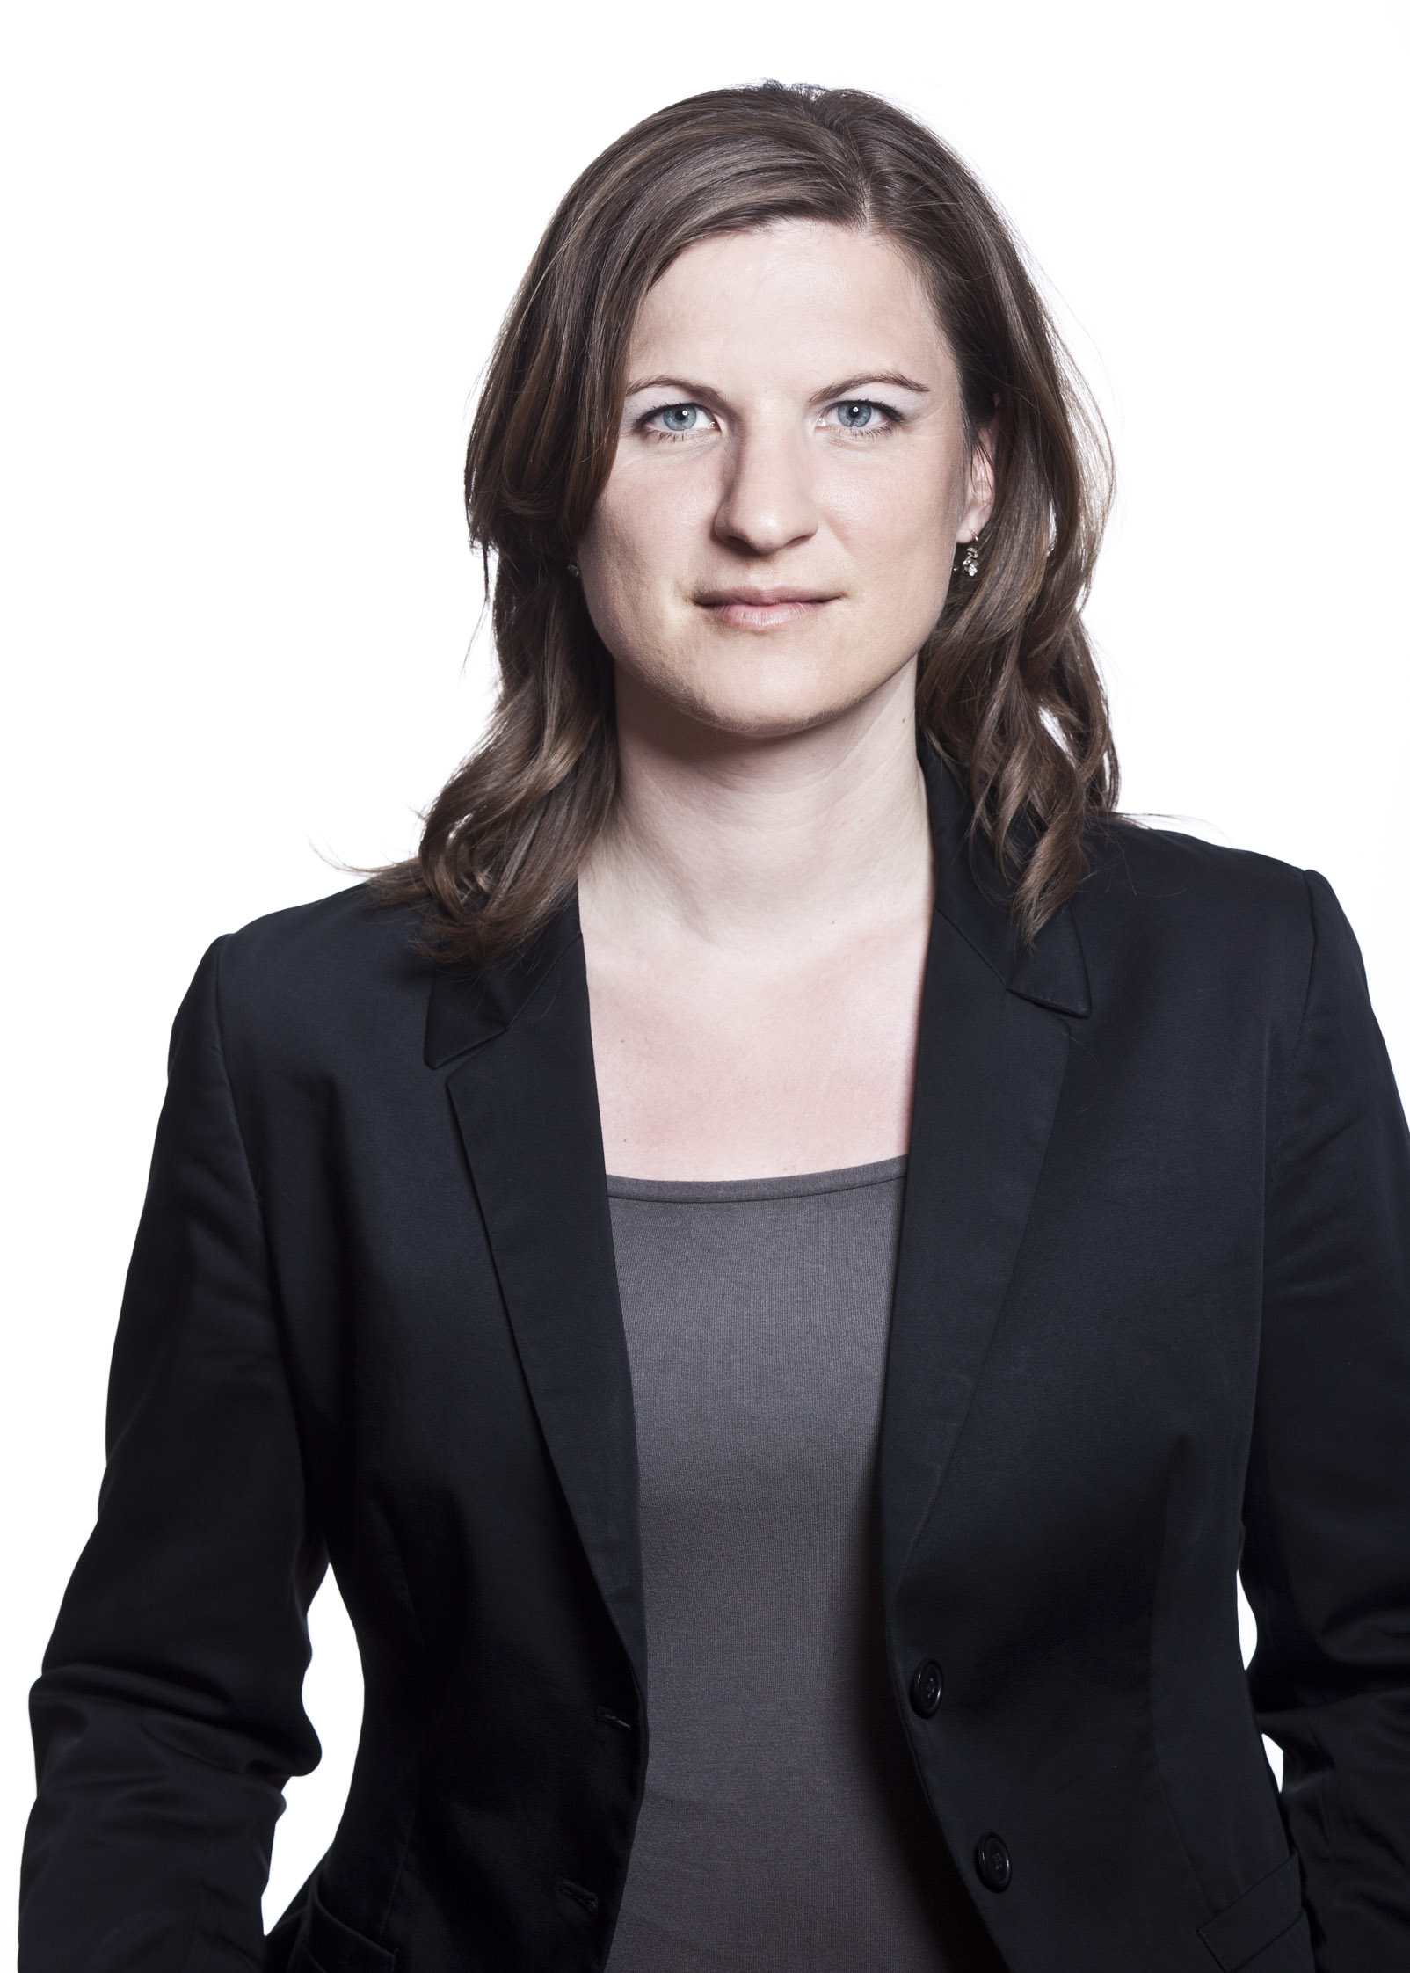
Curriculum Vitae

Professional experience:
Since 07/2003: Legal advisor at the Ombud for Equal Treatment at the Federal Chancellery (National Equality Body), department manager (Equality between men and women at the workplace)
since 2006 Deputy Director of the Ombud for Equal Treatment
- Main activities
  - develop strategies in the field Gender Equality at the workplace
  - counsel and support people feeling discriminated against in grounds of gender and in multiple discrimination grounds (such as ethnic origin, religion or belief, age, sexual orientation) including gender dimension in employment and occupation (negotiation, pass cases onto the Equal Treatment Commission)
  - report to the national assembly about the work and the observations of the Ombud
  - public relation work
  - address general equality matters

- Special activities
  - Equal Pay Expert
  - Gender Trainer
  - Trainings at the European Law Academy and lectures at the University of Vienna (Law)
  - Participation as an expert in EQUINET, the European Network for Equality Bodies

Education:
10/1993-06/2001: University of Vienna (06/1999: Magistra iuris/Master’s degree in law)
- Special Course: Legal Gender Studies
- working on a thesis in the field of access to justice (equal pay for equal work or work of equal value)

Special Trainings:

- Mainstreaming Gender and Diversity in modern organisations
- Special Course about Basis and Strategies of Equal Pay – “Equal Pay Expert”, Equal Partnership KLARA!

Other activities:
- Austrian Women Lawyers’ Association
Board member, Vice- President

