PERSONAL INFORMATION | Petr Polák
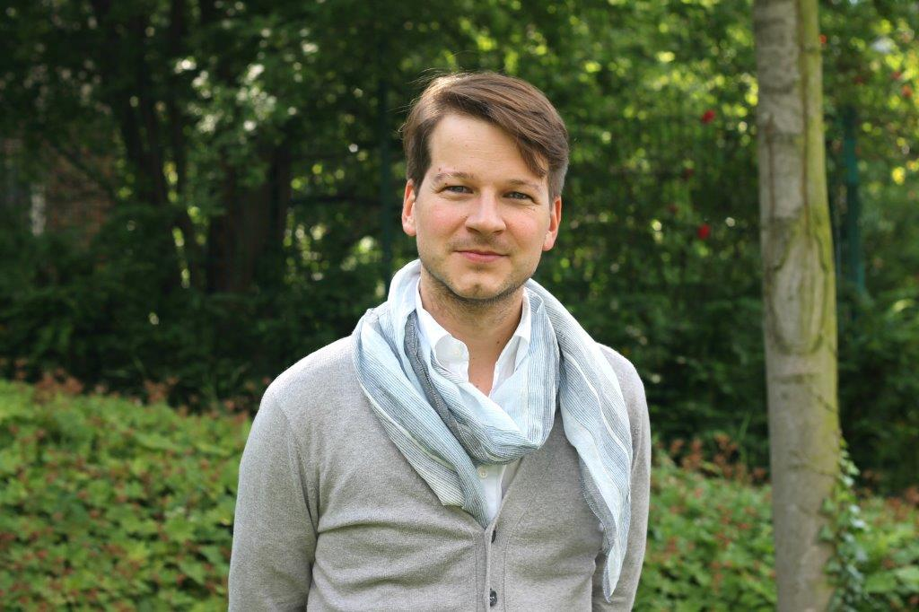 | +420 542 542 374  +420 602 727 838
 | petr.polak@ochrance.cz
 | Sex Male | Nationality Czech Republic

WORK EXPERIENCE

2007 - 2015 | Office of the Public Defender of Rights (Ombudsperson)
 | Údolní 39, 602 00 Brno, Czech Republic, www.ochrance.cz/en
- Head of the Division of Equal Treatment (2012 – 2015)
- Deputy of Head of the Division of Justice, Immigration and Finances (2010 – 2012)
- Lawyer, Division of Public Order and Finances (2007 – 2010)
 | Sector Public Administration
2010 - 2015 | Masaryk University (Faculty of Law, Faculty of Arts)
 | Žerotínovo nám. 617/9, 601 77 Brno, Czech Republic, www.muni.cz/?lang=en
- Lecturer, Spanish Legal Terminology, Faculty of Arts (2010 -2015)
- Lecturer, Legal Clinic of Equal Treatment and Discrimination, Faculty of Law (2012 – 2015)
 | Sector Academics
2011 - 2013 | Office of the Personal Data Protection
 | Pplk. Sochora 27, 170 00 Praha 7, Czech Republic, www.uoou.cz/en/
 | - Member of the Appellate Commission
 | Sector Public Administration

EDUCATION AND TRAINING

2009 | Master´s Degree – Spanish Language and Literature
 | Masaryk University, Faculty of Arts, Brno, Czech Republic
2007 | Master´s Degree – Law and Legal Science
 | Masaryk University, Faculty of Law, Brno, Czech Republic
2006 | Bachelor´s Degree – Theory and History of Theatre
 | Masaryk University, Faculty of Arts, Brno, Czech Republic

EDUCATION AND TRAINING

Mother tongue | Czech
Other languages | UNDERSTANDING |  | SPEAKING |  | WRITING
 | Listening | Reading | Spoken interaction | Spoken production
English | C1 | C1 | C1 | C1 | B2
Spanish | C2 | C2 | C2 | C2 | C1

Communication skills | - good communication skills gained through my work experience in the Office (communication with legislators, relevant decision makers, media, stakeholders, social partners and victims of discrimination)

Organisational / managerial skills | - leadership (currently responsible for a Division of 10 people)  - results-driven  - organized  - methodical  - decisive  - committed  - strong presentation skills

Computer skills | - extensive knowledge of Microsoft Office™ tools  - advanced user of Internet  - fully computer literate

Other personal skills | - fast learner, courteous, lively, hardworking, loyal, willing to travel, team player

