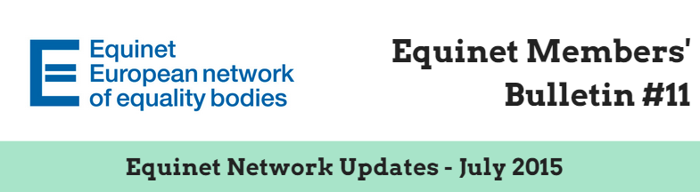

**Dear Equinet Members,**

This Members’ Bulletin gathers **the main Equinet internal updates, with the objectives of giving you a clearer overview of Equinet activities**. We very much hope this members’ bulletin will be useful in your day-to-day work and we would be grateful if you could **disseminate it among your colleagues**. Your feedback is also greatly appreciated. Should you have any comments or further questions, please do not hesitate to contact **Jessica Machacova, Equinet Project Officer** ([Jessica.machacova@equineteurope.org](mailto:Jessica.machacova@equineteurope.org) / 0032 2 212 31 80).

**Equinet Members’ Bulletin on Network Updates – Table of contents**

***(Ctrl + Click to follow the link)***

* **Reminder:** Equinet 2015 Board Elections & Registration to Equinet AGM (Friday 9th October 2015, Brussels)
* **Reminder:** Equinet survey on religion and belief (Deadline: Monday 27th July)
* Equinet Charter and Work Life Balance Seminars: **Materials available**
* **Request from the Maltese National Commission for the Promotion of Equality** (Deadline: Friday 28th August)
* **Latest Equinet members’ visit and bilateral meetings**
* **4th ERIO’s workshop “**Fighting hate speech against Roma: the Role of Equality Bodies”
* **Equinet is recruiting a Policy Officer focusing on Gender Equality** (Deadline: 2nd August 2015)
* **Next Equinet Events**

# Reminder: Equinet 2015 Board Elections & Registration to Equinet AGM (Friday 9th October 2015, Brussels)

1. **Equinet Board Elections 2015 - Candidate nominations (Deadline: 8th September 2015)**

The Chair of the Equinet Executive Board and the Executive Director of the Equinet Secretariat call upon all Equinet member organisations to consider **nominating a candidate for the election of the new Executive Board** (maximum one per member organisation). The nine members of the next Equinet Board will be elected by secret ballot for a two-year mandate (October 2015-October 2017) by the General Assembly of Equinet Members at the Annual General Meeting (AGM) on **Friday 9th October 2015 in Brussels**.

It is possible for interested member organisations that have already selected a candidate to submit the full candidacy information through the **Candidate Nomination Form** (Deadline: **8th September 2015**).

The **Candidate Nomination Form** and the **Equinet Board Elections Guide 2015** are available on [Equinet’s online Members’ Area](http://www.equineteurope.org/-EQUINET-2015-BOARD-ELECTIONS-).

For more information about the Equinet Board elections, **please do not hesitate to contact the Equinet Secretariat** (Yannick Godin, Administration and Finance Officer – [Yannick.godin@equineteurope.org](mailto:Yannick.godin@equineteurope.org) – 0032 2 212 31 82).

1. **Equinet Annual General Meeting 2015 (Friday 9th October 2015, Brussels)– Registrations are open (Deadline: 1st September 2015)**

We are pleased to announce that **registration is now open** for the **Equinet Annual General Meeting** that will take place on **9 October 2015**, in **Brussels at the Thon Hotel EU** – Rue de la Loi 75, B-1040 Brussels, Belgium

In observance of the Equinet Statutes, the Chair of the Equinet Executive Board is calling upon all Members of Equinet to **nominate their representative(s) to the AGM**. The meeting will be conducted **in English**. A maximum of two representatives from each member and observer organisation, including the head or senior representative of the equality body, are invited to participate in the AGM.

The **following items** will be submitted to the vote of the General Assembly:

* Equinet AGM 2014 Minutes and 2014 Accounts
* New Membership application from Federal Ombudsman for People with Disabilities, Austria
* Equinet Work Plan and Budget 2016
* Equinet Board Members elections

Each organisation must inform the Equinet Secretariat of the representative who will be granted the right to vote on its behalf. They can do so in the [online registration form](http://www.jotformpro.com/form/51741712707958) or by contacting the Secretariat directly.

A Member Organisation unable to send any representative to the AGM can delegate its voting right to another Member Organisation that will be present (proxy voting). A Member Organization cannot hold more than two proxy votes.

For more information, **please contact the Equinet Secretariat** (Yannick Godin, Administration and Finance Officer – [Yannick.godin@equineteurope.org](mailto:Yannick.godin@equineteurope.org) – 0032 2 212 31 82).

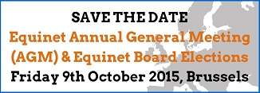

# Reminder: Equinet survey on religion and belief (Deadline: Monday 27th July)

Equinet 2015 Work Plan foresees that the Working Group on Policy Formation will *“Discuss and produce a perspective on the work done by equality bodies in order to advance equality and counter discrimination on the ground of religion and belief. The perspective will take account of the practices of equality bodies applying their legal, promotional, research and promotional functions as well as the political context they operate in. The perspective will inform the agenda of the Equinet seminar on the grounds of religion and belief. The work will contribute to the Council of Europe, FRA, ENNHRI and Equinet platform on economic, social and cultural rights.”*

On 2nd June 2015, a survey was disseminated to the members of the Working Group Policy Formation. However, as the answers will provide the basis for the Equinet perspective on the topic, we would be grateful **if all Equinet member organisations could fill in and return the survey by Monday 27th July at the latest.**

The survey is available here:



Thank you very much for your cooperation!

# Equinet Charter and Work Life Balance Seminars: Materials available

Presentations and materials from the two latest Equinet Seminars have been made available on Equinet’s website.

## Charting the Charter: Equality Bodies and Fundamental Rights in the EU (16th and 17th June 2015, Brussels)

Presentations from speakers and materials are available [here](http://www.equineteurope.org/Charting-the-Charter-Equality).   
A summary of the seminar can also be downloaded [here](http://www.equineteurope.org/IMG/pdf/seminar_report.pdf).

## Work-Life Balance and Pregnancy and Parenthood-Related Discrimination (1st and 2nd July 2015, Tallinn)

Presentations from speakers and materials are available [here](http://www.equineteurope.org/Work-Life-Balance-and-Pregnancy-682).   
**A summary of the seminar will be published soon.**

# Request from the Maltese National Commission for the Promotion of Equality (Deadline: Friday 28th August)

The NCPE would appreciate feedback from EQUINET members with reference to what the different Equality Bodies do during the investigations of complaints in cases **where the same complaint is being investigated by other legitimate bodies**, such as for instance by the Executive Police or the Industrial Tribunal.

Please send your feedback to Maria Filletti from the NCPE ([maria.filletti@gov.mt](mailto:maria.filletti@gov.mt)) with Jessica Machacova, Equinet Project Officer in copy ([Jessica.machacova@equineteurope.org](mailto:Jessica.machacova@equineteurope.org)) by Friday 28th August. Should you need more information, please contact directly Maria Filletti.

# C:\Users\jema\AppData\Local\Microsoft\Windows\Temporary Internet Files\Content.Word\Visit FR BE.JPGLatest Equinet members’ visits and bilateral meetings

## Visit of the French Defender of Rights to the Belgian Interfederal Centre for Equal Opportunities

On 23rd June 2015, a delegation comprising the French Defender of Rights Jacques Toubon and staff members visited the Belgian Interfederal Centre for Equal Opportunities. The visit took place in the context of the partnership signed between the two equality bodies in 2012. It aimed to exchange on the Interfederal Centre’s approach concerning racist, hate speech and strategic planning in view of the launch of a platform against racism by the French Defender of Rights on 15th September 2015.

**Malta’s National Commission for the Promotion of Equality's Study Visit to the Equality Commission for Northern Ireland**

Jacques Toubon, Defender of Rights (FR), and Patrick Charlier, Acting Director of the Interfederal Centre for Equal Opportunities (BE)

*Article co-drafted by the Maltese National Commission for the Promotion of Equality and the Equality Commission for Northern Ireland*

The study visit was hosted by the Equality Commission for Northern Ireland and took place in Belfast between 23rd and 25th June 2015, ending with a visit to the Irish Human Rights and Equality Commission Ireland in Dublin on 26th June. Given that NCPE is expected to become a NHREC in the near future, meetings such as the one with IHREC in Dublin were especially beneficial.

**The full article is available** [**here**](http://www.equineteurope.org/Latest-Equinet-Members-Study)**.**

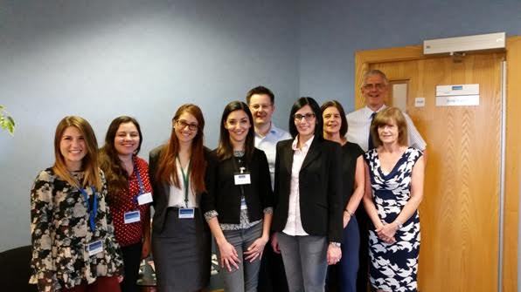

Representatives of the Malta’s National Commission for the Promotion of Equality  
and the Equality Commission for Northern Ireland

# Register to 4th ERIO’s workshop “Fighting hate speech against Roma: the Role of Equality Bodies”

The European Roma Information Office (ERIO), in close cooperation with EQUINET (European Network of Equality Bodies) invites you to attend a workshop with Equality Bodies and Roma representatives which will take place on **16 October** **2015** at the **Rue de Ligne 37, 1000 Brussels, Belgium**. Please see the attached invitation.

Within the framework of the Race Equality Directive 2000/43 (RED) and national equality laws (legal provisions regulating media), the workshop will focus on how Equality Bodies can fight hate speech against Roma. By organising this workshop, we aim to:

* Foster discussion between different Equality Bodies, civil society and experts on effective practices and challenges to tackle hate speech against Roma
* Provide a platform for Equality Bodies to exchange good practices on hate speech (e.g. prevention, public awareness, litigation)
* Promote cooperation between Equality Bodies and civil society to jointly address hate speech against Roma

ERIO will arrange and cover the expenses of the accommodation and travel of representatives of Equality Bodies.

The workshop will be in English.

**Places are limited**. Please confirm participation as soon as possible, latest by **25 September 2015**.

Register by email/phone, by sending your name, surname and the organisation you represent to: [office@erionet.eu](mailto:office@erionet.eu)  - Tel: +32 (2) 733 3462.

# Equinet is recruiting a Policy Officer focusing on Gender Equality (Deadline: 2nd August 2015)

For its Brussels-based Secretariat, Equinet is seeking to recruit a **Policy Officer**, with a particular focus on the work relating to **gender equality and cooperation with members and partners in this field**. The successful candidate will lead Equinet’s work on the ground of gender and gender identity and ensure that gender equality is mainstreamed in all Equinet activities. S/he will also contribute to the overall policy and legal work of Equinet on all grounds and in all fields of discrimination, including multiple discrimination.

More information and the application form are available [here](http://www.equineteurope.org/Equinet-is-recruiting-a-Policy).

We would be grateful if you could disseminate this information to your relevant contacts.

# Save the date!

|  |  |
| --- | --- |
| **Governance Meetings**  **Thursday 17th September: Board** **Meeting** (Brussels, Belgium)  **Friday 9th October:** Annual General Meeting & Board Elections (Brussels, Belgium) | **Capacity-Building Events & Conferences**  **Monday 9th and Tuesday 10th November:** Religion & Belief Seminar, London, United-Kingdom  Tuesday 8th December |
| **Training Sessions**  **Thursday 3rd and Friday 4th September:** Training Session on EU Funds, Sofia, Bulgaria | **Other meetings (invitation only)**  **Wednesday 16th September:** Second Meeting of Equinet Cluster on Standards (Brussels, Belgium) |