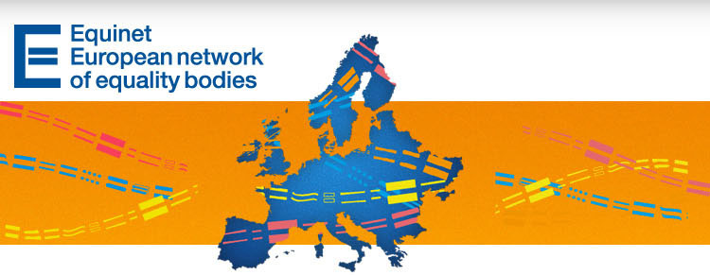

Equinet Legal Seminar to Look at Application of EU Equality Directives - E-Newsletter No. 27

Contents
News from Equinet
News from Equality Bodies
European Developments
Upcoming Events
Latest Publications

News from Equinet

Registrations are now open for the 2013 Equinet Legal Seminar (16 May, Brussels)
This one-day Seminar represents one of Equinet's contributions to the discussions and consultations leading up to the adoption of the European Commission's joint report on the application of the Race Directive (2000/43/EC) and the General Framework Directive (2000/78/EC).
The seminar will be opened by Mr. Aurel Ciobanu-Dordea – Director for Equality, DG Justice at the European Commission and will be divided into three sessions:
Session 1 – Reporting on the Application of the Non-Discrimination Directives
Session 2 – Interactive Panel Debate on Relevant Aspects of the Directives and The Experiences of Stakeholders
Session 3 – Putting the Directives into Context and Potential Developments
TARGET AUDIENCE: legal experts and practitioners involved in anti-discrimination law – including senior legal staff from national equality bodies, from the European institutions, agencies and other international organisations, from national and European NGOs, the academic world and social partners active in the field of non-discrimination and equal treatment law.
More information about the agenda, venue and registration (DEADLINE 30 APRIL) can be found here.

Read our report from the Equinet Legal Training in Berlin
On 18-19 March 2013 in Berlin, Equinet, with the support and hosting of the Federal Anti-Discrimination Agency of Germany, organised a training dedicated exclusively to national equality bodies.
The discussions, presentations and arguments put forward at the training would nevertheless be interesting to a wider audience, as they relate to topics such as:
The shift of the burden of proof and types of evidence in discrimination cases
Situation testing and its use
Practicalities of involvement in a case before the European courts
Disability discrimination
Therefore, you can visit the webpage of the event and access our summary report, speakers' presentations, and recommended readings.

News from Equality Bodies


Austria – Ombud for Equal Treatment
On 22 April the Ombud, together with the Information Office the European Parliament and the Representation of the European Commission, will organise an event focused on "The Burden of Proof in Equality Law from European and National Perspectives". Continue reading
(contact: Maria Felzmann)

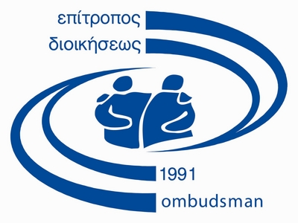
Cyprus – Office of the Commissioner for Administration (Ombudsman)
The Ombudsman issued a report regarding the non-payment of welfare allowances to women who are third country nationals, single parents and whose children are Cypriots. These women are subjected to discrimination in relation to their eligibility for public assistance from the welfare department. The report recommends to the competent authorities that the policy which is applied by the welfare department in these cases should be revised, in the light of the principles of equal treatment and non-discrimination. Continue reading (Greek)
The Ombudsman also issued a report after its investigation into the response of schools to racist incidents. Following previous interventions of the Ombudsman regarding the same matter, the report reaffirmed the position that by underestimating and not dealing with the racist incidents in a decisive way, schools fail to protect the victims, to educate the actors and to break the tensions developed among student groups of different races or ethnicities. Emphasizing the obligation of schools to protect all students from all kinds of discrimination - racist violence and harassment included - the Ombudsman invited the Minister of Education and Culture to work with her Office towards the drafting of a Code of Conduct against Racism in schools.
The Ombudsman, under her competence as the Independent Authority for Human Rights, called for a series of meetings with all stakeholders, to discuss and review the current institutional framework of prostitution in Cyprus. The first meeting will take place on April 17, 2013.
The office of the Ombudsman is co-organizing with the Law Department of the European University in Cyprus a seminar entitled "Civil Partnership: Cyprus and European Perspectives". The seminar is held in view of the upcoming discussion in the Cypriot Parliament of the draft legislation on civil partnership between couples of the same or different gender, and focuses on the legal and societal aspects of the issue, in respect to human rights, at local and European level.
(contact: Thekla Demetriadou)


Czech Republic – Public Defender of Rights
The Public Defender of Rights has concluded a Cooperation Agreement on situation testing with two Czech non-governmental organizations (Counselling Centre for Citizenship, Civil and Human Rights in Prague and IQ Roma Servis in Brno), by means of which the NGOs will assist the victims of discrimination in acquiring evidence for possible court or administrative proceedings for breaching the prohibition of discrimination. Continue reading
(contact: Iva Hrazdilkova)

Denmark – Danish Institute for Human Rights (DIHR)
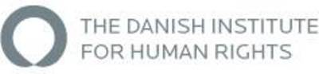
The lack of accessibility for persons with disabilities is on the Danish Institute for Human Rights' list of the 10 biggest challenges for Denmark in relation to the UN Convention on the Rights of Persons with Disabilities. Denmark is still a country where the environment itself is often a barrier.
Therefore, the Danish Institute for Human Rights has conducted in 2012 and 2013 an investigation into whether Danish law meets the convention's Article 9 on accessibility and into other structural barriers that may be, for example, developed when constructing new buildings.
Based on the investigation the institute has made five recommendations on what should be done to remove the main barriers preventing new buildings from meeting the demands of accessibility. Among these are:
- An Action Plan for Disability: The Danish government has initiated the work on a long-term disability action plan. This plan should include accessibility as an independent area of focus.
- A Prohibition of Discrimination: Denmark should introduce a general prohibition of discrimination on grounds of disability, which also includes access to new buildings open to the public.
The investigations have resulted in two publications on accessibility which may be found in Danish on the Institute's website:
- "Please Come In – About Accessibility to Buildings" – a short and illustrated presentation of the investigation
- "Report on Accessibility to Buildings Open to the Public"
(contact: Christine Bendixen)

France – Defender of Rights
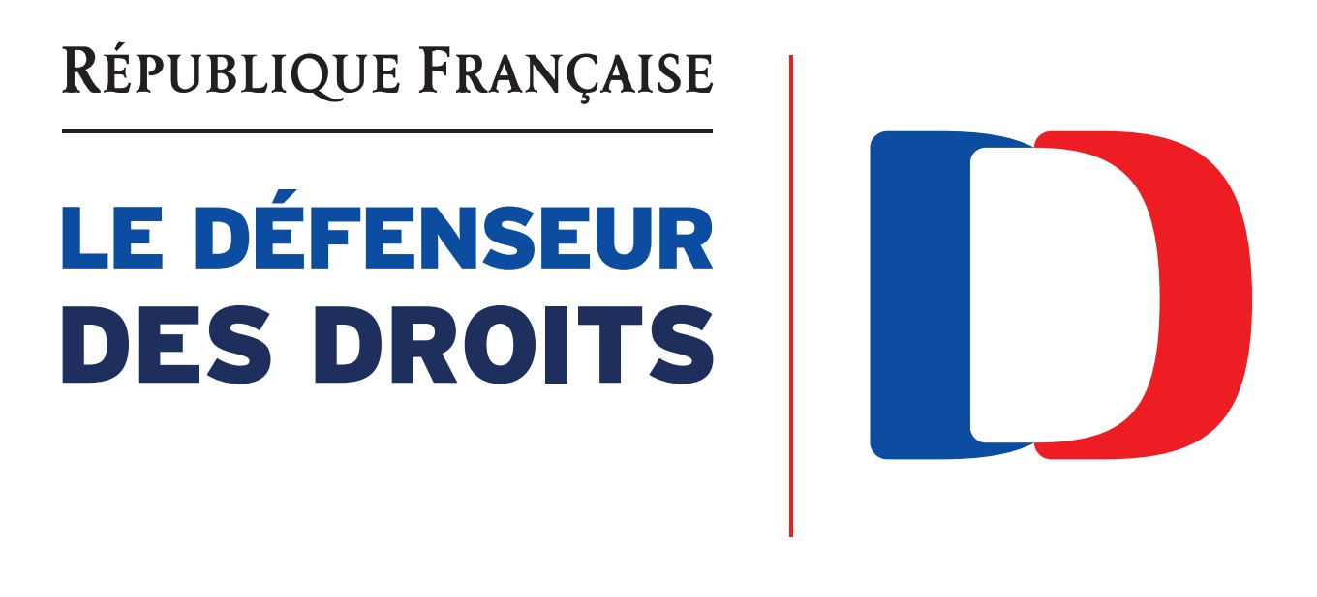
Gender stereotypes and the gender segregation of the labour market brings a de-valorisation of jobs where women are predominant. On the occasion of the International Women's Day on March 8, the Defender published a guide aimed at helping to identify the problem and its roots, and at finding solutions via non-discriminatory tools for the evaluation of jobs, in order to achieve equal pay for work of equal value. You can access the guide here (French only). (contact: Nepheli Yatropoulos)

Italy – National Office against Racial Discrimination - UNAR
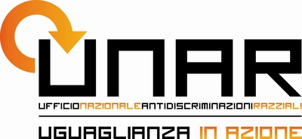
On the occasion of the International Day for the Elimination of Racial Discrimination, UNAR organised a Week of Action between 17-24 March. The initiatives included educational projects with audio-visual engagement, meetings, exhibitions and mutual learning seminars between culturally diverse communities, television and radio shows, etc. More information, especially in Italian, can be found on the organisers' Facebook page or website.
(contact: Valerio Serafini)

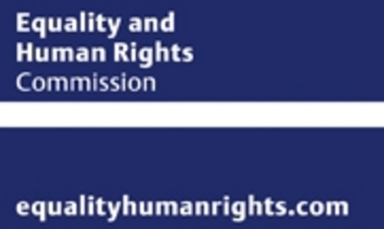
United Kingdom – Equality and Human Rights Commission (EHRC)
The EHRC has launched easy to understand advice for businesses on how to prevent discrimination and avoid costly legal challenges.
"The Equality Act: Guidance for Small Business'' explains how the 2010 Equality Act relates to their operations and what they need to do to ensure they stay within the law. It includes practical advice in managing important business challenges such as recruitment, promotion and what to do to ensure as many customers as possible can access their services. "A guide to business and human rights" helps businesses identify and manage human rights issues which may arise in their business operations. These could include supplier considerations and the impact on their customers. For example, businesses might think about the right to privacy and the confidential information they hold online about customers and staff.
(contact: international@equalityhumanrights.com)

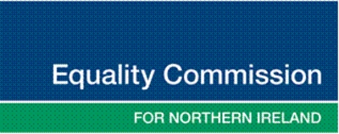
United Kingdom – Equality Commission for Northern Ireland (ECNI)
The Commission has launched a new microsite for Lesbian, Gay and Bisexual people in Northern Ireland: www.SoMe-ni.co.uk. This unique site includes information on Your rights, How we can help, Discrimination FAQs, personal stories and info about what's happening in Northern Ireland for LGB people. It also features a live chat facility for those needing assistance and an anonymous reporting facility for those wishing to share their experiences. The promotional video can be accessed here.
A nursing auxiliary with a disability, whose employer failed in its duty to act promptly to put a reasonable adjustment in place to allow her to return to work, has been awarded £16,684 by an Industrial Tribunal. The case, supported by the Equality Commission for Northern Ireland, was taken by Angela McCracken against the Northern Health and Social Care trust. Continue reading
Childcare in Northern Ireland costs nearly half (44%) the average income, compared to 33% in Great Britain and 12% across the European Union. This is one of the findings of a new report launched by the Equality Commission. Continue reading (and check videos)
The Commission has launched a new report on Childcare: Maximising the Economic Participation of Women. A summary can be read here, while the full report can be downloaded here.
(contact: Mark Soult)
Top of page

European Developments
Episode 6 of the European Network Against Racism's video series has been launched on Are Roma doomed to end up begging in the streets?
The European Parliament wants to outlaw homophobic crime and speech in the EU
Upcoming events
Please bear in mind that some of these events may be attended upon invitation only. For more details please contact the organisers.

9-10 May (Dublin) - Irish Presidency: Strengthening institutional arrangements in Europe for protecting equality & fundamental rights
17 May (The Hague) - FRA: Presenting the findings from the largest-ever LGBT hate crime and discrimination survey
7 June (Vienna) - FRA: FRA Symposium: Promoting the rule of law in the EU
13 June (Brussels) - EIGE: Launch of the Gender Equality Index
Top of page
Latest publications
Equinet "Law in Practice Report 2012 - Comparative Analysis of Discrimination Cases in Europe"
Equinet perspective on "Equality Bodies Combating Discrimination on the Ground of Racial or Ethnic Origin"
The final report of the Annual Convention of the Platform Against Poverty and Social Exclusion has been launched by the European Commission
New FRA report on "Inequalities & multiple discrimination in access to & quality of healthcare"
New report from the European Network against Racism on 'Recycling Hatred: Racism(s) in Europe Today'
New publication of the German Institute for Human Rights on "Combating Discrimination: How a National Human Rights Institution can strengthen Civil Society Organisations – An Example of Good Practice"
New Employment and Social Situation Quarterly Review: March 2013 launched by the European Commission
New Issue of the Equal Rights Review Published by Equal Rights Trust
Summary of the Mutual Information System on Social Protection (MISSOC) Analysis report (2012/2) on gender differences in social protection

 | Equinet Secretariat  Rue Royale 138  1000 Brussels - Belgium  Tel : +32 (0) 2 212 3182  Fax : +32 (0) 2 212 3030 | 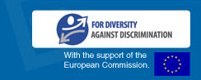
   |  |  |  | 
  Copyright 2012 © Equinet. All rights reserved.

