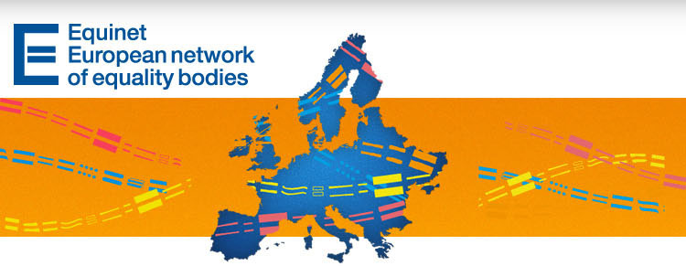

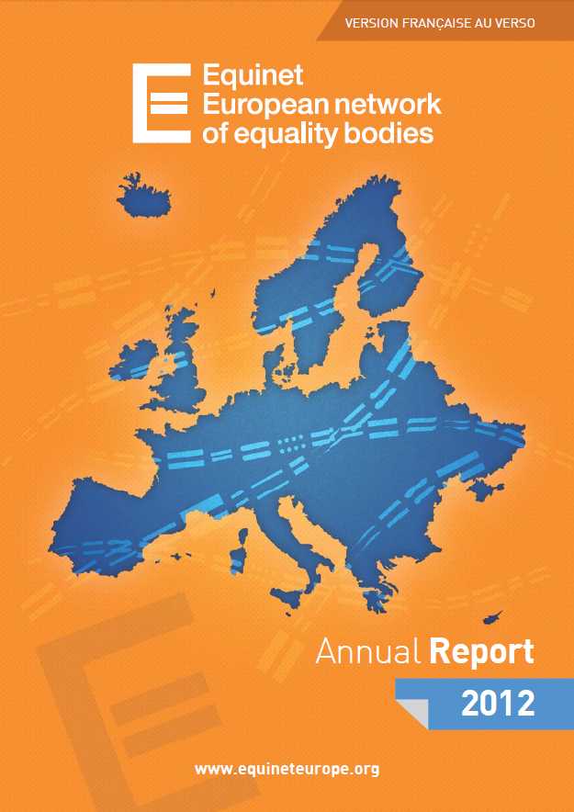
Latest publications, vacancies and developments from Equinet & Equality Bodies - E-Newsletter No. 29

Contents
News from Equinet
News from Equality Bodies
European Developments
Upcoming Events
Latest Publications

News from Equinet

Equinet is recruiting an intern! - DEADLINE FOR SUBMITTING CV & APPLICATION FORM: SUNDAY 14 JULY (midnight)
We offer a 5-month full-time paid internship from the end of August 2013 until the end of January 2014 to assist the Equinet Secretariat, a small team of 5 staff members based in Brussels. The intern will in particular assist the Policy and the Communications Officers in carrying out activities and tasks in the field of equal treatment and human rights policy and legislation and (s)he will also contribute to the planning and organisation of Equinet events.
More information about the position and the recruitment process is available here.

Equinet has released its Annual Report for the year 2012
Adopting a new design compared to previous years, the report aims to highlight the need for standards to support the work of equality bodies and key insights from the work of equality bodies in tackling under-reporting through good communication strategies and practices. It also illustrates how our network works, what are our main objectives, and the main activities and milestones from 2012.
Download or read a summary of the report here.

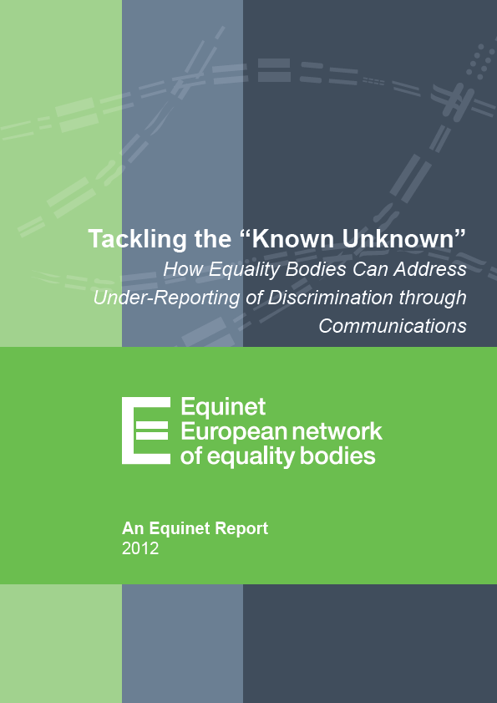
Tackling the "Known Unknown": How Equality Bodies Can Address Under-Reporting of Discrimination through Communications
This new Equinet report from the Working Group on Communication Strategies and Practices considers the nature of under-reporting and the challenge to equality bodies to identify and address any barriers that may contribute to the issue. It also highlights the need to have robust systems to capture both formal and informal reports and to be able to interrogate this data when developing activities to embed good equality practices in workplaces and service provision. The report also raises the question around the capacity of equality bodies to deal appropriately with increased reports of discrimination.
Download or read a summary of the report here.

High-Level Seminar on Gender Equality in the Labour Market: the Role of Equality Bodies
This High Level Seminar was held on 27 June 2013 in Brussels and is the first event dedicated to gender equality organised by Equinet following the incorporation of the work of the former European Commission led Network of Gender Equality Bodies.
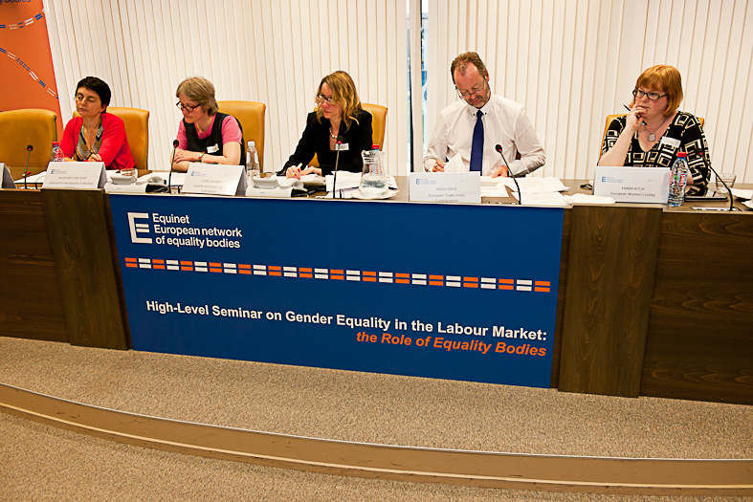
The seminar benefited from the contribution and attendance of high-level speakers and participants representing key European stakeholders in the field of gender equality, including the European Commission, the European Parliament's Women's Rights and Gender Equality Committee, the European Institute for Gender Equality, the European Network of Legal Experts in the field of Gender Equality, the European Women's Lobby, and so on.
To read more about the seminar and download some of these contributions please visit the event's webpage. A summary will soon be made available on the website as well.

Top of page

News from Equality Bodies


Belgium – Centre for Equal Opportunities and Opposition to Racism
The Centre has recently presented its "2012 Annual Report on Migration" focused on the mobility of foreigners to and from Belgium. In addition to a quantitative mapping of migration in Belgium, the Centre also focused on recent developments related to issues such as family reunification and return policy in order to point out that sometimes there is a tension between the individual autonomy of migrants and the state's need to manage migration flows. Continue reading (in French or Dutch)
A person using a motorised wheelchair has encountered difficulties when trying to book a flight with an airline. After the intervention of the Centre and the opinion of the Belgian Civil Aviation Authority provisions will be made for reasonable accommodation to be made in the future so that persons in similar situations do not face such difficulties.
(contact: Eef Peeters)

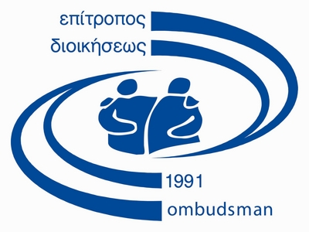
Cyprus – Office of the Commissioner for Administration (Ombudsman)
An representative of the Office participated at an International Conference entitled "Revisiting Sexualities in the 21st Century", organized by the Cyprus Sociological Association, presenting the topic "The Public Discourse of LGBT issues in Cyprus". The presentation consisted of a short history of the struggle for equality of LGBTs in Cyprus, with specific reference to the contribution of the equality body, followed by the public discourse that accompanied these developments, especially in the political sphere and the media.
The Head of the Office gave a lecture at the Cyprus Academy of Public Administration on the obligation of all public authorities, and each public officer individually, to protect and treat people of different ethnic origin respectfully.
The Ombudsman addressed the award ceremony for the School Competition titled "Talk about racism and Xenophobia: Silence is not a solution", co-organized by the Ombudsman's Office, along with the Representation of the European Commission in Cyprus and the UNHCR Representation in Cyprus, with the support of the Ministry of Education and Culture. The competition called for the creation of a school newspaper against racism and xenophobia, prepared by secondary-school students, once they conducted their own research on the subject. Six schools received awards and four others were praised for their entries, while all ten of them were also awarded with wall plaques containing the text "School against Racism". During the ceremony, students of migrant background shared their own personal experience as regards racism and integration in Cyprus. According to the Ombudsman, the competition gave the opportunity to students to take a closer look at this difficult matter and to send a message that by combating stereotypes and prejudice against migrants and refugees and by integrating them successfully, Cyprus society builds and maintains a strong shield against racism.
The Ombudsman, acting as Independent Mechanism for the Monitoring of the Implementation in Cyprus of the UN Convention for the Rights of Persons with Disabilities, co-organized along with the Cyprus Confederation of Organizations for the Disabled, a day conference titled "The transition from the medical model to the social model of disability". Addressing the conference, the Ombudsman stressed that the rights of persons with disabilities must not be undermined on the basis of the financial crisis, adding that understanding the social model of disability may even contribute to the prevention and eradication of social exclusion and poverty.
The Office, bearing in mind that a substantial number of migrants are regular bus users, is currently preparing, in collaboration with the Transportation Organization of Nicosia District, a Manual for Bus Drivers, as regards their duty to provide services without discrimination. The document refers to the relevant legal anti-discrimination framework and includes guidelines as regards the responsibilities of the parties involved in matters of behavior towards, and treatment of, bus passengers of different ethnic origin. The manual will be issued and circulated in the next few weeks.
(contact: Thekla Demetriadou)
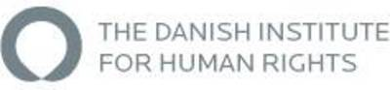
Denmark – Danish Institute for Human Rights (DIHR)
The DIHR has recently launched its Annual Report containing general information about the institute's research, current projects, documentation, training, information work, administration, and the various specific activities in which the Institute has been engaged both nationally and globally. In the area of equal treatment DIHR has among other things focused on equal pay – the gender pay gap between women and men, registration of hate crimes, and ethnic diversity in the Danish police force.
In co-operation with the web governance firm Siteimprove the DIHR has put focus on digital accessibility. This is done by making a film showing how persons with disabilities can experience difficulties using public web sites. On the basis of the film five basic principles on how to create good accessibility levels for websites were set up. In addition, DIHR has put up five recommendations for how the authorities should promote accessibility to public websites; among them being a right to accessibility to public websites based on the international standard for accessibility to websites WCAG 2.O.
(contact: Christine Bendixen)

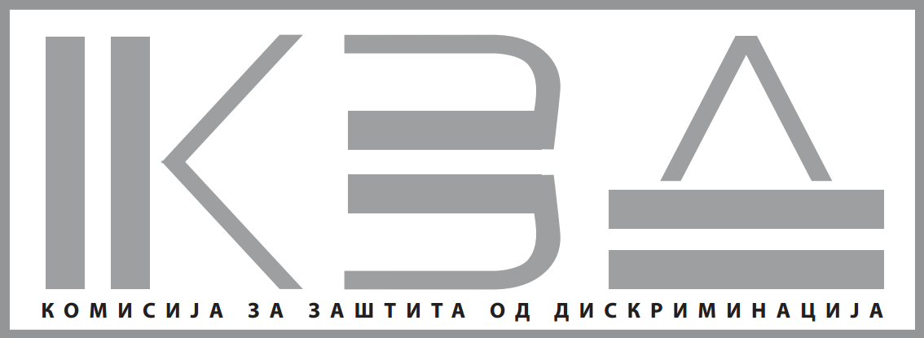
(FYRO) Macedonia – Commission for Protection against Discrimination
The Commission for Protection Against Discrimination in cooperation with the OSCE Mission to Skopje, recently held a press conference on the occasion of its "Presentation of the activities of the 2012 Annual Report".
A total of 75 complaints were submitted to the Commission for Protection against Discrimination in the course of 2012, where the greatest number of complaints relate to the area of labour and work relations, social security, access to goods and services, education, science and sport, public information and media, as well as on some other grounds under the Law on Prevention and Protection against Discrimination. According to the submitted complaints, it is predominantly the ethnic communities that suffer most discrimination, and in particular the members of the Roma community. The greatest number of complaints (70%) were submitted against legal entities, 20% of the complaints were against natural persons mostly in the state sector, while only a small number relate to the private sector.
(contact: Irena Mitevska)
Top of page
Hungary – Commissioner for Fundamental Rights

"There is a violation of the principle of human dignity and the requirement of equal treatment if a company requires workers in community employment to wear a distinctive sign" - this was the decision of the Commissioner in a recent case. The employees had to wear a yellow visibility vest with the label "community employment" because the head of the company they were working for wished to promote the "social usefulness of community employment".
(contact: Nikolett Babos)

Malta – National Commission for the Promotion of Equality
In exercise of the powers conferred by article 11 of the Equality for Men and Women Act, and for the purpose of that Act, the Prime Minister of Malta has recently appointed Ms. Renee Laiviera Dip. Ed.(Melit), Dip. Pol.Stud.(Melit), as the new Commissioner of the National Commission for the Promotion of Equality. This appointment is valid for a period of two years, with effect from the 20th May, 2013.
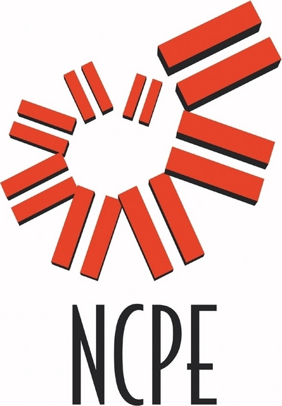
(contact: Therese Spiteri)

Slovakia – National Centre for Human Rights

The Centre organised a specialised event for high school representatives and students to discuss issues related to "Tolerance-Prejudices-Bullying". The activity was focused on understanding prejudices, stereotypes and their influence on the opinions and values of young students. In addition to the representatives of the Centre, experienced psychologists and professionals also participated in an inspirational discussion. The main aim of the event was to point out the existing parallelism between the acts of discrimination among adults and the manifestation of intolerance within high-school environments.
On 10 June 2013 more than 90 3rd grade students from the Grammar School of Jozef Gregor Tajovský in Banská Bystrica attended lectures on the issues of antidiscrimination provided by the Centre's experts. The day after a similar lecture was given to the 54 pupils form the Pradiarenska Street Elementary School in Kežmarok. The significance of the second meeting was that the Pradiarenská Street Elementary School is solely attended by Roma children living in the nearby communities. The antidiscrimination issue loomed large in the students' minds and their honest interest was proven by the vivid discussion at the end of both events.
(contact: Zuzana Pavlíčková)

Sweden – Equality Ombudsman
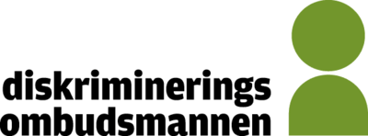
In October 2012 the Swedish Equality Ombudsman published a study on equality data. The study focuses on the possibility to include new variables in the Swedish Living Conditions Survey (that is partially connected to EU-SILC) and was conducted at the request of the Swedish government. The variables considered concern the following discrimination grounds: ethnic origin, religion or belief, transgender identity or expression, disability and sexual orientation. Data concerning the five legally recognized national minorities in Sweden - Jews, Roma, Sami, Finns and Tornedalers - are also covered by the study. There is now an English summary available here. For further information on the study contact Yamam Al-Zubaidi: yamam.al-zubaidi@do.se or +46.8.120 20 733.
The Equality Ombudsman continuously develops its selection of education for employers, trade unions and education providers. This autumn EO will offer a more diversified selection of courses, with a possibility to choose between basic information and continuation courses. There will also be new courses for heads, principals and strategists in working life and education. In the spring EO also introduced a new course for representatives from civil society about how to use the Discrimination Act in their local activities.
(contact: Kerstin Jansson)
Top of page
United Kingdom – Equality and Human Rights Commission (EHRC)
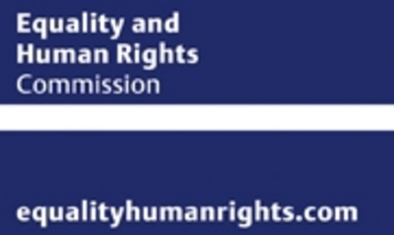
EHRC publishes Stop and Think report: Police forces have reduced their unfair use of stop and search powers, while continuing to see a reduction in crime rates, after intervention by the Equality and Human Rights Commission. The details of this work are in Stop and Think Again, a new report published by the EHRC. The report also reveals that the five forces concerned have seen reductions of up to 50 percent in overall usage and a fall for some in the disproportionate use against ethnic minorities. Forces are being fairer and more efficient in their use of stop and search as a result. This followed the EHRC's intervention which focused on an intelligence-based use of stop and search powers rather than one based on racial stereotypes. The success of the EHRC's work has created a best practice blueprint with positive measurable results for other forces to follow. The EHRC will continue to track the progress of the five forces and engage with them and other forces if necessary.
The EHRC has updated its previous submission (August 2012) to the United Nations Committee Against Torture (UNCAT). The report covers the legal framework, policies and practices in Britain (England, Scotland and Wales) that under the UK's constitutional arrangements, are the responsibility of the UK Government or have been devolved to the Welsh Assembly. On the EHRC's analysis, the provisions of the Convention Against Torture are largely incorporated into the domestic legislative framework, but there is still some work to be done in ensuring that its protections are always fully implemented in practice. Continue reading.
Assistance dogs - a guide for all businesses (new for June 2013): the EHRC has published a guidance to help businesses understand what they can do to comply with their legal duties under the Equality Act 2010 and encourage businesses to welcome registered Assistance dogs accompanied by their disabled owner onto their premises.
The EHRC has recently published an updated briefing paper seeking to present within a single, short, document the best available, and publicly accessible, recent statistical data in the United Kingdom (UK) relating to gender pay gaps.
The EHRC has welcomed a Supreme Court ruling on armed forces and human rights protection. In this landmark judgment the Supreme Court ruled that British soldiers killed while serving in Iraq were still under UK jurisdiction and so were entitled to human rights protection to the extent that is reasonable and does not interfere with the demands of active service. Continue reading
Scottish pupil wins landmark disability discrimination tribunal: A ten year old disabled pupil from St Hilary's Primary School in East Kilbride will be able to attend guitar classes thanks to the decision of an Additional Support Needs Tribunal. In the first case of its kind in Scotland, the tribunal decision stated that school run extra-curricular activities, and not just the day to day curriculum, are covered by the Equality Act duty to make reasonable adjustments to avoid substantial disadvantage to any disabled pupil. Continue reading
(contact: international@equalityhumanrights.com)
Top of page

European Developments

New PROGRESS Calls for Proposals on Gender Equality and Anti-discrimination
Two new open call for proposals have been published in the European Commission's DG Justice's website. One, on gender equality, focuses on the gender pay gap and gender balance in economic decision-making. The second one, on anti-discrimination, is restricted to national authorities in charge of equality and non-discrimination.
European Commission proposes recommendations for faster socio-economic integration of Roma
ECRI, the European Commission Against Racism and Intolerance, has published its summary of the Seminar with National Specialised Bodies to combat Racism and Racial Discrimination: "Challenges faced in the current institutional and budgetary environment"
EU foreign affairs ministers adopt ground-breaking global LGBTI policy
Gender identity: the Court of Cassation considers Italian law requiring the termination of marriage in case of gender reassignment unconstitutional
The Italian Supreme Court (Corte di Cassazione) has decided to stay the proceedings waiting for the Constitutional Court's assessment on a case on legal provisions requiring the automatic termination of the marriage of those married persons who decided to undergo gender reassignment. According to the view of the Supreme Court as elaborated in its order n.14329 / 13, such ‘imposed divorce' would violate Italian constitutional provisions read in conjunction with articles 8 and 12 of the European Convention of Human Rights. The Court, in its legal reasoning, makes reference not only to the European Court of Human Rights, but also on German and Austrian Constitutional Courts' decisions on similar topics. The Italian Constitutional Court will now have to decide on the constitutionality of the provision.
European Institute for Gender Equality Call for Nominations for the 2014 Wo/Men Inspiring Europe Calendar (DEADLINE 15 SEPTEMBER)
European Network Against Racism Foundation Awards - Call for applications (DEADLINE 31 AUGUST)
Top of page
Latest publications

Equinet Annual Report 2012
Tackling the "Known Unknown": How Equality Bodies Can Address Under-Reporting of Discrimination through Communications
EC Study on "The role of men in gender equality – European strategies & insights"
Childcare: a report on the Barcelona objectives
In 2002 EU countries have agreed in Barcelona two targets for the availability and accessibility of childcare services. A just published Commission report shows that only eight EU Member States were able to meet the targets for both age categories (0-3 years; 3 years to mandatory school age) in 2010: Belgium, Denmark, Spain, France, the Netherlands, Sweden, Slovenia and United Kingdom. Significant improvements still need to be made to achieve a satisfactory level of availability, especially for children under 3. High costs incurred by parents and the opening hours of facilities, which are incompatible with full-time work remain challenging. Investment in high quality services must be continued.
EU Study: 39 % of gender pension gap
A new expert study on the gender gap in pensions in Europe reveals a 39% gender pension gap. Gender gaps in pensions are the result of three labour market trends: (1) women are less likely to be in employment than men; (2) they work fewer hours and/or years; and (3) they receive lower wages on average. Pension systems are not simply neutral reflections of past employment histories: pensions may reduce, reproduce or even reinforce gender inequalities in the labour market and in the division of care responsibilities between women and men.
EU Agency for Fundamental Rights Annual Report 2012
EU Agency for Fundamental Rights and the European Court of Human Rights (ECHR): Handbook on European law relating to asylum, borders and immigration
European Institute for Gender Equality Index
European Women's Lobby Observatory of Violence against Women's 2013 Barometer publication - the 2013 Barometer on Rape
PICUM, the Platform for International Cooperation on Undocumented Migrants, launched a report on "Child poverty and well-being: Spotlight on the situation of migrant children in Cyprus and the EU"
PICUM, the Platform for International Cooperation on Undocumented Migrants, launched a report on "Using Legal Strategies to Enforce Undocumented Migrants' Human Rights"
Top of page

 | Equinet Secretariat  Rue Royale 138  1000 Brussels - Belgium  Tel : +32 (0) 2 212 3182  Fax : +32 (0) 2 212 3030 | 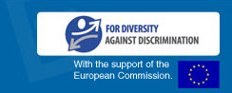
   |  |  |  | 
  Copyright 2012 © Equinet. All rights reserved.

