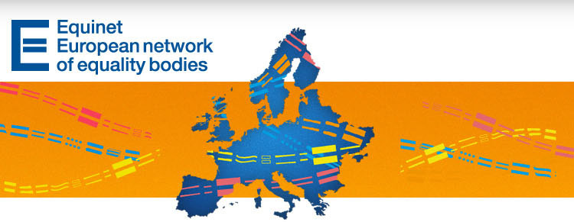

EQUALITY BODIES AND THE RACE GROUND - EQUINET E-NEWSLETTER NO. 25
Dear Subscriber,
The Equinet e-newsletter and the Equinet website are the leading sources of information at European level about and for equality bodies in Europe. We encourage you to forward this newsletter to potentially interested colleagues and partner organisations. Subscription to our newsletter is possible through the homepage of our website at www.equineteurope.org.
Don't forget that you can also connect with Equinet through social media on Facebook (https://www.facebook.com/EquinetEurope) and Twitter (@equineteurope).
We wish you all a wonderful month ahead,
The Equinet Team

Contents

News from Equinet
European Developments
News from Equality Bodies
News from European Institutions and Partners
Upcoming Events
Latest Publications

News from Equinet
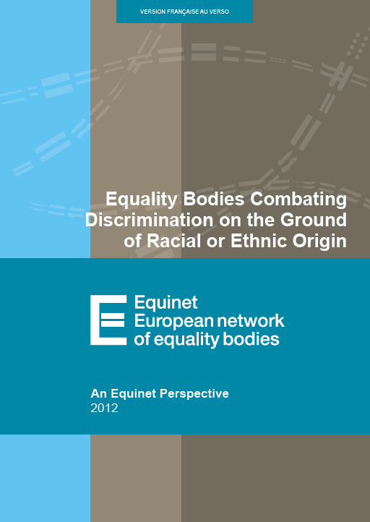
Equinet has launched its latest perspective on "Equality Bodies Combating Discrimination on the Ground of Racial or Ethnic Origin"
The perspective was prepared by Equinet’s Working Group on Policy Formation and seeks to fulfil the following aims:
Examine the law governing the work of equality bodies on the ground of racial or ethnic origin and explore the strategic approaches developed by them in this field.
Identify the body of work carried out on the ground of racial or ethnic origin by the diversity of equality bodies across Europe.
Present suggestions for further development by equality bodies and identify the implications for policy formation at EU and Member State levels.
Continue reading
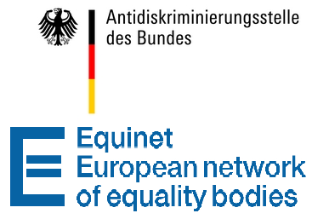
Staff members of equality bodies are invited to register for the Equinet Legal Training in Berlin on 18-19 March
Equinet and the Federal Anti-Discrimination Agency of Germany will organise a training for staff members of equality bodies handling cases of alleged discrimination.
The topics that will be focused on during the training are:
The shift of the burden of proof and types of evidence in discrimination cases;
Situation testing and its use;
Practicalities of involvement in a case before the European courts;
Disability discrimination.
More information can be found on the training’s webpage, while staff members of Equinet member-organisations can register for the event here until 22 February 2013.
Equinet key dates in 2013
18-19 March Equinet Legal Training (Berlin, Germany)
16 May Equinet Legal Seminar (Brussels, Belgium)
27 June Equinet Seminar on gender related issues (Brussels, Belgium)
18-19 September Equinet Training on gender related issues (Lisbon, Portugal)
24-25 October Equinet Training on supporting duty bearers (Zagreb, Croatia)
For more details about these events and for an overview of Equinet’s activities planned for the year, read our 2013 Equinet Workplan.

Note that Equinet trainings are dedicated exclusively to staff members of national equality bodies.

European Developments
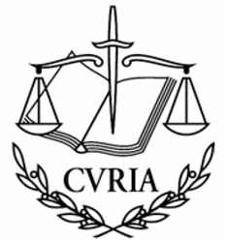
CJEU decides equality body not a "court or tribunal"
The Commission for Protection against Discrimination (CPD), a member of Equinet and a quasi-judicial equality body with a competence to give legally binding decisions on discrimination complaints, has in 2011 requested a preliminary ruling from the Court of Justice of the EU (CJEU) under Article 267 TFEU. The request concerned a case of alleged discrimination against the Roma minority in a Bulgarian city (see background and details here).
However, in order to deal with the substantial questions asked by the CPD, the CJEU first had to decide whether the CPD, entrusted by law with different categories of functions, could be regarded as a court or tribunal within the meaning of Article 267 TFEU, and thus if the reference is admissible. The admissibility of the reference would have given the CJEU an opportunity to decide on an interesting case of indirect discrimination based on ethnic origin and the possibilities for justification of such discrimination.
Although the Opinion of Advocate General Kokott (delivered on 20 September 2012) suggested that the reference is admissible and regarded the CPD in the present case a court or tribunal within the meaning of Article 267 TFEU, the CJEU has followed a different approach in its judgment delivered on 31 January 2013. Continue reading
European Court judgement in the case of Eweida, Ladele, and others
An important judgment was delivered on 15 January 2013 by the European Court of Human Rights on a case touching upon freedom of religion, religious discrimination and the balance between competing Convention rights, notably those of freedom of religion and the prohibition of discrimination.
Equinet discussed some of these issues and cases in its 2011 report "A question of faith: religion and belief in Europe", within the Equinet Working Group on Equality Law in Practice.
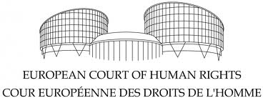
You can read the Court’s full decision here or read a short summary of it by accessing the Court’s official blog.
European Court of Human Rights rules against Hungary in the case of Horváth and Kiss v Hungary
The case of Horváth and Kiss v Hungary concerned the complaints of two young men of Roma origin that due to their ethnic origin they had been wrongly placed in a school for the mentally disabled and that their education there had amounted to discrimination. The Court ruled in favour of the applicants – finding a violation of Article 2 of Protocol No. 1 (right to education) to the European Convention on Human Rights read in conjunction with Article 14 (prohibition of discrimination). Continue reading
Top of page

News from Equality Bodies

Belgium – The Centre for Equal Opportunities and Opposition to Racism
The CEEOR has published a report on mediation and alternative measures in the fight against discrimination. Alternative measures give the offenders the opportunity to take responsibility for their behaviour and address the harm that has been committed. The CEOOR will continue developing specific instruments to promote alternative measures in the fields of discrimination and hate speech. Continue reading (in French)
The CEEOR also published a research about stereotypes based on age in the employment sector (in French) The survey shows a positive evolution in stereotyping patterns based on age (with the exception of particular sectors). However, the key finding of the survey is that 1 out of 3 respondents (employees or potential employees) consider discrimination based on age by recruiters to be more or less acceptable and justified.
Discrimination based on age will be the main focus of CEOOR’s next annual report about discrimination, to be published in May 2013.
The CEEOR won a court case related to the wearing of religious symbols (in this case the Islamic headscarves) in employment. After receiving some complaints from customers, the company decided not to renew the contract of an employee who had recently started to wear a headscarf. The employer’s action was considered discriminatory, although the company can still appeal the decision. Continue reading (in French) (contact: Nadine Brauns)

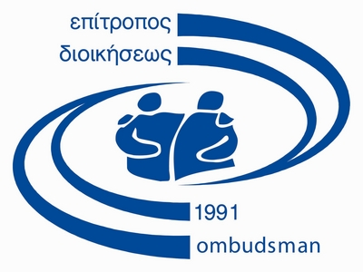
Cyprus - Office of the Commissioner for Administration and Human Rights
A report on Homophobia in schools and the handling of homophobic incidents was published. According to the findings of the research, bullying based on sexual orientation or gender manifestations is a common phenomenon, expressed by both students and teachers.
Exemption from religious studies in secondary schools was the topic of another report by the Ombudsman. A 15-year old Jehovah’s Witness complained of having been verbally assaulted by the school personnel and then repeatedly subjected to a penalty of a two-day expulsion from school due to her decision not to attend religious education classes, which the Ombudsman found to be a severe violation of religious freedom. The Ombudsman had previously published a report on effectively implementing exemption from religious studies without violating religious liberty and stigmatizing students with different beliefs.
The Ombudsman also published a report on job advertisements that call for a specific gender. The Report was based on an advertisement for a cleaning job vacancy addressed to women and other similar advertisements. The Ombudsman explained the relevant legal framework and how this practice constitutes discrimination based on gender, and stressed the significance of gender-neutral for achieving equal representation of men and women in the labour market. In conclusion, the Ombudsman suggested that the Media and the State Printhouse examine all advertisements in advance to secure their compliance to the legal framework.
The Ombudsman financially supports a flashmob dance activity that will take place at 14 February 2013 at the Mall of Cyprus, within the context of the international campaign One Billion Rising which aims to raise awareness regarding violence against women. The activity is co-organized by the Mediterranean Institute of Gender Studies, the Office of European Parliament in Cyprus, and others.
A school competition entitled Talk about racism and xenophobia: silence is not a solution is co-organized by the Ombudsman’s Office, along with the Representations of the EC and the UNHCR in Cyprus and with the support of the Ministry of Education and Culture. The competition calls for the creation of a school newspaper, while the general campaign includes the holding of discussions and workshops at schools. There is also a Facebook page of the event. (contact: Thekla Demetriadou)


Czech Republic – Office of the Public Defender of Rights
The 1st December 2012 marked three years since the Ombudsman became the Czech Equality Body. Nevertheless, for ensuring the right to equal treatment and to the protection of persons against discrimination, the Ombudsman was provided with only rather “soft” legal instruments, such as assisting the victims of discrimination, publishing opinions and recommendations, carrying out research etc. Therefore the Ombudsman will hold two expert meetings reviewing the knowledge experience gathered during the last three years and enquiring into the sufficiency of the current legal instruments.
The consultations with various stakeholders will take place 19-20 February 2013. The first day is dedicated to a round table discussion with selected central, inspection and supervisory bodies, in order to discuss discrimination data collection, the theoretical and practical problems in proving discriminatory behaviour within the state supervision and administrative actions (situation testing, admissibility of recordings as evidence), among others. The second day will include discussions by legislators, representatives of administrative bodies and local authorities, judges, academics, NGOs, and the media, but also the representatives of institutions that are often accused of discriminatory practices (employers; service, housing, education and health care providers, etc). The purpose of the meeting is to identify the institutional, legal, and factual barriers faced when enforcing claims arising from the anti-discrimination law and to propose methods for solving the problems (on legislative, methodical, institutional and research levels). (contact: Hrazdílková Iva)
Top of page

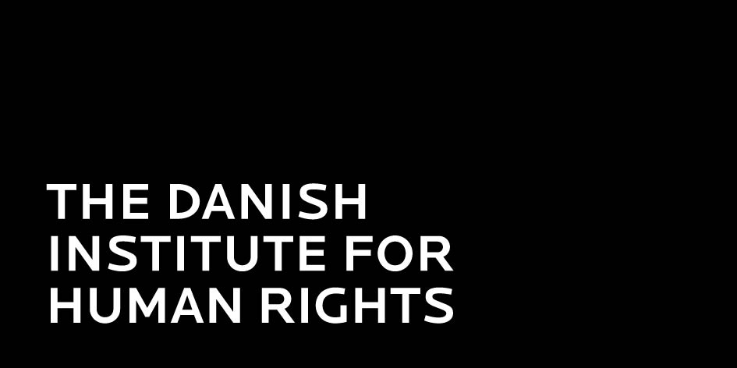
Denmark – Danish Institute for Human Rights (DIHR)
As a part of the obligation to monitor the human rights situation in Denmark, the Institute has published a new kind of status report in 2012. This report addresses various issues such as children, imprisonment and freedom of expression and it recommends approaches that may improve the conditions in Denmark.
Read the full English summary of the status report here or the Equinet news item here
Six leaflets on discrimination and where to turn for assistance in case of discrimination have been published. The leaflets provide information on legislation and on the right not to be discriminated against in different areas within the Danish system. Furthermore, the leaflets contain information on the advice and assistance service offered by the DIHR to citizens experiencing discrimination due to their gender, race, or ethnic origin. Finally, the leaflets inform about The Board of Equal Treatment which deals with complaints related to discrimination.
The leaflets are available in Arabic, English, French, Greenlandic, Somalian, Turkish, Urdu, and Danish. (contact: Christine Bendixen)


Finland – Ombudsman for Equality
Discrimination on the grounds of pregnancy and family leave has been a considerable problem in Finland. Majority of the cases where the Ombudsman for Equality is contacted concerning issues related to working life, and the majority of the lawsuits concerning gender discrimination are related to discrimination on the grounds of pregnancy and family leave. These cases are highly under-reported: only a few women turn to authorities for legal advice and help.
Thus, the Ombudsman for Equality launched a campaign Oikeutta odottaville (“Justice for those expecting a baby”, with the slogan “Is your employer expecting too?”) in December 2012.
The aim of the campaign was to:
- Raise public awareness of the rights of the pregnant women in working life
- Encourage the women suspecting discrimination to contact their trade union, occupational health and safety authorities and the Office of the Ombudsman Equality and ask for legal advice and to report
- Challenge the employers to check their attitudes and the legality of their measures. (contact: Ojanperä Päivi)

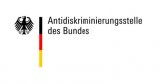
Germany – Federal Anti Discrimination Agency (FADA)
For the Thematic Year 2013 – Discrimination against people with disabilities - the FADA has commissioned three research projects on the following topics:
Barrier-free access to goods and services. This research intends to identify typical situations in which people with disabilities are discriminated in the access to and supply of goods and services. The research will enquire which forms and mechanisms of discrimination can be found in this area, in which contexts can differential treatment of persons with disability be justified. Also recommendations for creating barrier-free access to goods and services will be provided.
Legal Expertise: Discrimination against people with chronic diseases. The expertise will determine what kinds of protection exist for people with a chronic disease who face discrimination in their daily or work life. The expertise aims to identify gaps in protection, analyse the potential improvement of General Equal Treatment Act (e.g. establishing a new category), identify the need for action with regard to private insurances, employees etc., and examine the relation between chronic diseases and disability.
Access to the labour market by persons with disability. This research seeks to explore the types of discrimination people with disabilities are likely to face when accessing the labour market. It will try to identify both psychological and structural barriers, provide recommendations and support to people with disabilities along with enterprises and organisations, in order to counteract discrimination. (contact: Hermann-Josef Lange)


Hungary - Office of the Commissioner for Fundamental Rights
The Office has released an overview of statistical information on the changes and trends in the institution throughout the year 2012. As of January 1, 2012, instead of the four independent ombudsman offices a new, one ombudsman system headed by Máté Szabó, Commissioner for Fundamental Rights, was established, where the interests of national minorities and future generations are protected by deputy commissioners. The number of complaints filed to the Office increased by 25% during the first year of the reorganized ombudsman system and its information service was accessed by almost 13 000 people, against 9500 a year earlier. It is also important to note that 61% of the Ombudsman’s recommendations were accepted and 14% were refused or ignored; while the remaining 25% are still waiting for a response.
A comprehensive report on community employment reveals improprieties violating basic rights of persons. In 2012, in the framework of the project “Dignity of Labour”, the ombudsman examined the constitutional aspects of getting into and getting out of community employment, community employment programs, data management and administration and the review and management of these programmes. The report underlines that persons in community employment are in a vulnerable situation in multiple fronts since there is a possibility of arbitrary application of law by the employers and the authorities and the situation can even deteriorate due to problems of administration. Continue reading (in Hungarian). (contact: Balajti Ágnes)

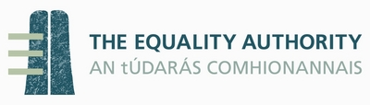
Ireland - Equality Authority
The EA together with The Economic and Social Research Institute recently published two research reports that also utilise data from 2004 in order to compare the circumstances during the boom with those during the recession.
The first report “Disability in the Irish labour market” found that in 2010, working-age people with a disability were less than half as likely to be active in the labour market (36% compared to 77% of other adults) and had a considerably higher unemployment rate (22% compared to 16% of other adults). Those rates are especially low in comparison to other European countries.
But there have been improvements in the area of discrimination against people with a disability: there was a significant fall in the percentage of people with a disability who experienced discrimination between 2004 and 2010 (from 26% to 19%). Both discrimination in relation to work (in seeking work or in the workplace) and in relation to gaining access to services decreased over those years.
However, it seems like the recession has a worse impact on women with disabilities, as the labour market participation rate of men with a disability increased slightly while the rate fell slightly for women with a disability.
The other report entitled “Ethnicity and Nationality in the Irish Labour Market”, shows that Black African, Ethnic Minority EU and EU New Member State (NMS) groups fare worse than other national-ethnic groups in terms of both objective labour market outcomes (e.g. employment and unemployment) and in their experience of discrimination, with the results varying according to nationality and ethnicity.
White individuals from the ’old’ EU-13 Member States recorded the lowest unemployment rate at 9%, followed by Asians at 12%. Black Africans recorded the highest unemployment rate (36%), and were four times more likely to be unemployed than White Irish individuals. However, compared with 2004, Black African individuals were more likely to be employed in 2010, which suggests a slight improvement in their situation. But Black Africans were still almost seven times more likely to report experiencing discrimination in the workplace or when looking for work. (contact: Cathal F. Kelly)
Top of page
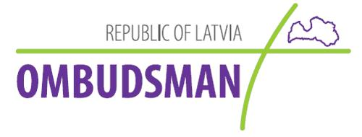
Latvia - Office of the Ombudsman
The Ombudsman has presented a report on the risk of poverty in Latvia. Notwithstanding the information provided by the Latvian government about rapid recovery of the national economy, social reality and statistical data suggest that the economic stress is still felt by more than one half of the Latvian population. 40% of the Latvian population including 43% of children and 33% of pensioners are exposed to the risk of poverty and social exclusion. Continue reading
Therefore, the Ombudsman Mr. Juris Jansons appealed to the responsible institutions of the EU within the scope of their competencies to use the rights and powers defined by the Treaty on European Union and the Treaty on the Functioning of the European Union in order as far as possible to prevent infringements of social rights in acts of the Member States. This report was addressed to several high officials in Latvia and Europe.
In mid-December 2012 Latvian society and the media were informed about the activities of Ombudsman’s office in year 2012. In the eleven month period between January and November 2012, the Ombudsman’s office received 2443 applications from individuals (increase of 400 compared to the previous year). Most of the applications are related to civil and political rights questions (1533 applications) and social and economic rights questions (624 submissions). There was also a significant increase in consultations for residents, providing information on where and how to apply in order to solve their problem. (contact: Laura Bagata)


Malta - National Commission for the Promotion of Equality (NCPE)
During a half day final conference concluding the EU co-funded project "ESF 3.47 Unlocking the Female Potential", the NCPE launched the outcomes of the research on ‘Life Prospects of Teenage Parents’. This is the result of a two year longitudinal study, with a total of 100 participants who became parents during their teenage years. The study identified the respondent profile; overall feelings and perceptions of teenage parents; educational prospects and job prospects among teenage parents; lifestyle and hobbies/pastimes; immediate family’s reaction to respondent becoming a teenage parent and views and attitudes on sex among teenage parents as well as their relationship with the other parent. To download the respective study, click here
Meanwhile, NCPE formally certified another fifteen organisations with the Equality Mark. These organisations have been certified as true equal opportunities employers in relation to gender and hence are authorised to use the Equality Mark logo on their publications and documentation. The certification and accompanying logo is valid for two years from the date of award. This brings the number of companies certified with the Equality Mark to a total of 51 certified companies and 15,253 employees working under gender certified conditions. (contact: Maria-Theresa Portelli)


Poland - Human Rights Defender (HRD)
As a part of celebrations of the European Year for Active Ageing and Solidarity between Generations the Human Rights Defender released a publication entitled “Strategies of actions in an ageing society. Theses and recommendations”. It is a collection of articles, constituting a part of a broader public debate on the implementation of international standards and the Madrid International Plan of Action on Ageing of 2002. The publication was launched at a conference that was followed by 10000 viewers on the Internet, thus contributing to a wide public debate on social inclusion of seniors. Continue reading
The Human Rights Defender also carries out social research on counteracting discrimination. In 2012 the research concerned seniors’ access to financial services, the way seniors are perceived by younger people and vice versa, violence against elderly women and women with disabilities and access to healthcare by non-heterosexual people. (contact: Katarzyna Wilkołaska)


Spain – Race and Ethnic Equality Council
The Council has published three new reports on racial and ethnic discrimination in Spain:
Study on racial and ethnic discrimination: potential victims’ perceptions - fieldwork for the study was carried out in 2011, mirroring the research that was conducted in 2010, thus making it possible to compare the evolution of the perception of discrimination by the potential victims.
Report on the Network of Support Centres for victims of racial and ethnic discrimination, analysing the main activities of the Network in 2011. The Network was set up as a project of the Race and Ethnic Equality Council that aimed to empower eight NGOs to provide independent assistance to victims of discrimination through a network of centres all over the country during 2011.
Annual report on discrimination and application of the principle of equality on the grounds of racial and ethnic origin in Spain in 2011. The report analyses legislation, recent jurisprudence, surveys, studies and reports on equal treatment and non-discrimination based on racial or ethnic origin as well as the main activities of the Council in 2011 and other good practices.
These publications were presented at a public event that took place on 10th December 2012, observing the Human Rights Day. The publications are available (in Spanish). (contact: Ignacio Sola Barleycorn)


Sweden – Equality Ombudsman
In late December, the Equality Ombudsman sent an information pack to all employers in Sweden with more than 10 employees, amounting to around 40000 employers. The aim of the information campaign is to remind employers of their responsibilities for equal treatment and to provide them with tools and information so that they can live up to these responsibilities. Apart from a letter reminding them of their legal responsibilities it also included a guide to preventing discrimination at the workplace and an information folder about available tools.
The Ombudsman also plans to increase the number of audits and inspections of employers to support increased compliance to Swedish anti-discrimination laws.
A study on equality data has been published recently, focusing on the possibility to include new variables in the Swedish Living Conditions Survey (that is partially connected to EU-SILC). The variables considered concern the following discrimination grounds: ethnic origin, religion or belief, transgender identity or expression, disability and sexual orientation. Data concerning the five legally recognized national minorities in Sweden - Jews, Roma, Sami, Finns and Tornedalers - are also covered by the study.
The report is currently available in Swedish, with an English translation expected during the first half of 2013. (contact: Yamam Al-Zubaidi)
Top of page
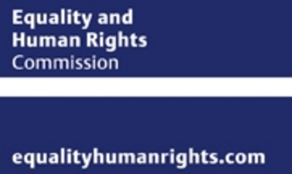
United Kingdom – Equality and Human Rights Commission (EHRC)
EHRC will be working with employers and religious groups to help them interpret the European Court of Human Rights’ ruling on a series of cases involving religious freedom in the workplace. (More information on the Court decision on Eweida and Chaplin case can be found here).
The EHRC’s view is that the Government should now look at the need to change the law to take the European Court judgment into account. However, until this takes place, there is potential for confusion for both employers and employees following the ruling. This is in particular due to the fact that the Court found that one of the plaintiffs (Eweida) had suffered discrimination but that the other one (Chaplin) had not.
The EHRC will therefore be publishing new guidance on this issue for employers and employees, to help them avoid further confusion and potentially costly litigation while the government considers whether to change the law. The EHRC also welcomed the Court’s statement of principle that "as enshrined in Article 9, freedom of thought, conscience and religion is one of the foundations of a ’democratic society’ within the meaning of the European Convention.’
A new guidance on the Public Sector Equality Duty (PSED) under the Equality Act has been published, intending to help public authorities encourage good relations, promote equality and eliminate discrimination in the workplace and in delivering public services. The guidance gives a straightforward but comprehensive explanation of how public authorities – both as employers and service providers – should comply with the duty, as well as practical advice on how to do so. Continue reading (contact: Aidan Toomey)

United Kingdom – Equality Commission for Northern Ireland (ECNI)
ECNI publishes the 13th Annual Report, covering the period 1 April 2011 to 31 March 2012.
Highlights of the report include:
- campaigns promoting new rights for people with disabilities in accessing public transport
- a focus on providing information to employers in SMEs (small and medium enterprises)
- promoting the Commission’s services to other harder to reach groups such as minority ethnic communities, gay, lesbian and bisexual people and young people
A woman whose request to work flexibly was refused after she returned to work from maternity leave has settled her case against Smyth’s Toys (NI) Ltd for £15,000. ECNI supported her in taking her sex discrimination case to the Industrial Tribunal. Continue reading
A survey from the ECNI has found that employers in Northern Ireland have record levels of awareness of equality law. Nearly all employers surveyed (99%) know about the anti-discrimination laws on the grounds of age, religion and politics, with disability and race next at 98% and awareness of sexual orientation at 94%. Continue reading
The Equality Commission has published the 22nd Annual Monitoring Report on the composition of the workforce in Northern Ireland. Commenting on the report Chief Commissioner Michael Wardlow said, “This year’s returns show that the composition of the monitored workforce is broadly in line with the community shares of those available for work.” Continue reading (contact: Mark Soult)

News from European Institutions and Partners
European Anti-Poverty Network (EAPN)
EAPN has launched the 1st EAPN Award for Transnational Inspiration and Learning in the Fight against Poverty and Social Exclusion. The award seeks to recognize NGOs and Public Sector entities who have initiated new positive approaches to fighting poverty and social exclusion that foster direct participation of people living in poverty, resulting from such transnational work. Deadline for submitting entries is 15 February 2013.
For award criteria and application details click here.
European Women’s Lobby (EWL)
The EWL published the first edition of its “Ticking Clocks” report, which aims to provide input for the European Commission annual drafting of recommendations to the Member States in socio-economic policies. The report has been drafted with the input of the EWL’s member organisations, which provided "alternative" country-specific recommendations on Europe 2020 Strategy, on the basis of an analysis of the National Reform Programmes (NRPs). Continue reading

Upcoming events
Equinet members
21-22 March: The Office of the Ombudsman of the Republic of Latvia will host the Annual workshop for Children’s Ombudsmen of Nordic—Baltic countries. The main themes of the conference will be access to rights, working with families that have separated children, “baby-hatches” and ways for institutions to find out the opinion of the child.
Europe
28 February – 1 March: Seminar on the Charter of Fundamental Rights of the European Union in Practice in Barcelona, Spain. The event is aimed at legal practitioners and will focus on the Charter’s application to civil law, employment and social rights. Continue reading

Latest Publications
Equinet perspective on "Equality Bodies Combating Discrimination on the Ground of Racial or Ethnic Origin"
European Commission report on "The Impact of the Economic Crisis on the Situation of Women and Men and on Gender Equality Policies"
European Parliament note on "The Policy on Gender Equality in Ireland"

 | Equinet Secretariat  Rue Royale 138  1000 Brussels - Belgium  Tel : +32 (0) 2 212 3182  Fax : +32 (0) 2 212 3030 | 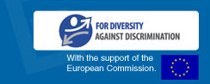
   |  |  | 
  Copyright 2012 © Equinet. All rights reserved.

