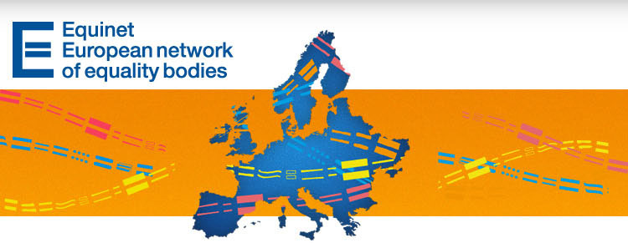

EQUINET ANALYSES EQUALITY LAW IN PRACTICE AT EU LEVEL

EQUINET E-NEWSLETTER NO. 26

Dear Subscriber,
Are you connected with Equinet through social media? You can follow us on Facebook (https://www.facebook.com/EquinetEurope) and Twitter (@equineteurope) to find out about the latest initiatives, campaigns, reports and events organised by equality bodies across Europe. You can also subscribe to our RSS feed, check out the photos from our latest events on Picasa, and (if your organisation is an Equinet member) join our LinkedIn group.
Also keep in mind that you can find all our past newsletters on the Equinet website, providing you with a rich source of information on best practices, activities and experiences of equality bodies in Europe. Therefore we would be grateful if you forwarded this information to your colleagues and any contacts who may interested in our work.
Thank you for your support,
The Equinet Team

Contents

News from Equinet
News from Equality Bodies
European Developments
Upcoming Events
Latest Publications

News from Equinet

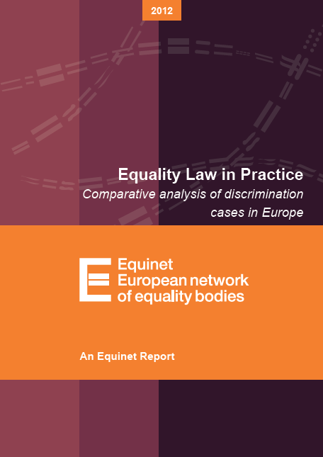
Equinet has launched its latest Equality Law in Practice report
The report was prepared by Equinet's Working Group on Equality Law in Practice. One aspect of the Group's work is using real-life cases to analyse how the EU Equal Treatment Directives and relevant national legislation are applied in practice. This method permits a comparison of the different national legal solutions to the cases which in turn achieves a number of objectives:
identifying patterns in the way in which Directives have been implemented and applied in national laws;
identifying potential gaps in protection or provisions in the EU Directives requiring further clarification;
identifying potential and existing legislative gaps in national legal systems.
The latest report looks at cases on associative sex discrimination on grounds of the pregnancy of the claimant's partner, on discriminatory dismissal of older workers, and on discrimination on the ground of nationality or citizenship.
Continue reading

1 March brought two new staff members to the Equinet Secretariat team
Ms. Ilaria Volpe joined the Equinet Secretariat team as permanent staff member with the position of Policy Officer (gender focus). She will be responsible for advancing the work of Equinet on the ground of gender and doing so in a manner that takes account of issues of gender identity and intersectionality. She will also work in close collaboration with the newly established Equinet Working Group on Gender-Related Issues. Ilaria can be contacted by email at Ilaria.Volpe@equineteurope.org or by phone at +32 (0) 2 212 3186.
In addition to Ilaria, Ms. Vasiliki Gkesouli began her internship with Equinet that will last until the end of July, supporting our policy, administrative and communication initiatives. Vasiliki can be reached by email at Vasiliki.Gkesouli@equineteurope.org or by phone at +32 (0) 2 212 3185.

News from Equality Bodies


Belgium – The Centre for Equal Opportunities and Opposition to Racism
The Law governing the functioning of the Belgian Centre for Equal Opportunities and Opposition to Racism celebrated its 20th anniversary on 15 February 2013. On this occasion, the centre organised a "day of reflection" on the first objectives it was recognized to aim for: fighting racism and promoting integration, diversity and the rights of foreigners. This day was an opportunity to discuss the form taken by these issues over time and the answers that the government and the Belgian society have given them. It was also an opportunity to discuss the issues that could arise in the next 20 years. Continue reading (French)
(contact: Nadine Brauns)

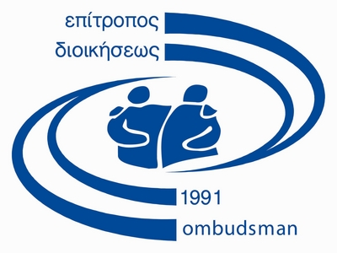
Cyprus - Office of the Commissioner for Administration and Human Rights
Following a complaint submitted by an NGO (ACCEPT_LGBT) concerning the detention of a female transsexual in a detention centre for male detainees, the Ombudsman issued a report suggesting the adoption of a specific police order which will give precise guidelines to all members of the police, concerning the handling of cases of transsexual person so that the full respect of the rights is safeguarded. As it was pointed out, a decisive factor for the treatment of transsexual detainees as male or female should be the self-determination of their gender identity.Continue reading (Greek)
The Ombudsman offered financial support for a flashmob dance activity that took place at the Mall of Cyprus within the context of the international campaign One Billion Rising. This campaign aims to raise awareness regarding violence against women, while the activity in Cyprus was co-organized by the Mediterranean Institute of Gender Studies, the Office of the European Parliament in Cyprus, and others.
On the occasion of the International Day for the Elimination of Racial Discrimination, the Ombudsman (in cooperation with KISA, an NGO for the promotion and support of migrants' rights in Cyprus, and the European Parliament Office in Cyprus) will organize the screening of the short film Anna. The film tells the story of the relationship between a Filipino domestic worker and her employer, whom she takes care of. The film screening will be followed by a discussion on the issue of the integration of migrants in Cypriot society.
A school competition entitled Talk about racism and xenophobia: silence is not a solution is co-organized by the Ombudsman's Office, along with the Representation of the European Commission in Cyprus and the UNHCR Representation in Cyprus, with the support of the Ministry of Education and Culture. The competition calls for the creation of a school newspaper, while the general campaign includes the holding of discussions and workshops at schools. The deadline for the submission of entries is 29 March 29 2013.
(contact: Thekla Demetriadou)

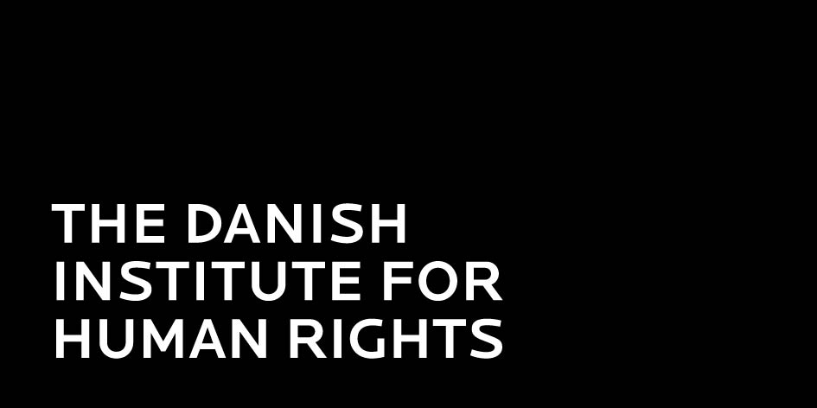
Denmark – Danish Institute for Human Rights (DIHR)
In March 2013 the DIHR launches a report which clarifies the extent and scope of the prohibition against sex discrimination in access to and supply of goods and services which has existed in Denmark since the adoption of the Equality Act in 2000. The Equality Act is mandatory for all sellers/service providers in both the private and public sectors and is of great practical importance in the everyday life of citizens. The purpose of the report is also to clarify the duty to incorporate gender equality into all planning and management that applies in the public sector (the so-called mainstreaming duty). It also discusses to what extent Danish gender equality rules – within the existing framework of EU rules – can and should be made stricter to provide better protection of the principle of equality. The report is in Danish but has an extensive summary in English which can be accessed here.
(contact: Christine Bendixen)

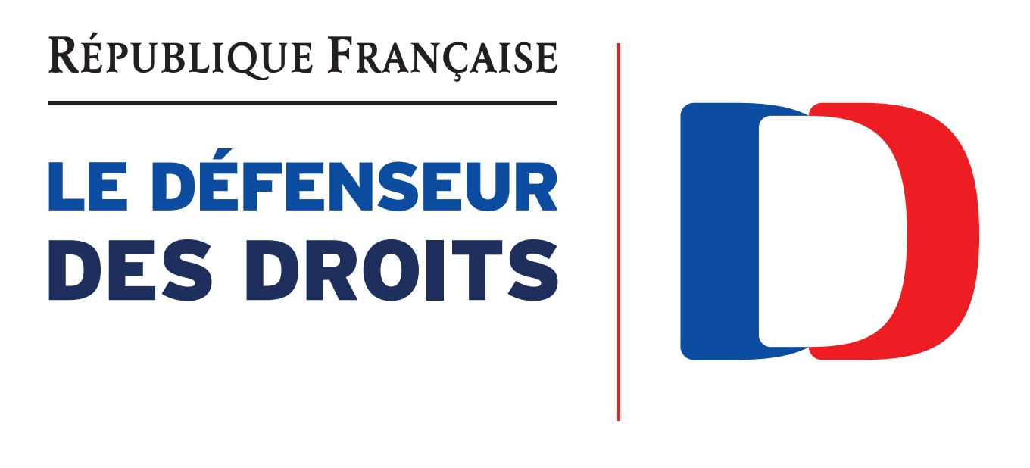
France – Defender of Rights
The Defender has recently published a Guide for Preventing Discrimination and Safeguarding Equality (only in French), aimed at helping local authorities' human resources departments with improving their HR policies and implementing real equality in their hiring practices and throughout employees' careers.
(contact: Nepheli Yatropoulos)

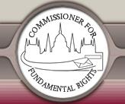
Hungary - Office of the Commissioner for Fundamental Rights
The Commissioner for Fundamental Rights observed that the Act on person transportation services does not guarantee the right to access to the public transportation with respect to the equal opportunities principle and also it involves only the gradual implementation of the obstacle-clearance of the public transportation instead of a definitive deadline. Due to that, the Commissioner for Fundamental Rights requested the Constitutional Court to review the provision. Continue reading
(contact: Balajti Ágnes)

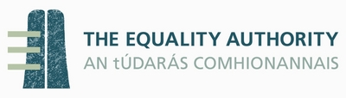
Ireland - Equality Authority
The Authority published a Report on ‘Selected Issues in Irish Equality Caselaw 2008-2011', which was launched by the Minister for Justice and Equality, Alan Shatter TD in Dublin on 4 February 2013. The report was written by David Fennelly, who is a barrister practising at the Irish bar. The focus of this review is on application of the law, following well-chosen themes - the jurisdiction of the Equality Tribunal, sharing of the burden of proof, important recent developments in the case-law, interpretation of the exemptions in the legislation, and interpretation by the Irish courts of the legislation.
(contact: Cathal F. Kelly)

Top of page
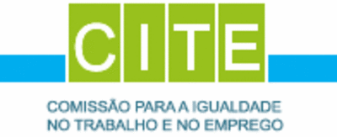
Portugal - Portuguese Commission for Equality in Labour and Employment
In the frame of its mission, competencies and powers and taking into account the European Strategy 2020, as well as the priorities of the Portuguese state on gender equality within this strategy,CITE boosted the development of a partnership project with companies with the main objective of creating a forum of companies that, in face of the challenges of competitiveness, take on a culture of collective responsibility and incorporate into their management strategies the principles of equality between women and men with a clear commitment to promoting equality and non-discrimination in the workplace. On the 18th February, in a public ceremony with the members of the Portuguese Government in attendance, the CEOs of 21 companies representing the most important sectors of the Portuguese economy signed the project's Membership Agreement Letter. Continue reading.
(contact: Sandra Ribeiro)


Slovakia – National Centre for Human Rights
The Centre leads an on-going research aimed at understanding human rights awareness among students in primary and secondary schools in Slovakia. The research is supported by a survey, distributed to schools where educational activities or training on human rights have been performed during the past school year. The results of the research will be published at the end of 2013.
In early March the Centre also launched a communication campaign focusing on people with disabilities. The campaign comprises an internet bulletin board open both to job seekers with disabilities and to employers who hire people with disabilities. The bulletin board assists in the understanding of the key issues that people with disabilities encounter in relation to their employment. It is the objective of the bulletin to assist the Centre in collecting all the necessary information in order to improve the current situation of people with disabilities in the Slovak labour market.
Another communication campaign from the Centre is aimed at increasing of the awareness and interest in human rights of young people. The campaign will be supported by the launch of a national competition in essay writing, open to high school and university students. Proposed essay themes for the competition include topics such as ‘employment of people with disabilities', ‘positive discrimination' and ‘multiculturalism'.
(contact: Barbara Ostoverchá)


Sweden – Equality Ombudsman
Earlier this year the Equality Ombudsman sent an information pack to all bodies responsible for education. This includes all preschools, schools and universities in Sweden, amounting to around 20 000 recipients. The aim of the campaign is to remind education providers of their responsibilities for equal treatment and to provide them with tools and information so that they can live up to these responsibilities. In addition to a letter reminding them of their legal responsibilities, the material provided included a guide to preventing discrimination in education and an information folder about available tools. The Ombudsman expects to increase the number of audits and inspections of education providers to support increased compliance to Swedish anti-discrimination laws.
(contact: Mattias Falk)

Top of page
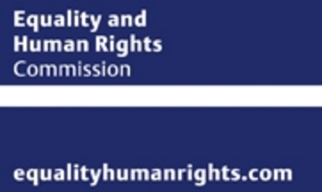
United Kingdom – Equality and Human Rights Commission (EHRC)
The EHRC has published new guidance recently to help employers and employees deal with the expression of religion or belief at work and avoid conflict and costly court cases. The guidance was issued on the same day that the EHRC provided a briefing to MPs on the Marriage (Same Sex Couples) Bill as it was scrutinised in Parliament. Both publications will help to clarify two complex areas of law that will have a direct impact on people's lives. It includes good practice advice for employers such as how to tell if a religion or belief is genuine, the kinds of religion and belief requests employers will need to consider and how to deal with them.
The EHRC has welcomed a new report into home care by the CQC (Care Quality Commission), and said that better management and tighter regulation of home care must continue, to safeguard the rights of older people, and to ensure their voices are heard. Continue reading
The UK Government has published the Children and Families Bill, which aims to fulfill a number of commitments it has made on children and families. These include proposals on shared parental leave and pay and extending the right to request flexible working to all employees, which were included in the UK Government's response to its Modern Workplaces consultation. The Bill had its first reading on 4 February 2013. Continue reading
On 13 February 2013 the UK Government published ‘Fulfilling Potential: Building a deeper understanding of disability in the UK today' . The aims of the report are: to provide an analysis of the current evidence on disability in the UK to inform the development of the next stage of work on Fulfilling Potential – the development of actions, outcomes and indicators; to inform public understanding and prompt debate about disability and the issues faced by disabled people; to raise awareness, drive a change in attitudes and support an increase in commitment to improving the lives of disabled people in the UK today.
(contact: international@equalityhumanrights.com)

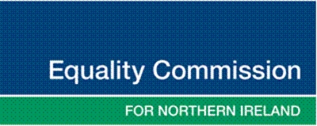
United Kingdom – Equality Commission for Northern Ireland
While in Northern Ireland the public are becoming more aware of the issues and challenges facing the Trans community, many are still unaware that Trans people are protected from discrimination under sex discrimination laws. The Equality Commission in partnership with the Transgender NI and Youthnet ran a seminar in early March to highlight some of the issues faced by Trans people. It was targeted at service providers and aimed to help them promote good practice when dealing with transgendered people. Continue reading
‘Getting a Fair Share?' was an event organised by the Commission which focused on the issues impacting on women's economic independence in Northern Ireland. It saw the release of details of a new study entitled ‘Childcare: Maximising the Economic Participation of Women'. The report highlights the high costs of childcare in Northern Ireland, costs which make up around 44% of an average income compared to the UK overall figure of 33% and 12% across the EU. It also identifies that the availability of appropriate childcare does not match demand, particularly for families in rural areas or those with children with disabilities. Continue reading
A nursing auxiliary with a disability, whose employer failed in its duty to act promptly to put a reasonable adjustment in place to allow her to return to work, has been awarded £16,684.22 by an Industrial Tribunal. The case, supported by the Equality Commission, was taken by Angela McCracken against the Northern Health and Social Care Trust. Continue reading (contact: Mark Soult)

European Developments

CJEU clarifies field of application of Fundamental Rights Charter

ECHR ruling on refusal to adapt working time to child care

ECHR ruling on discrimination in relation to second-parent adoption in a same-sex relationship

European Parliament LIBE Committee delegation visits FRA with a view to strengthening cooperation

FRA research on inequalities and multiple discrimination in access to and quality of healthcare

The impact of the crisis on gender equality needs to be addressed, say Women's Rights and Gender Equality Committee of the European Parliament

European Network Against Racism launches first episodes of its new ‘Recycling Hatred' video series

The European Women's Lobby has officially launched the call for supporters to take part in the 20KM Run of Brussels on 26 May 2013

Upcoming Events

Please bear in mind that some of these events may be attended upon invitation only. For more details please contact the organisers.

20 March - European Network Against Racism: Launch event of ENAR's 2011-2012 Shadow Report on racism in Europe

20 March - Institute for European Studies: The Europeanization of EU Anti-Discrimination Policies. Did it Reduce Ethnic Discrimination in the Member-states?

21 March - European Commission: Business Forum Equality Pays Off - A Europe 2020 initiative

22 March - EESC Europe 2020 Steering Committee: The gender dimension in the Europe 2020 Strategy

26 March - French Ministry of Women's Rights: Regional Seminar on LGBT Rights in Europe

25-26 April - EU Fundamental Rights Agency: 6th Fundamental Rights Platform meeting

6-7 May - European Commission: Demography Forum: Enhancing employment for the next – where investments count

Latest Publications

Equinet "Law in Practice Report 2012 - Comparative Analysis of Discrimination Cases in Europe"
Equinet perspective on "Equality Bodies Combating Discrimination on the Ground of Racial or Ethnic Origin"
European Network of Legal Experts in the field of non-discrimination "Thematic report on Evolution and impact of CJEU case law on Racial and Employment Directives"
Eurobarometer survey on Women and Gender Inequalities in the Context of the Crisis
Open Society Foundations briefing paper on "The EU Charter of Fundamental Rights: What can it do?"
Migration Policy Group and Human European Consultancy "Training manual for capacity building and awareness-raising of civil society organisations that are dealing with anti-discrimination and equality"
European Institute for Gender Equality report on the "Review of the Implementation of the Beijing Platform for Action in the EU Member States: Violence against Women - Victim Support"

 | Equinet Secretariat  Rue Royale 138  1000 Brussels - Belgium  Tel : +32 (0) 2 212 3182  Fax : +32 (0) 2 212 3030 | 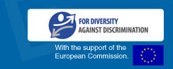
   |  |  |  | 
  Copyright 2012 © Equinet. All rights reserved.

