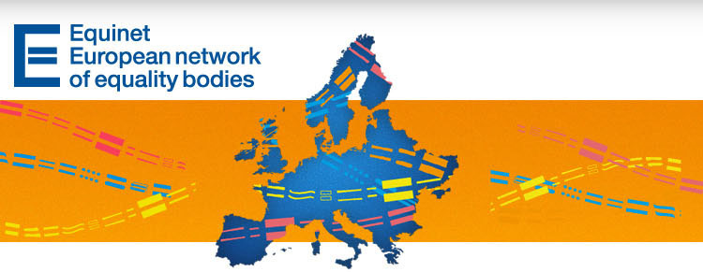

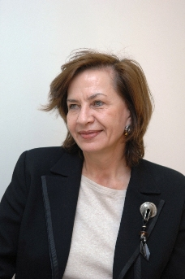
Equinet e-newsletter No. 23

Welcome to the Equinet e-newsletter
Dear Subscriber,
The Equinet e-newsletter and the new Equinet website are the leading sources of information at European level about and for equality bodies in Europe. We encourage you to forward this newsletter to potentially interested colleagues and partner organisations. Subscription to our newsletter is possible through the homepage of our website at www.equineteurope.org.
PDF and Word versions of all our newsletters are also available on this page of the Equinet website.
We hope you will find the current edition of the e-newsletter informative and we thank you for your interest in Equinet.
We wish you all a wonderful month ahead,
The Equinet Team

Contents
News from Equinet
European Developments
News from Equality Bodies
News from European Institutions and Partners
Latest Publications

News from Equinet
Equinet's work can now be followed through social media
With the recent launch of its social media profiles, Equinet has stepped up its communication efforts to raise awareness about the work and importance of equality bodies in the field of equal treatment, as well as share important updates on its initiatives and publications.
You can thus follow Equinet on Facebook and Twitter (@equineteurope), see photos from events and meetings on Picasa, or join the Equinet LinkedIn Group (the latter only for staff members of equality bodies).
Interview with head of Cypriot equality body
For our new edition of "Member in the Spotlight" we talked to Ms. Eliza Savvidou, Cyprus Commissioner for Administration and Human Rights, about the challenges faced by her institution in times of austerity, the opportunities provided by Equinet, and the commitment of Cypriot society to equal treatment. Continue reading
Report from the Equality Summit
The 2012 Equality Summit, on the topic of "Equality for Growth", was held on 22-23 November in Cyprus, gathering more than 300 participants from EU Member States and acceding countries.
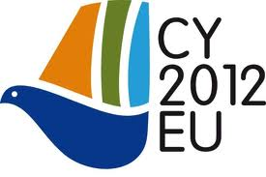
Equinet was present at this important event, being represented in many of the discussions. Jozef De Witte (Chair of Equinet) participated in the panel discussion on the contribution of equality and accessibility policies to the EU 2020 Strategy, Niall Crowley (Equinet Board Advisor) participated in the plenary concerning the economic case for diversity and the benefits of antidiscrimination policies, and Ms. Mandana Zarrehparvar from the Danish Institute of Human Rights delivered the summit's closing speech. Read their contributions and our report from the summit

European Developments
The Special Eurobarometer "Discrimination in the EU in 2012" has been launched
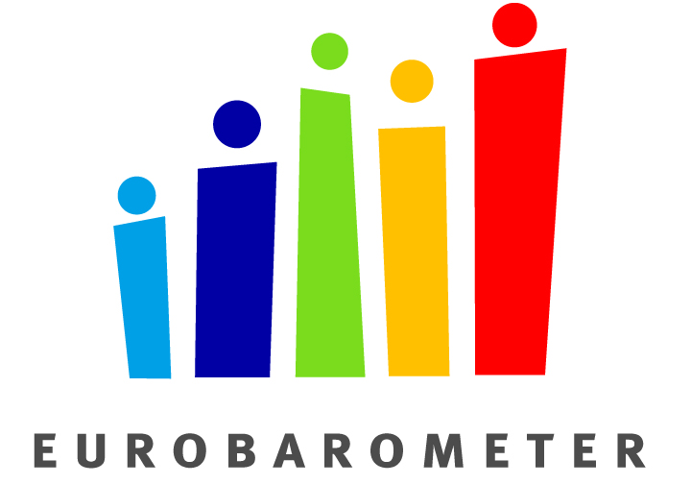
The European Commission released a new Eurobarometer on discrimination in the EU, looking into attitudes and perceptions of Europeans towards discrimination based on different grounds.
A point of concern is that most Europeans (34%) prefer to report their case to the police, should they become a victim of discrimination or harassment. Only 16% of the people would prefer to report their case to Equality bodies (though up from 13% in 2009), closely followed by lawyers (14%) and tribunals and trade unions (10%). The low numbers point to the conclusions that were made at the Equinet communication training on Under-reporting that took place in September in Malta – great communication efforts are needed to make the public aware of the Equality bodies and to gain trust for the institutions. Continue reading
The proposed EC Directive on "Women on Boards" calls for the direct involvement of equality bodies
In mid-November, The European Commission took an important step to challenge the glass ceiling effect that persists in corporate management by proposing new EU legislation to improve gender balance in boardrooms.
According to Article 5 (4) of the proposed Directive, equality bodies will play an important role in the promotion and implementation of the Directive. The equality bodies designated for the implementation of the principle of equal opportunities and equal treatment of men and women in matters of employment and occupation are required to be competent for the promotion, analysis, monitoring and support of gender balance on the boards of listed companies. Continue reading
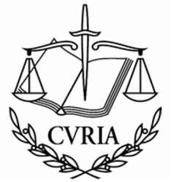
The radical lowering of the retirement age for Hungarian judges is age discrimination
In a recent judgment in an infringement case brought by the European Commission, the Court of Justice of the European Union declared that a retirement reform measure put in place in Hungary constitutes unjustified age discrimination, in contradiction with Directive 2000/78. Continue reading
Top of page

News from Equality Bodies

Croatia - Office of the Ombudsman
The Ombudsman was involved in the first Croatian Supreme Court case that established discrimination. The Supreme Court upheld the plaintiff's appeal (presented by NGOs LORI Rijeka, Zagreb Pride, Domino, Center for Peace Studies and the Ombudsman) and repealed the judgment of the Zagreb County Court, establishing that the statements of the Croatian Football Association President, Mr Vlatko Marković, were discriminatory. Marković stated in an interview to a popular daily newspaper in November 2010 that "homosexuals would not play for the Croatian football team as long as he was the President of the Croatian Football Association" and that "only healthy persons play football". The Supreme Court decided that these statements constitute discrimination based on sexual orientation, thus establishing the first discrimination case in the Croatian Supreme Court. (Contact: Teodora Matej)

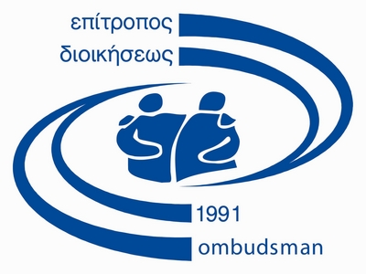
Cyprus - Office of the Commissioner for Administration and Human Rights
The Ombudsman Office co-hosted, along with PICUM, Action for Equality, Support and Antiracism KISA, the Representation of the European Commission in Cyprus, the Office of the European Parliament in Cyprus, AEDH and ENAR, an International Workshop on Migrants and the Right to Equal Treatment in Cyprus. The Workshop took place on 21 November and seeked to improve the understanding of the differential treatment third-country nationals face in Cyprus. The differential treatment in law and in practice, with regards to employment, social protection and inclusion may foster and perpetuate discrimination.
On the same date, for the first time in Cyprus, activities against transphobia were organised. The Ombudsman's office in cooperation with an LGBT Organization "Accept Cyprus", organised two activities on the occasion of the "Transgender Day of Remembrance" (celebrated annually on 20 November). A press conference was held at noon and the day continued with a memorial event and a movie screening. (Contact: Thekla Demetriadou)

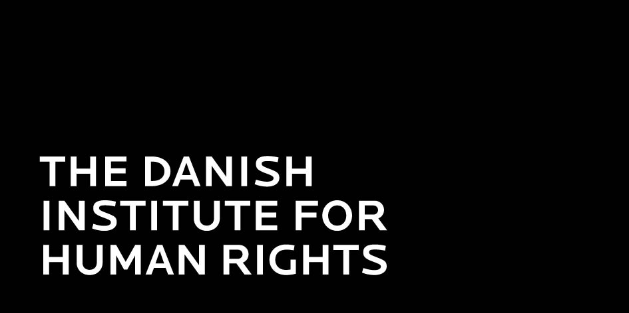
Denmark – Danish Institute for Human Rights (DIHR)
DIHR together with Disabled Peoples Organisations Denmark launched a series of seminars, focusing on the rights of persons with disabilities. The seminars are formed as a panel debate among the participants of the seminars and a panel. The first seminar took place on 3 December 2012 and focused on participation in the elections. The election for the local councils in Denmark is approaching and in this respect it is relevant to bring into focus the possibilities of persons with disabilities to be informed about the election campaign, to be able to vote in public polling places, and to be able to be represented in the local councils. Moreover, the right to vote for persons under guardianship was also debated at the seminar.
On 3 December the DIHR together with the Mainstreaming Network of 2005 had an after-work meeting on effective gender equality strategies, inspired by a recent study in Norway. The new extensive study gives answers to many of the central questions of the gender equality debate. The chairman of the committee behind the survey, Professor Hege Skjeie, presented some of the results of the survey, for instance, what are the most important problems of gender equality today? What is gender mainstreaming? How can authorities make sure to integrate gender equality in planning and administration?
"Stop hate crimes – show respect" is the slogan of a new campaign by, among others, DIHR. The campaign aims to increase reporting of hate crimes, both by victims and witnesses of verbal and physical violence. With posters visible in the townscape displaying victims of hate crimes and a competition on Facebook, the goal is that especially young people become aware of the problem and of their own responsibility. The campaign is based on the Facebook page 'Stop Hate crimes', where schools can participate in a competition in order to spread the message. (Contact: Christine Bendixen)


Hungary - Office of the Commissioner for Fundamental Rights
In November, a public opinion research institute Ipsos conducted a survey to find out about people's awareness and recognition of the Ombudsman institution. The most important finding of the survey is that people's active awareness has risen from 15% in 1998 and 32% in 2008 to 54% in 2012. The term "active awareness" describes the fact that the respondents mentioned this institution of rights protection without any allusion or guidance. 87% of the respondents know the Ombudsman institution by hearsay, 85% of them know about the position of the Parliamentary Commissioner for Fundamental Rights. 17% of the adult population would surely, and another 34% would probably bring his/her problem to the ombudsman, which is a significant increase compared to the results in previous years. Apart from widespread awareness about the institution, the Ombudsman's Institution enjoys very high levels of public trust, ranking first among all public institutions. (Contact: Babos Nikolett)

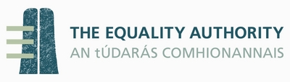
Ireland - Equality Authority
The Authority recently launched a targeted promotion campaign to inform expectant mothers and their employers about their rights to maternity protection. A Guide "Your Maternity Leave Rights Explained" is made available online in easy-to-read English, Arabic, Chinese, Croatian, Czech, French, Gaeilge, Latvian, Lingala, Lithuanian, Polish, Portuguese, Romanian, Russian, Spanish. (Contact: Brian Merriman)

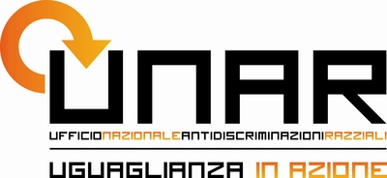
Italy – National Office Against Racial Discrimination (UNAR)
UNAR hosted the fourth Career Forum "Diversity at work" in November in Rome, targeting talented persons with disabilities, foreign nationals and transgender people. The Career Forum gives the members of those subjugated groups the opportunity to meet the human resources managers of some major companies in order to submit their CV and have a job interview. Furthermore, before the event took place, UNAR held meetings with the personnel selection managers of the companies present at the Forum. "Diversity at work" strives to support companies to embrace equal opportunities, diversity and inclusion and to disseminate good practices in the field of employment.
On The Transgender Day of Remembrance, 20 November 20120, the Director of UNAR, Marco De Giorgi, launched the National Working Group for an Italian Strategy against LGBT discrimination. The initiative is part of a wider project supported by the Council of Europe and involves the main Italian associations focusing on LGBT issues. The National Working Group, whose first session will be held on 12 December in Rome, will discuss concrete measures to be adopted to fight discrimination against LGBT people in the filed of employment, education, security and media.
UNAR cooperated with the Italian Police Force in an investigative operation which resulted in closing down the Italian branch of the racist association "Stormfront" and its website. The cooperation between UNAR and the Police Force has been crucial for monitoring the publication of discriminatory web contents praising racism, xenophobia and violence.
On the occasion of the IV National Week against Violence, which was celebrated in November, UNAR started a year-long education campaign addressed to teachers, students and their families involving over 100 Italian schools at different levels. The project will include learning sessions, conferences, and a series of commemorative events to encourage public understanding about anti-discrimination, diversity and non-violence. (Contact: Valerio Serafini)

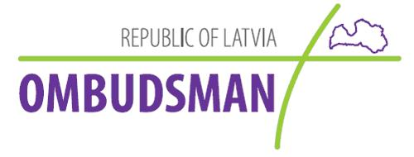
Latvia - Office of the Ombudsman
On November 11, The Ombudsman's Office of the Republic of Latvia was accepted into the International Ombudsman Institute (IOI) as a full member (Institutional Member). This IOI status confirms that the Ombudsman's Office activities are recognised and appreciated on both national and international level. The acquired membership status not only allows the institution to share experiences and best practices with other Ombudsman institutions, but also gives the right to vote at IOI meetings. (Contact: Laura Bagata)
Top of page
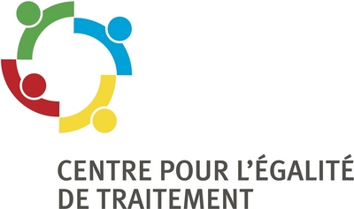
Luxembourg - Centre for Equal Treatment
The CET recently organised an awareness-raising afternoon on disabilities that targeted young people between 12 and 26 years. The event was called "Ech an denger Plaz… Entdeck d'Liewe mat enger Behënnerung!" (Me in your stead… Discover life with a disability!). Video footage from the event is available on the centre's webpage.
The Centre recently launched a campaign "Annoncer sans discriminer!" (Reporting without discrimination!). The campaign targets media employees (journalists, communication agencies etc). A newsletter was sent out with the aim to sensibilize media workers to discrimination on the basis of 6 grounds prohibited by Luxembourgish law and to encourage them to avoid stereotypes, clichés and prejudices. The newsletter included also explanations of the consequences of discrimination, such as influence on people's opinions or legal sanctions. Following a law amendment in June, sex has become the 6th ground of discrimination that is covered in media, publicity and education. The newsletter (in French) can be accessed here. (Contact: Nathalie Morgenthaler)


Malta - National Commission for the Promotion of Equality (NCPE)
The remit of NCPE was extended following amendments to Chapter 456 Equality for Men and Women Act approved in the Maltese Parliament in November 2012. As it follows from the Act, discrimination on the basis of sexual orientation, age, religion or belief, racial or ethnic origin, and gender identity are now fully prohibited in the field of employment, financial institutions and education. Continue reading
NCPE is currently concluding two EU co-funded projects. The first project - Unlocking the Female Potential aims to improve women's access to employment and enhance their participation and progress in the labour market. In-depth research was carried out on various facets related to women's participation in the labour market. Moreover, through this project, the Equality Mark was awarded to organisations which truly foster gender equal opportunities to employees.
The other project entitled I'm Not Racist, But… intends to develop a clear understanding of the situation of ethnic minorities and housing. Moreover, the project seeks to encourage respective stakeholders to prevent or combat discrimination in this area; to empower the African minority to get their voice heard, to advocate for their rights and to report discrimination. All in all, the objective of the project is to raise awareness on racial discrimination and to promote cultural diversity. (Contact: Maria Theresa Portelli)


Poland - Human Rights Defender (HRD)
The OHRD has launched several publications, all of which are accessible in Polish: a report on "The principle of equal treatment - law and practice. The guarantees of the right to vote by the elderly and people with disabilities"; a report on "The principle of equal treatment - law and practice. Equal Opportunities in Access to Education for Persons with Disabilities"; a "Human Rights guide for the elderly".
Regarding Commissioner Viviane Reding's recommendation to improve gender balance on corporate boards, Ms Irena Lipowicz, Human Rights Defender of the Republic of Poland petitioned The Government Plenipotentiary for Equal Treatment, Ms Agnieszka Kozłowska-Rajewicz, to analyze the issue and to inform whether The Council of Ministers in Poland plans to introduce legislation to achieve balanced representation of women and men on public company boards. According to a survey of the Confederation of Private Employers "Lewiatan", only 6.7 percent of presidents in 400 large Polish companies are women. (Contact: Katarzyna Wilkołaska)

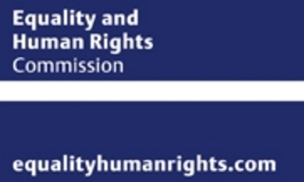
United Kingdom – Equality and Human Rights Commission (EHRC)
A new report ‘Meat and poultry processing inquiry review' has been released. The inquiry found mistreatment and discrimination against migrant and pregnant workers in particular. Although the review highlights clear signs of progress since the inquiry last year, it also reveals that significant problems still exist within some firms. The Commission has also launched a guide to help firms tackle some of the remaining challenges, and to support the meat and poultry processing sector to understand their obligations under the Equality Act.
The Commission has launched a new guide for older people, their families and friends, providing easy to understand information on home care and human rights. The guide ‘Your rights to home care' aims to empower older people so they know they are entitled to a home care service that respects their human rights, and what to do if those rights are at risk. The guide features: What to look for when searching for a home care provider; Case studies with examples; A checklist of rights home care users are entitled to; Funding for home care services; How to make a complaint.
The Department of Culture Media and Sport has published its interim evaluation of the impact and legacy of the London 2012 Olympic and Paralympic Games. The Commission has analysed information from the report on disabled people's benefit in terms of participation, improvements to infrastructure and attitudes of the general public. (Contact: international@equalityhumanrights.com)

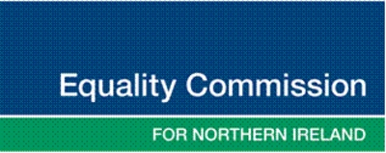
United Kingdom – Equality Commission for Northern Ireland (ECNI)
On 3 December 2012, in order to celebrate the International Day of Persons with Disabilities, Equality Commission for NI in partnership with Employers for Disability NI organised a seminar on Reasonable Adjustments in the Workplace. There were parallel sessions on Autism and Reasonable Adjustment and Sickness Absence and Reasonable Adjustment. (Contact: Mark Soult)
Top of page

News from European Institutions and Partners
European Network of Legal Experts in the non-discrimination field
The network has recently launched its "Country reports on measures to combat discrimination 2011". These reports are available for download here.
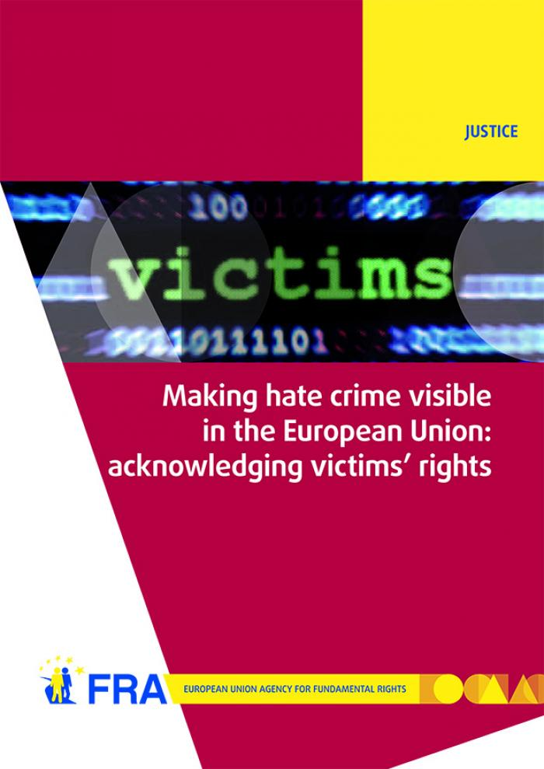
Fundamental Rights Agency (FRA)
On 27 November 2012, FRA published two new reports underlining that hate crime is a daily reality in the EU today. The reports highlight the need for the EU and Member States to make hate crimes more visible and hold perpetrators to account in order to better combat such crime. Both FRA reports look at hate crime from the perspective of victims' rights. Continue reading
European Institute for Gender Equality (EIGE)
The European Institute for Gender Equality (EIGE) launched Europe's Resources on Gender-based Violence, hosted by EIGE's Resource and Documentation Centre.
Top of page

Latest Publications
Equinet perspective on "Equality Bodies – Current Challenges"
Special Eurobarometer "Discrimination in the EU in 2012"
FRA's report on "Making hate crime visible in the European Union: acknowledging victims' rights"
FRA's EU-MIDIS Data in Focus 6 Report: Minorities as Victims of Crime
Country reports on measures to combat discrimination 2011 - European Network of Legal Experts in the non-discrimination field
 | Equinet Secretariat  Rue Royale 138  1000 Brussels - Belgium  Tel : +32 (0) 2 212 3182  Fax : +32 (0) 2 212 3030 | 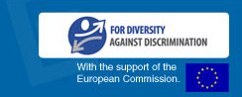
   |  |  | 
  Copyright 2012 © Equinet. All rights reserved.

