SUMMARY: Opening up the Issue
Equality Bodies Combating Discrimination Against and Promoting Equality for Young People

EQUINET, the European Network of Equality Bodies, brings together 46 equality bodies from 34 European countries. Equality bodies are public institutions set up across Europe to promote equality and tackle discrimination on grounds of gender, race, age, sexual orientation, religion and belief, disability or other grounds. They play a fundamental role in the non-discrimination architecture of the EU. As a first point of contact for victims of discrimination, equality bodies have an extensive understanding of how discrimination affects people in Europe.
Why a Perspective on Discrimination against Young People?
The Youth Perspective is authored by Niall Crowley (independent expert), and is based on a roundtable discussion of Equinet’s Policy Formation Working Group and on a survey of the Equinet members.
Young people experience inequality and individual and structural discrimination on the ground of their age as well as intersectional discrimination based on other characteristics such as disability, gender, race or ethnic origin, religion or belief, and sexual orientation. To combat discrimination and promote equality there is a need to raise awareness of the experience of and share good practices from equality bodies in their work on equality for young people. The perspective aims to draw out, analyse and learn from the work and experience of equality bodies at Member State level and to tease out the implications of their work for policy and practice development.

Combating Discrimination against and Promoting Equality for Young People

- Equality bodies report a spectrum of key issues faced by young people, including issues of economic, political, cultural and social inequality.
- A key to successful work to improve the situation of young people is to cooperate with and involve young people and their organisations in the work of the equality bodies.
- The equality bodies tend to give issues of discrimination against and inequality for young people medium to low focus, often due to limitations in the mandate of the equality bodies, under-reporting and lack of casework, and limited data.
- Equality bodies can be valuable actors in fighting discrimination against and promoting equality for young people if they are independent, adequately resourced and empowered.

Different Approaches to Working with Young People

REACTIVE |  | HORIZONAL
A reactive approach, evident in a responsiveness to invitations and a readiness to address cases brought to their attention. |  | A horizontal approach is used by most equality bodies where multi-ground activities include the ground of age, in particular communication and promotion of good practice activities.
INTERSECTIONAL |  | STRUCTURAL
Equality bodies are engaged in a wide range of intersectional work with young people that cover intersections with all discrimination grounds, in areas such as access to employment, education, access to leisure services, housing provision and social protection. |  | An approach focused on structural discrimination is viewed by some equality bodies as central to address current outcomes for young people, in mainstream systems such as the labour market, and in targeted systems such as education.
Challenges & Obstacles in Working with Young People

Conceptual Obstacle |  | Practical Obstacle
Equal treatment legislation tends not to define the age ground or young people. Equality bodies have defined young people in flexible ways in terms of age limits, perceived age, and as people in transition to autonomy. |  | Effective involvement of young people and their organisations in the work of equality bodies is recognised as a challenge still to be met by many equality bodies.

Recommendations for combating Discrimination against Young People
Entity | Action
National Equality Bodies | Equality Bodies could further develop their work in relation to young people, including to:  - Trace out and agree what full equality in practice might mean for young people;  - Involve young people and their organisations and share good practice in this;  - Respond to issues of structural discrimination in key areas that enable transitions such as education, employment, and housing;  - Raise awareness of rights under equal treatment legislation with initiatives specifically designed for young people.
European Union | - EU funding streams to advance the social inclusion of young people could be more explicit in their focus on equality, diversity and non-discrimination. This funding could resource equality bodies as an actor in on these issues.  - EU could adopt standards for equality bodies, that ensure they are sufficiently independent, resourced and have the necessary powers to make an impact.  - The proposed EU horizontal equal treatment Directive with its coverage outside the labour market is needed to ensure equality for young people.
National Jurisdictions | - National jurisdictions could mainstream a focus on young people in policy strategies using equality impact assessment tools and positive action. In particular this could be done in policy plans seeking to address and improve the situation of other groups of people experiencing inequality.  - National jurisdictions could include a focus on equality, diversity and non-discrimination in their funding streams targeting young people.  - Mainstreaming and developing an equality focus could involve engagement with equality bodies and dialogue with young people and their organisations.  - National jurisdictions could ensure equality bodies are adequately resourced and empowered to address age discrimination and inequality experienced by young people. Data collection and analysis at national level could be further developed to underpin and inform such interventions.

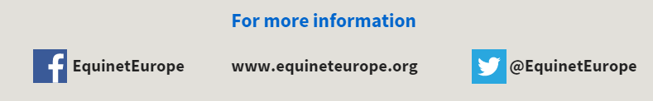
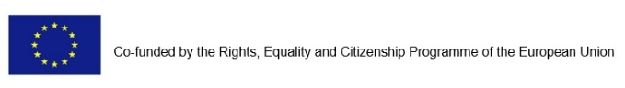
LIST OF CONTRIBUTORS
Commissioner for the Protection from Discrimination, Albania; Ombud for Equal Treatment, Austria; Unia (Interfederal Centre for Equal Opportunities), Belgium; Commission for Protection against Discrimination, Bulgaria; Office of the Ombudswoman, Croatia; Public Defender of Rights, Czech Republic; Danish Institute for Human Rights, Denmark; Defender of Rights, France; Federal Anti-Discrimination Agency (FADA), Germany; Equality and Human Rights Commission, Great Britain; Equal Treatment Authority, Hungary; National Office against Racial Discrimination (UNAR), Italy; Office of the Ombudsman, Latvia; Office of the Equal Opportunities Ombudsperson, Lithuania; Equality and Anti-Discrimination Ombud, Norway; High Commission for Migration, Portugal; Commissioner for Protection of Equality, Serbia; National Centre for Human Rights, Slovakia; Equality Ombudsman, Sweden

